Mp_temp_grate

## mu.spline lambda.spline A.spline integral.spline  
## 1 12.8419 NA 77.63383 9638.081

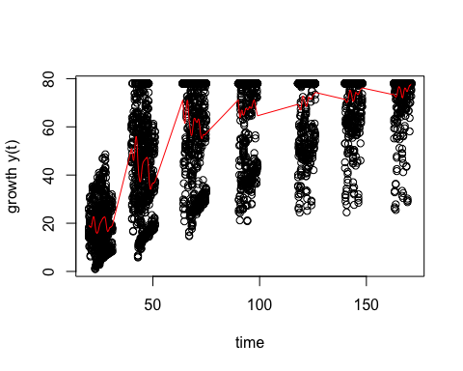

## mu.spline  
## 1 0.5496876

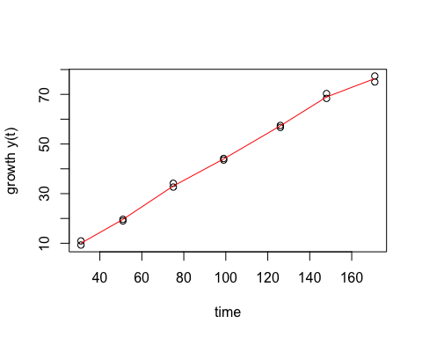

## mu.spline  
## 1 0.5986732

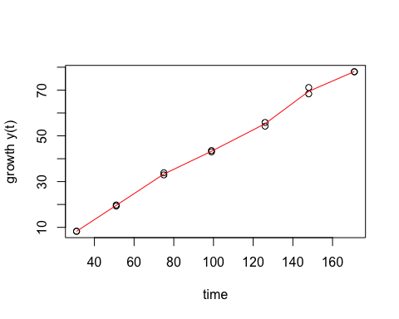

## mu.spline  
## 1 1.049446

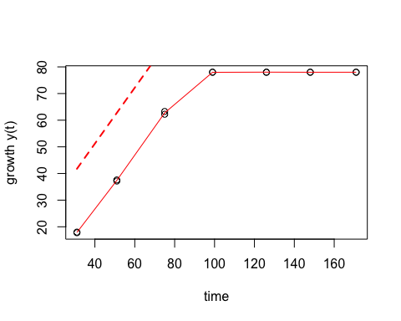

## mu.spline  
## 1 1.103461

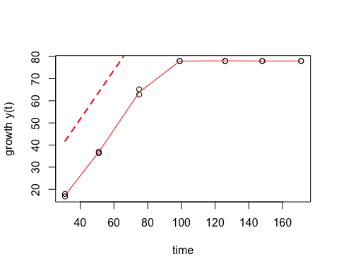

## mu.spline  
## 1 1.465735

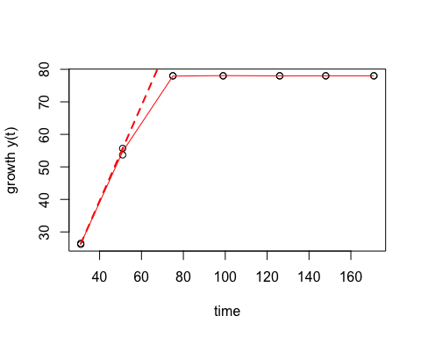

## mu.spline  
## 1 1.513866

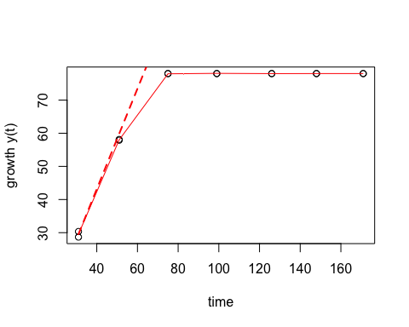

## mu.spline  
## 1 1.653388

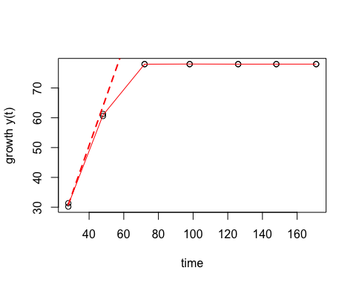

## mu.spline  
## 1 2.37125

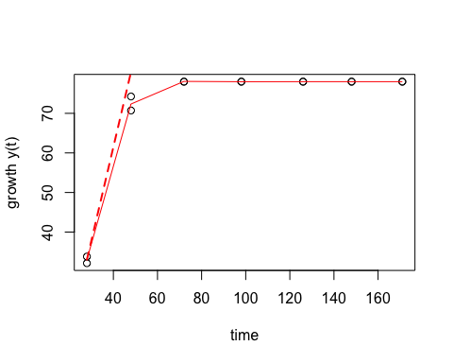

## mu.spline  
## 1 2.631419

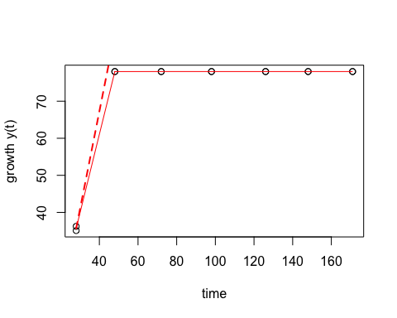

## mu.spline  
## 1 2.361156

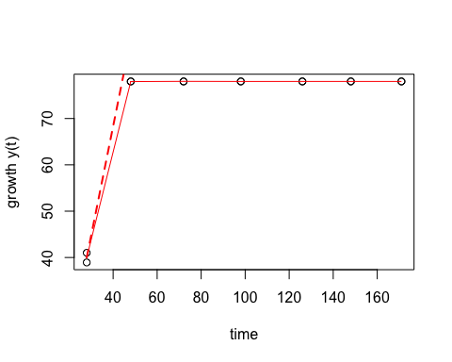

## mu.spline  
## 1 0.8989155

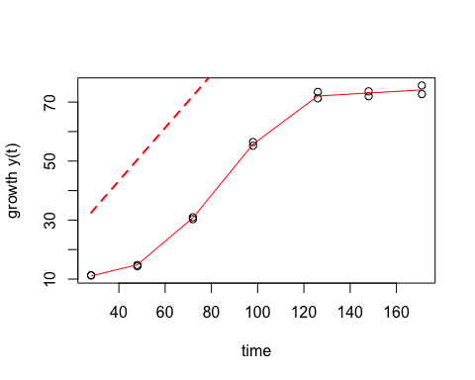

## mu.spline  
## 1 1.421741

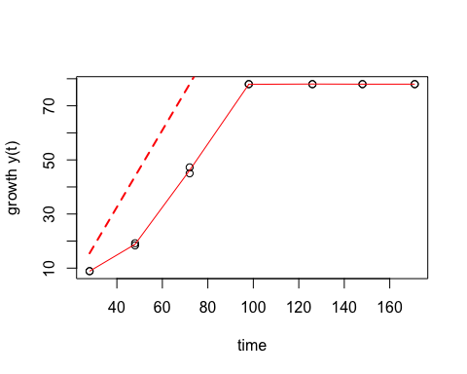

## mu.spline  
## 1 0.5062591

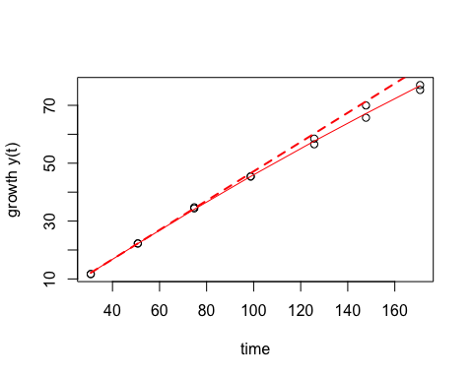

## mu.spline  
## 1 0.5266058

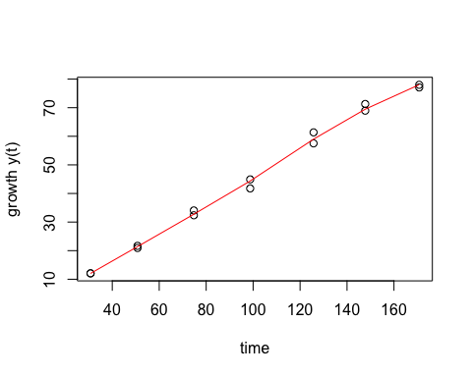

## mu.spline  
## 1 0.8701006

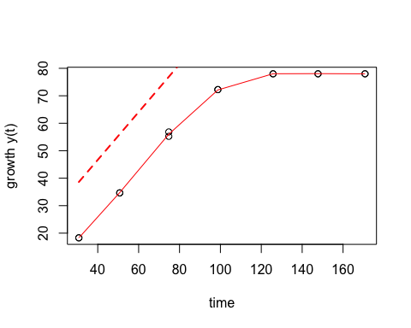

## mu.spline  
## 1 0.924765

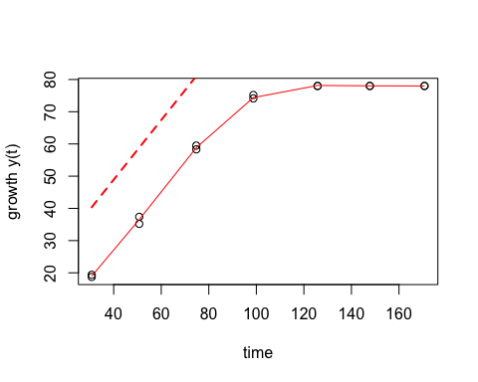

## mu.spline  
## 1 1.292549

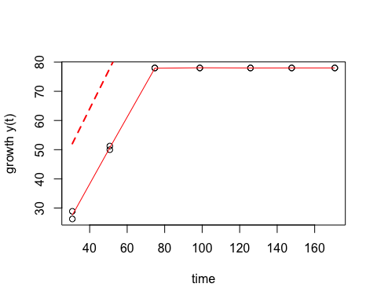

## mu.spline  
## 1 1.23249

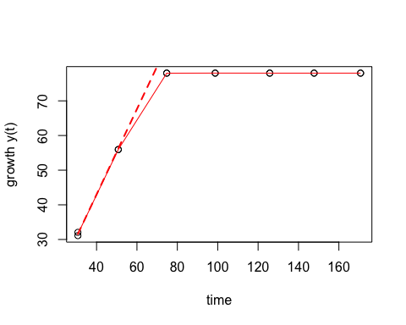

## mu.spline  
## 1 1.990628

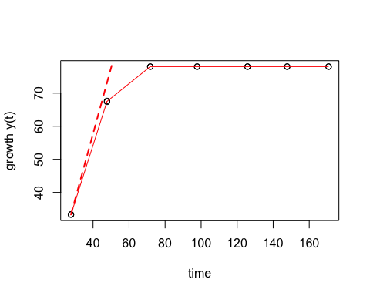

## mu.spline  
## 1 2.080656

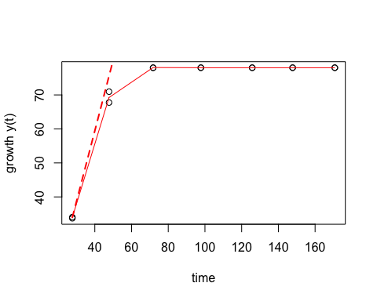

## mu.spline  
## 1 2.168809

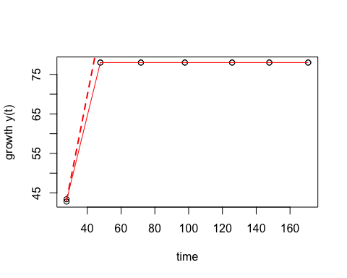

## mu.spline  
## 1 1.895375

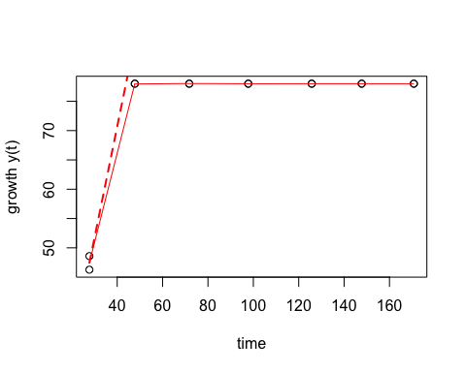

## mu.spline  
## 1 1.470509

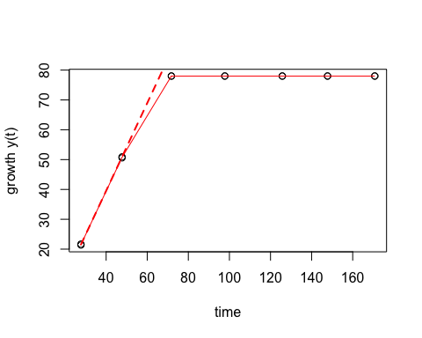

## mu.spline  
## 1 1.70291

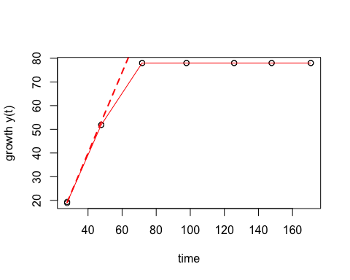

## mu.spline  
## 1 0.5399363

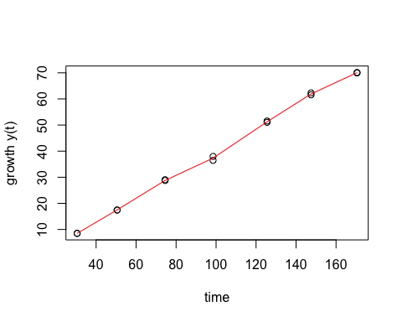

## mu.spline  
## 1 0.4583508

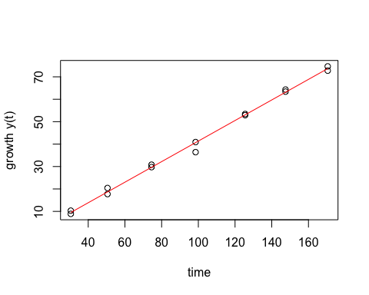

## mu.spline  
## 1 0.8842736

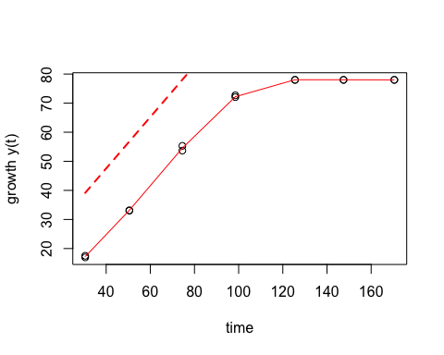

## mu.spline  
## 1 0.9318106

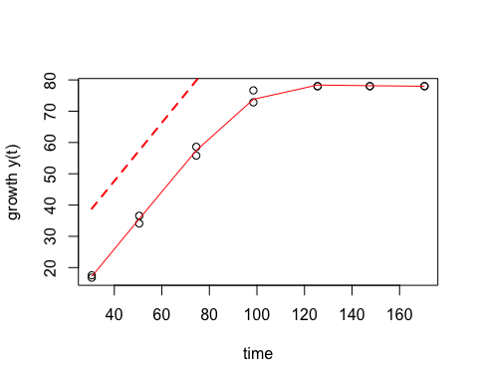

## mu.spline  
## 1 1.22479

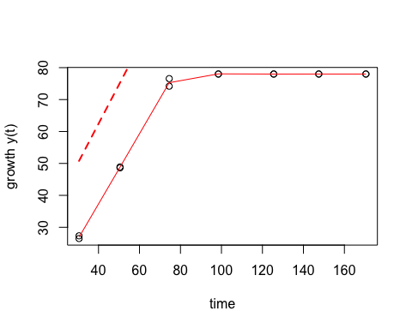

## mu.spline  
## 1 1.29551

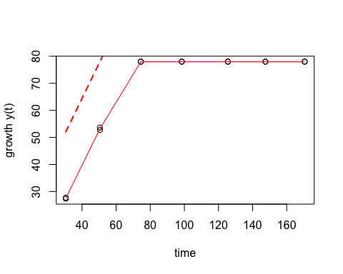

## mu.spline  
## 1 1.755985

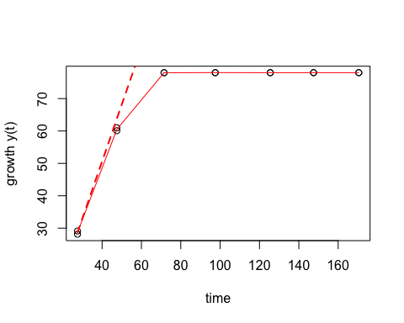

## mu.spline  
## 1 1.809877

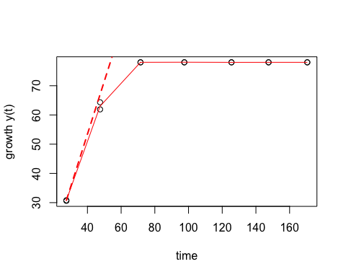

## mu.spline  
## 1 2.275439

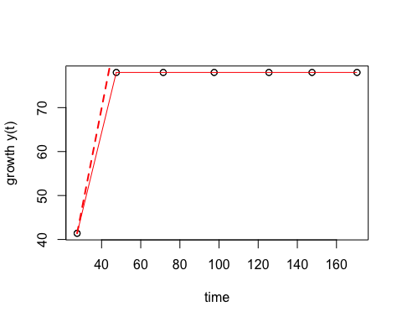

## mu.spline  
## 1 1.937744

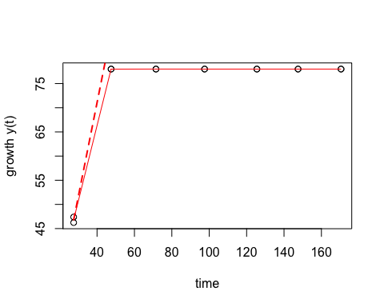

## mu.spline  
## 1 1.649164

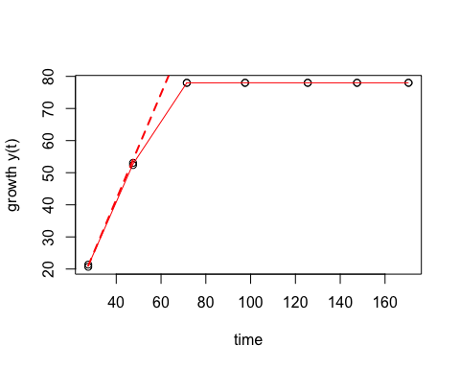

## mu.spline  
## 1 1.990978

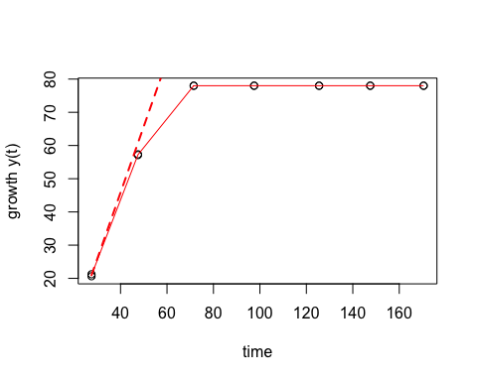

## mu.spline  
## 1 0.4939822

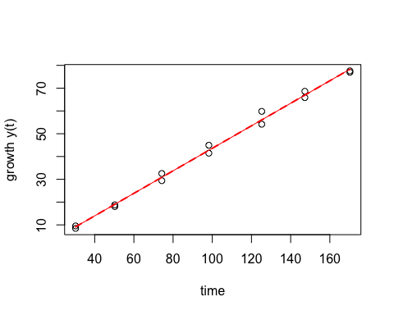

## mu.spline  
## 1 0.4998116

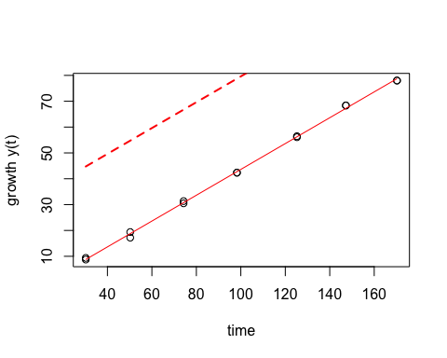

## mu.spline  
## 1 1.244258

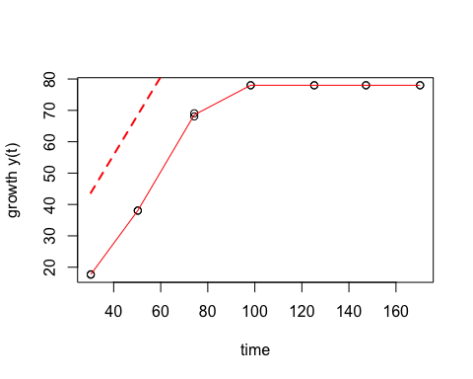

## mu.spline  
## 1 1.272685

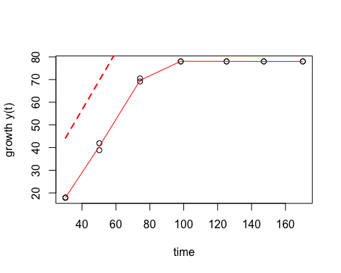

## mu.spline  
## 1 1.365512

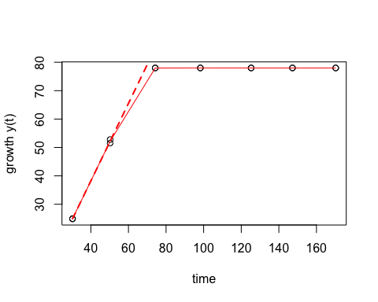

## mu.spline  
## 1 1.721838

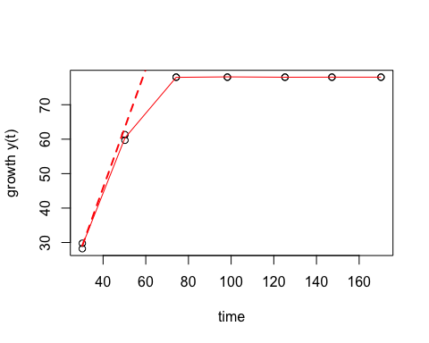

## mu.spline  
## 1 1.686191

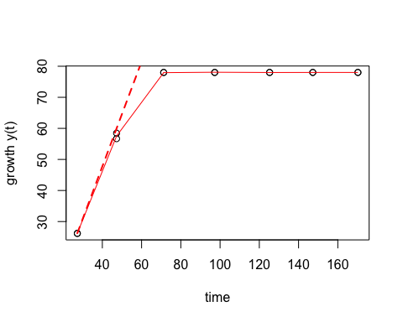

## mu.spline  
## 1 2.250879

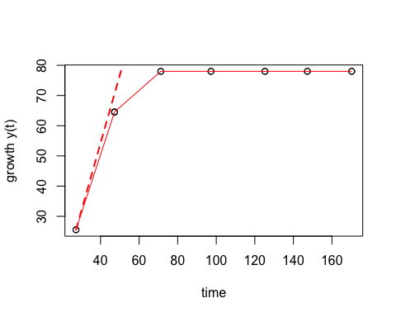

## mu.spline  
## 1 2.0345

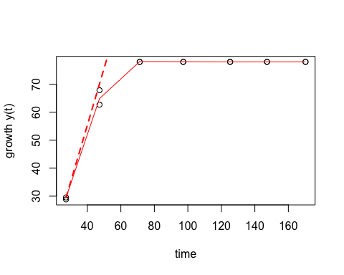

## mu.spline  
## 1 1.686404

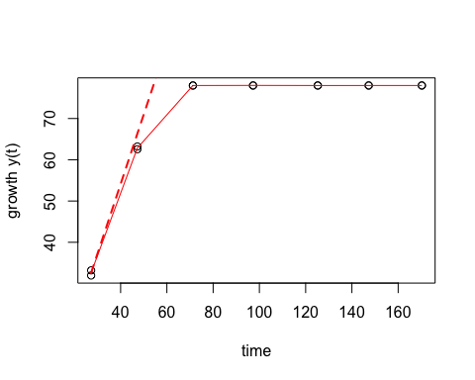

## mu.spline  
## 1 0.5705839

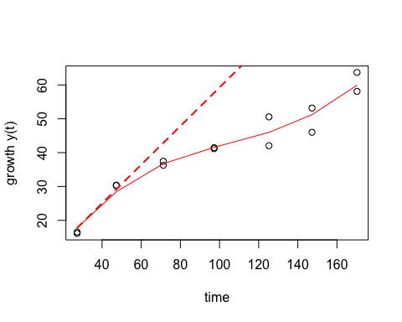

## mu.spline  
## 1 0.9563678

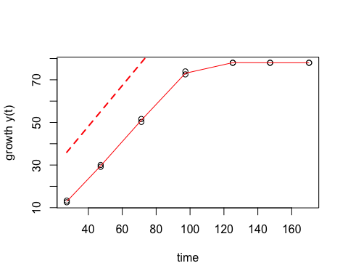

## mu.spline  
## 1 0.5299017

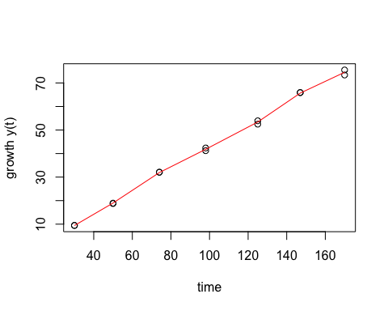

## mu.spline  
## 1 0.4635624

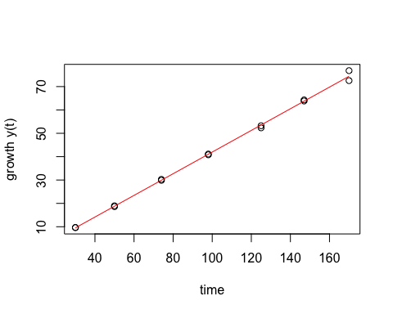

## mu.spline  
## 1 1.098921

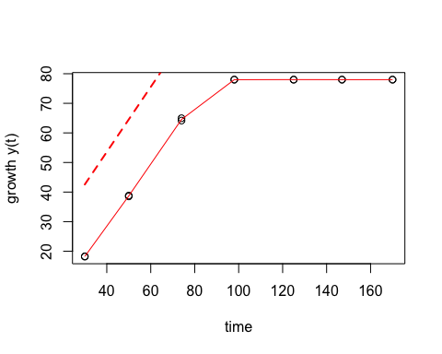

## mu.spline  
## 1 1.01907

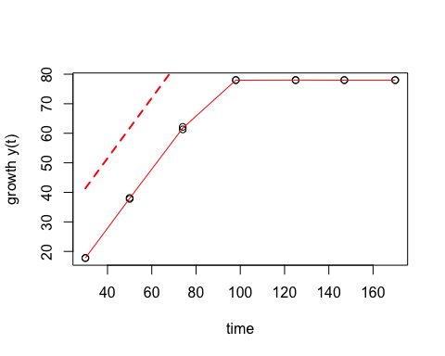

## mu.spline  
## 1 1.401468

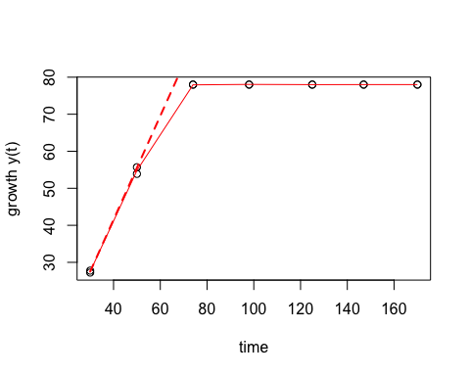

## mu.spline  
## 1 1.604386

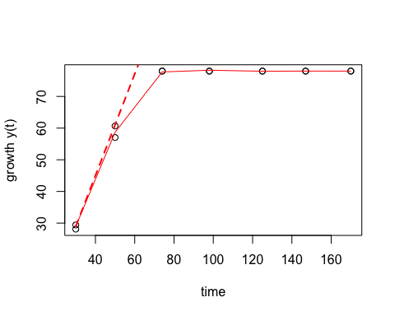

## mu.spline  
## 1 2.288679

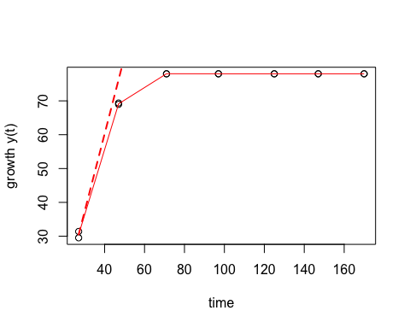

## mu.spline  
## 1 2.402407

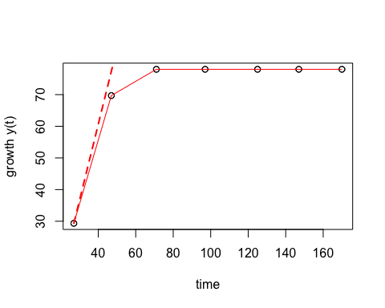

## mu.spline  
## 1 2.255186

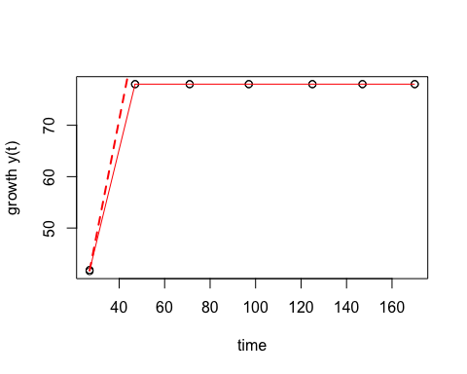

## mu.spline  
## 1 2.269791

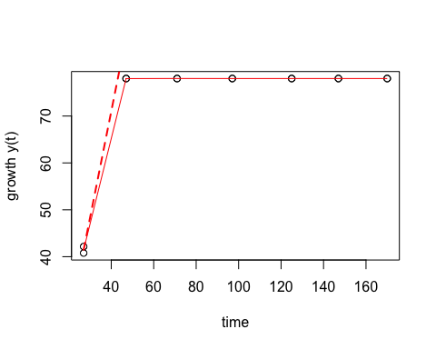

## mu.spline  
## 1 1.708088

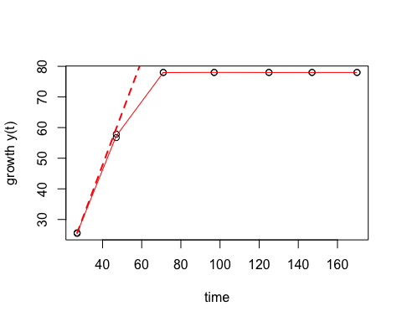

## mu.spline  
## 1 1.935021

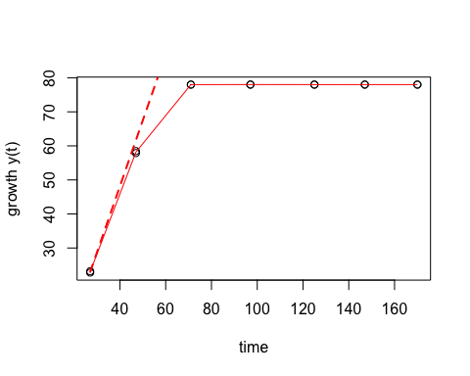

## mu.spline  
## 1 0.4982299

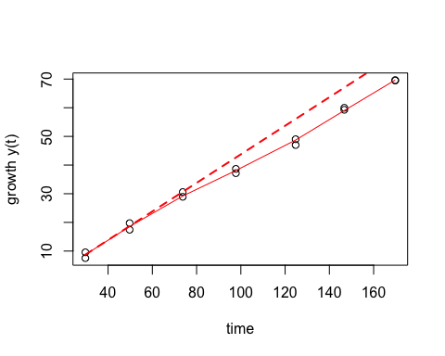

## mu.spline  
## 1 0.4587825

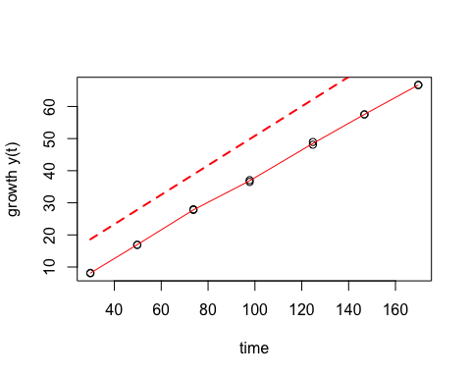

## mu.spline  
## 1 0.8734576

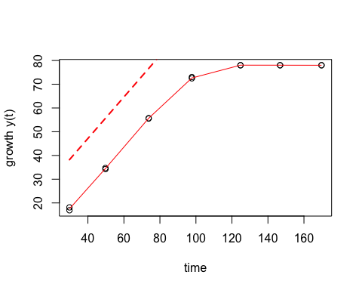

## mu.spline  
## 1 0.9153057

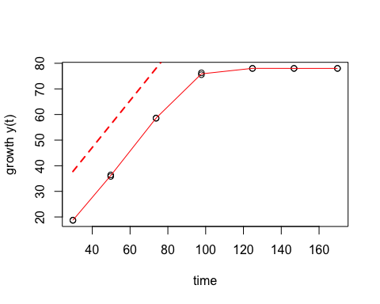

## mu.spline  
## 1 1.175924

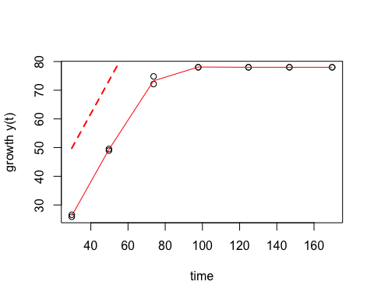

## mu.spline  
## 1 1.27806

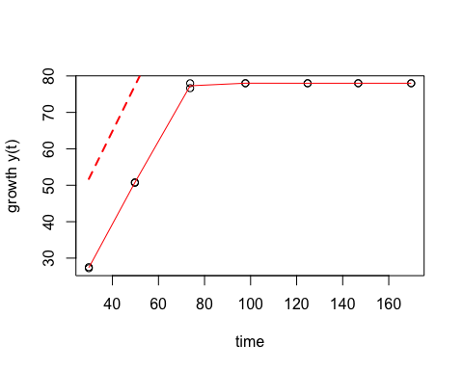

## mu.spline  
## 1 2.137104

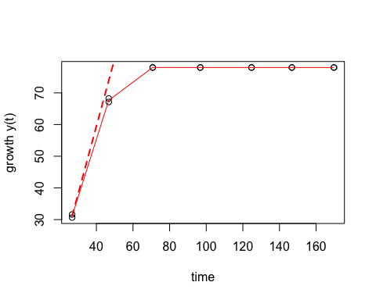

## mu.spline  
## 1 1.558706

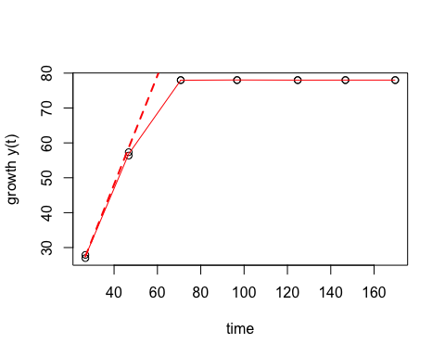

## mu.spline  
## 1 2.447656

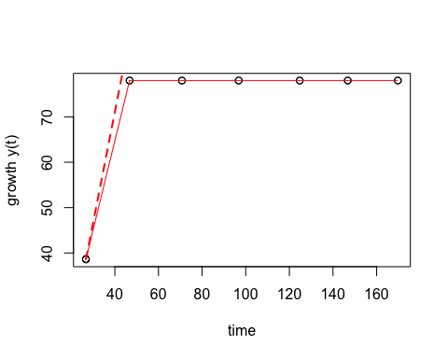

## mu.spline  
## 1 2.253062

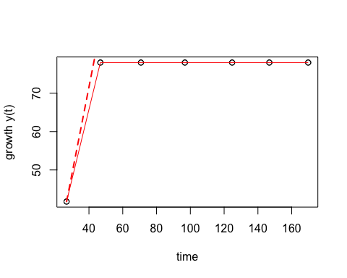

## mu.spline  
## 1 1.626147

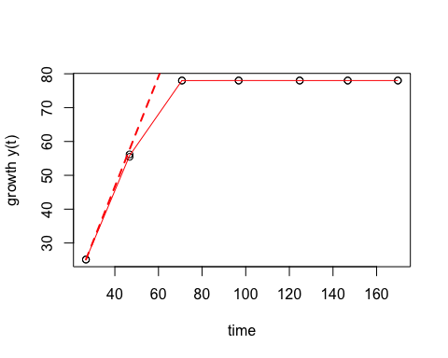

## mu.spline  
## 1 2.065793

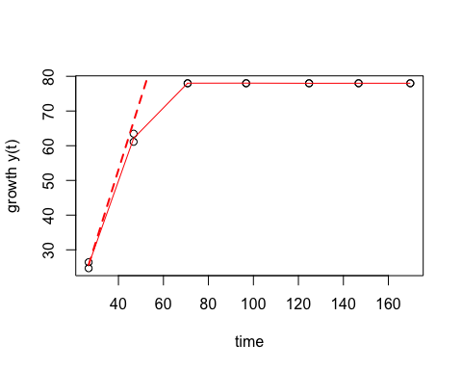

## mu.spline  
## 1 0.5257489

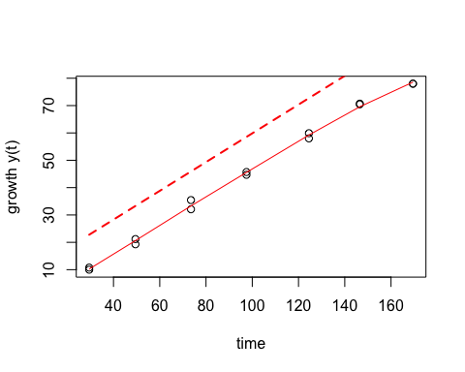

## mu.spline  
## 1 0.5896658

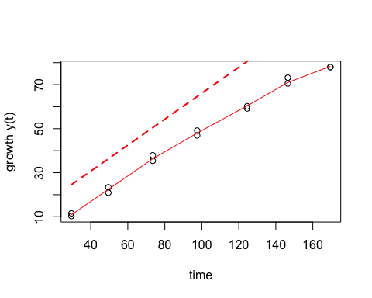

## mu.spline  
## 1 1.109311

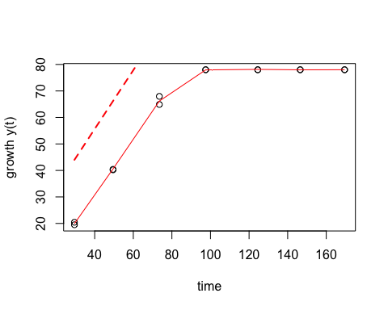

## mu.spline  
## 1 1.068467

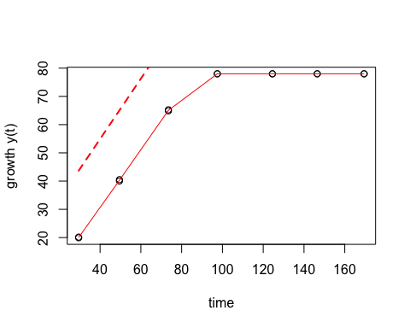

## mu.spline  
## 1 1.392665

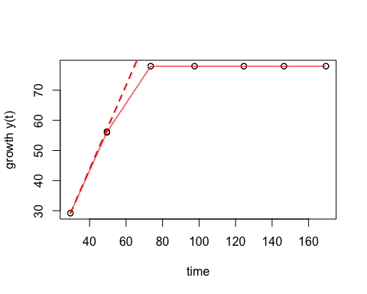

## mu.spline  
## 1 1.53957

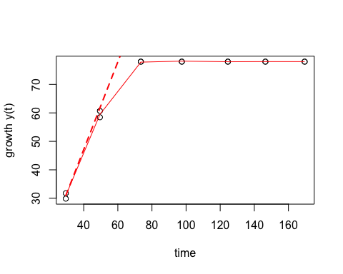

## mu.spline  
## 1 1.951884

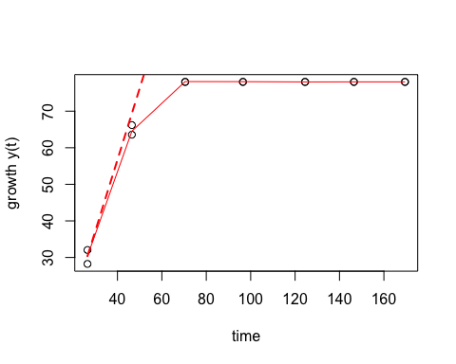

## mu.spline  
## 1 2.178621

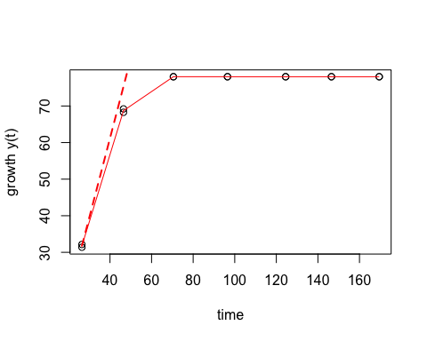

## mu.spline  
## 1 2.327307

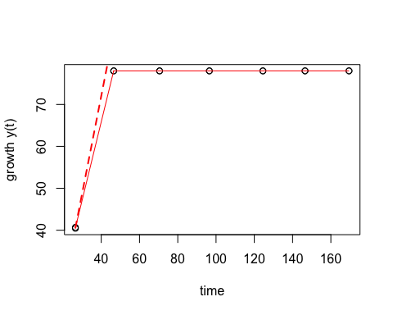

## mu.spline  
## 1 1.934594

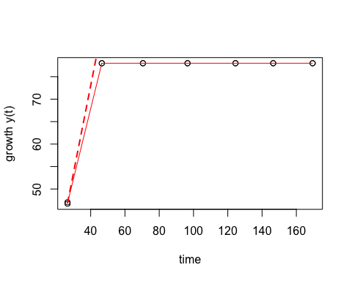

## mu.spline  
## 1 1.310691

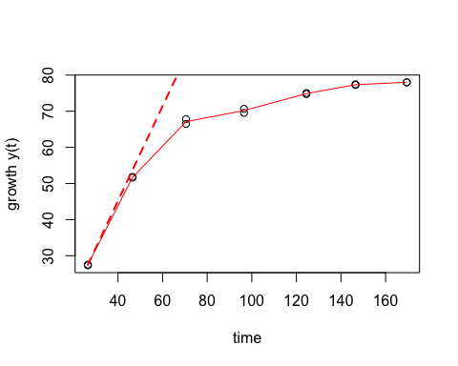

## mu.spline  
## 1 1.63143

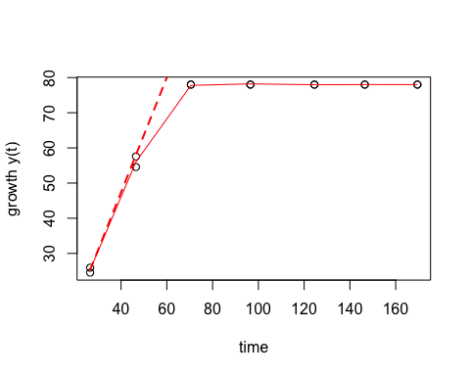

## mu.spline  
## 1 0.6103366

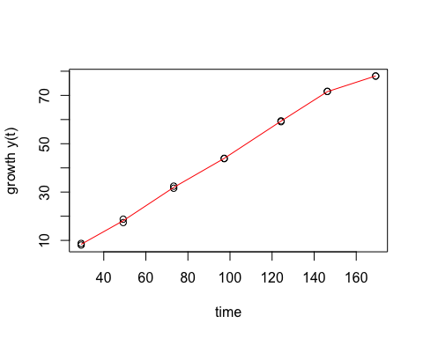

## mu.spline  
## 1 0.6376289

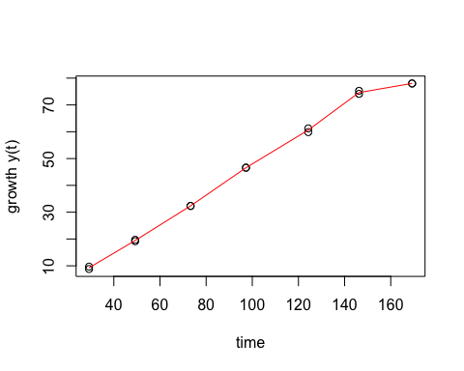

## mu.spline  
## 1 1.057938

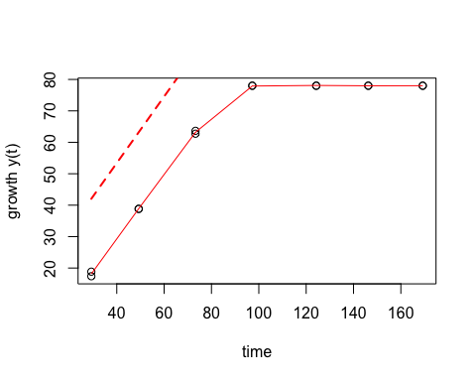

## mu.spline  
## 1 1.139948

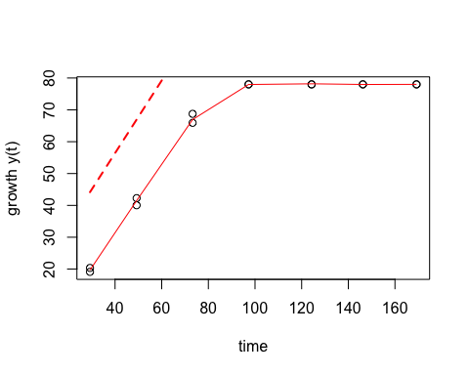

## mu.spline  
## 1 1.382059

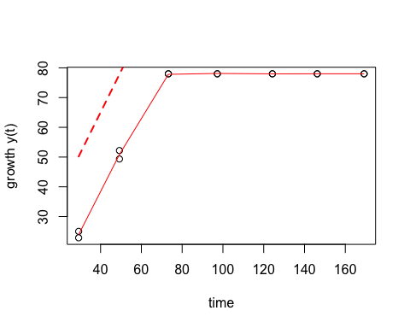

## mu.spline  
## 1 1.398426

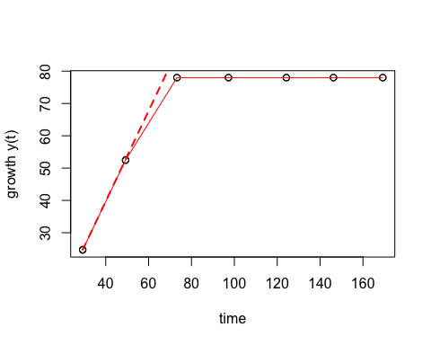

## mu.spline  
## 1 1.842698

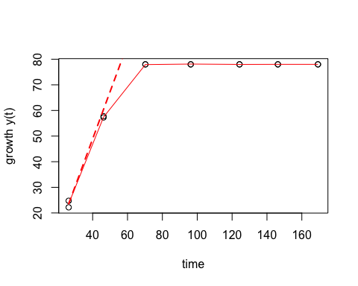

## mu.spline  
## 1 1.962206

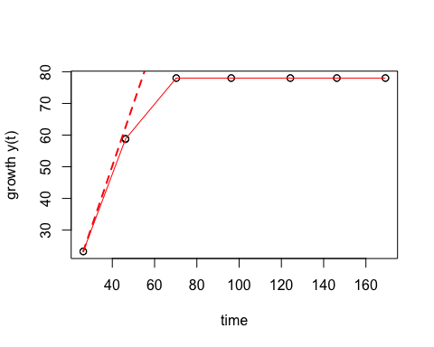

## mu.spline  
## 1 2.582471

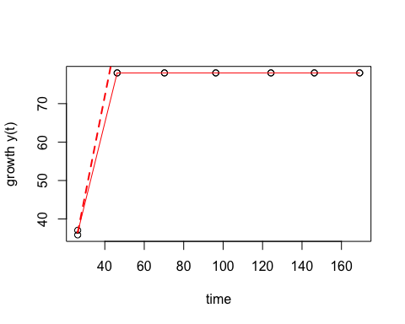

## mu.spline  
## 1 2.4017

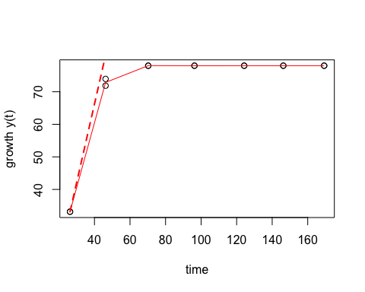

## mu.spline  
## 1 0.210952

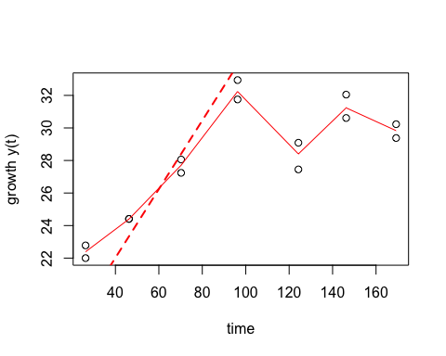

## mu.spline  
## 1 0.2177516

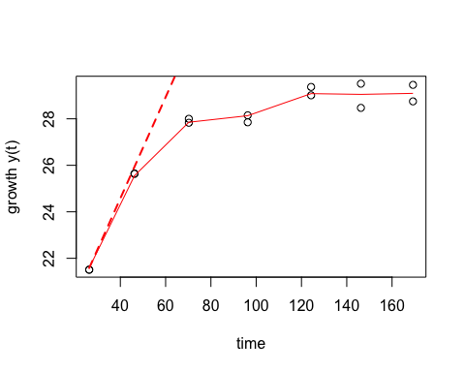

## mu.spline  
## 1 0.4625643

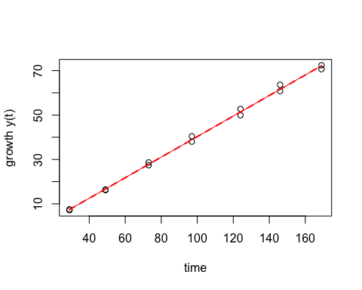

## mu.spline  
## 1 0.4914511

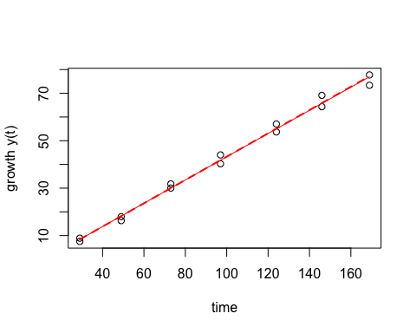

## mu.spline  
## 1 0.9532103

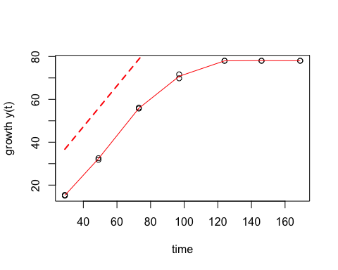

## mu.spline  
## 1 0.9054273

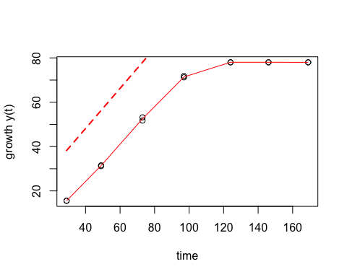

## mu.spline  
## 1 1.332036

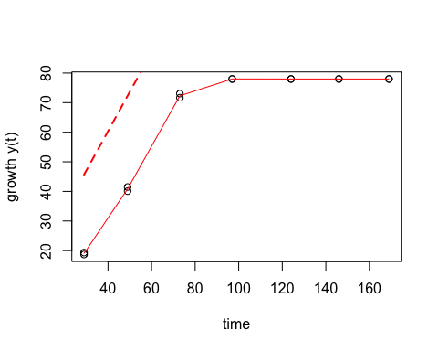

## mu.spline  
## 1 1.400984

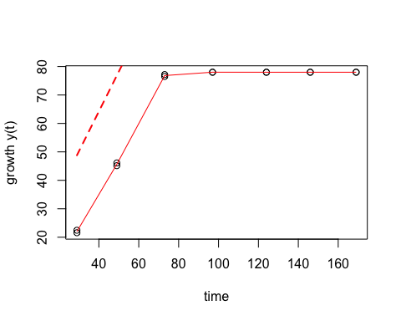

## mu.spline  
## 1 1.768729

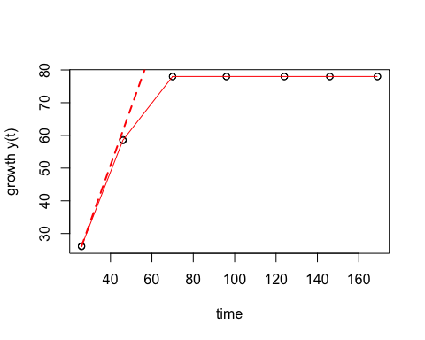

## mu.spline  
## 1 1.489685

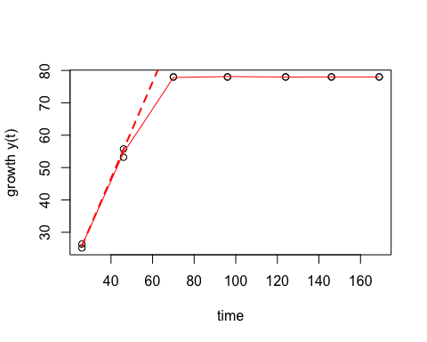

## mu.spline  
## 1 2.691909

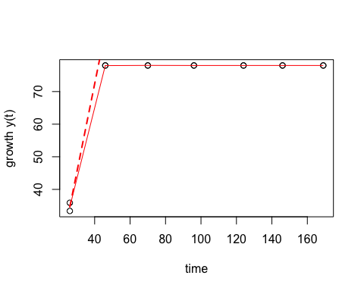

## mu.spline  
## 1 2.442198

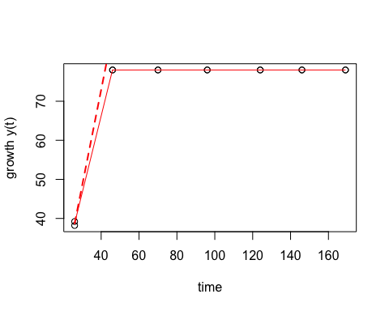

## mu.spline  
## 1 1.032968

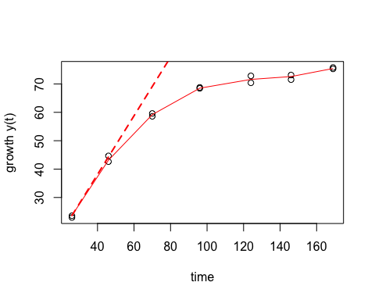

## mu.spline  
## 1 1.456397

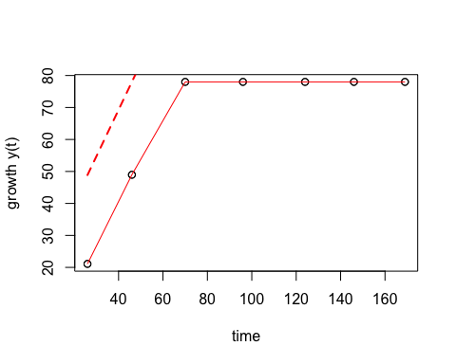

## mu.spline  
## 1 0.4605466

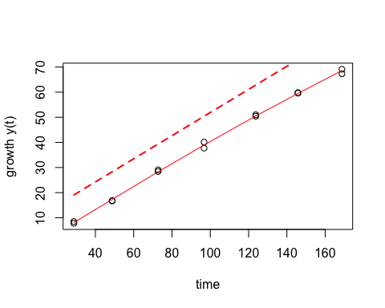

## mu.spline  
## 1 0.5207794

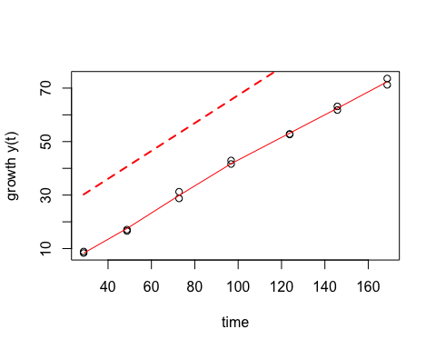

## mu.spline  
## 1 1.021428

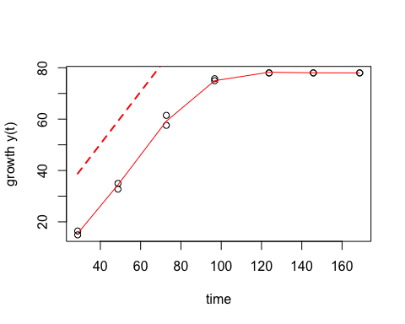

## mu.spline  
## 1 1.075676

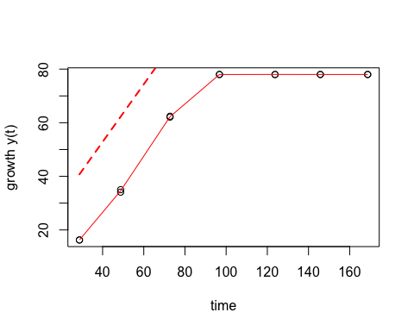

## mu.spline  
## 1 1.49237

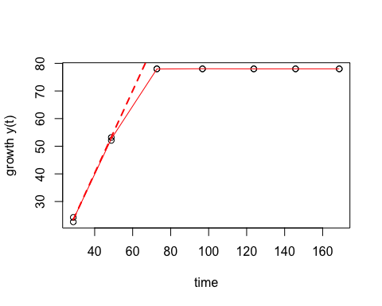

## mu.spline  
## 1 1.586431

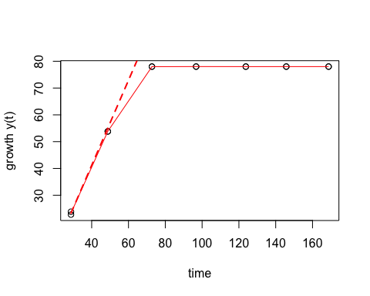

## mu.spline  
## 1 2.253198

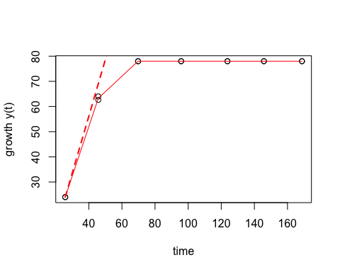

## mu.spline  
## 1 2.14775

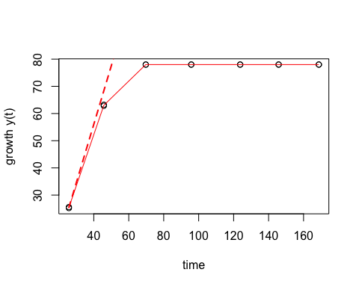

## mu.spline  
## 1 2.593698

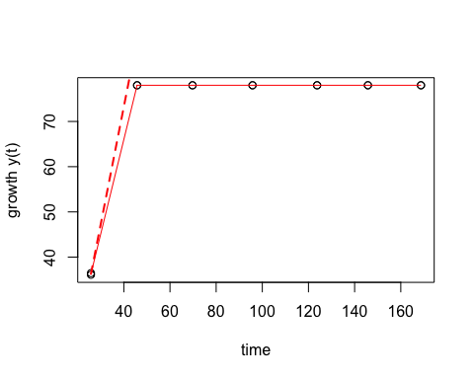

## mu.spline  
## 1 2.68334

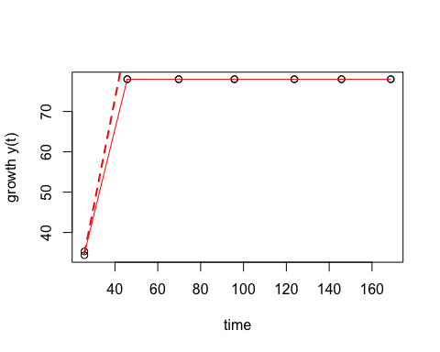

## mu.spline  
## 1 0.9561809

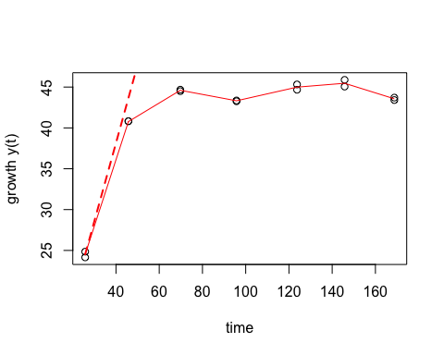

## mu.spline  
## 1 1.323661

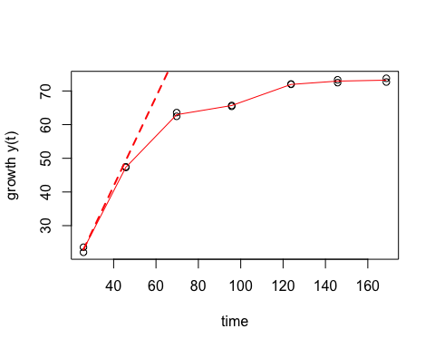

## mu.spline  
## 1 0.4377659

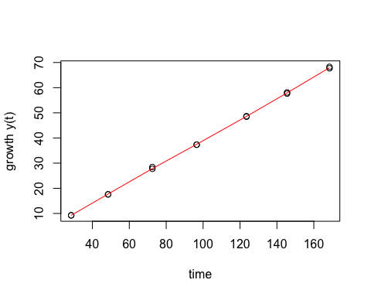

## mu.spline  
## 1 0.4551404

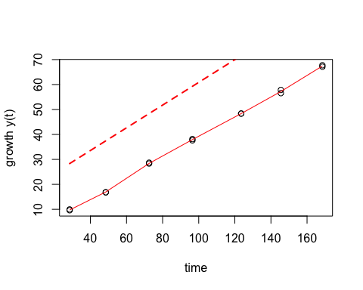

## mu.spline  
## 1 0.9651851

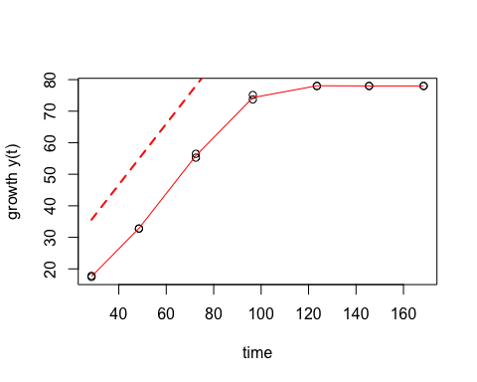

## mu.spline  
## 1 0.9405746

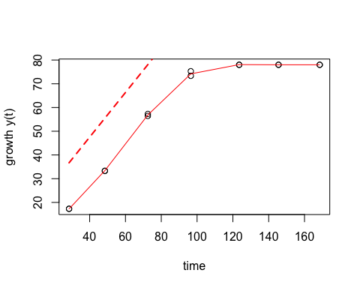

## mu.spline  
## 1 1.374564

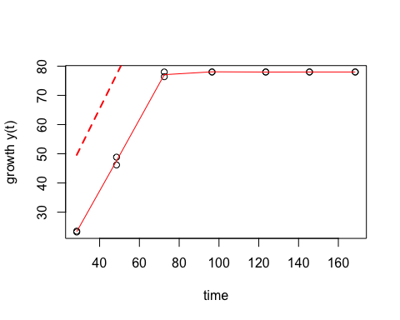

## mu.spline  
## 1 1.363965

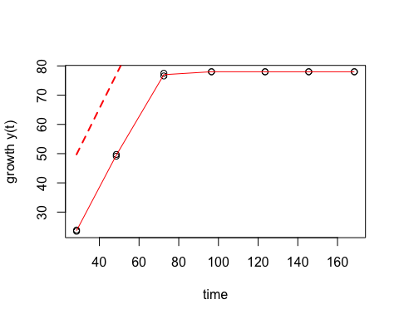

## mu.spline  
## 1 1.928092

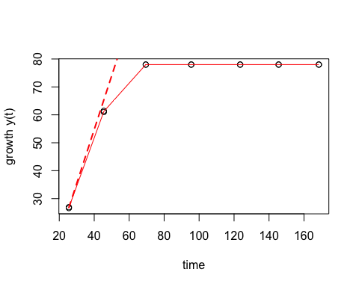

## mu.spline  
## 1 1.665979

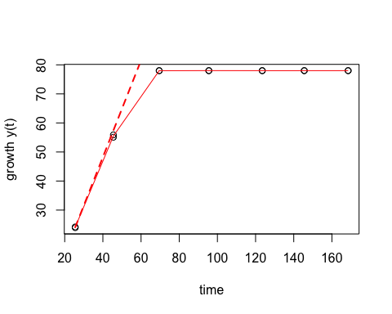

## mu.spline  
## 1 2.258578

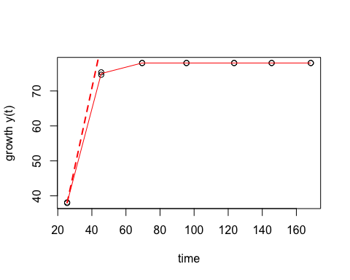

## mu.spline  
## 1 2.234968

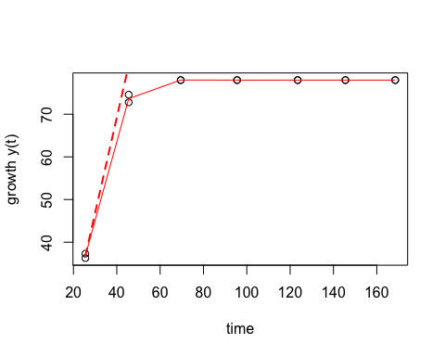

## mu.spline  
## 1 1.045797

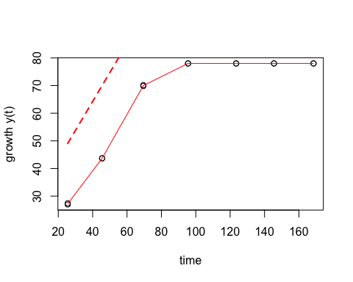

## mu.spline  
## 1 1.28046

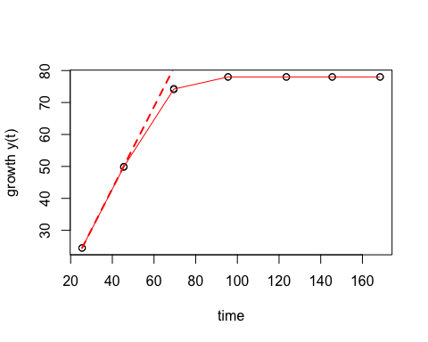

## mu.spline  
## 1 0.4982087

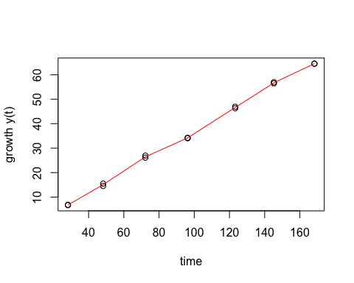

## mu.spline  
## 1 0.4248215

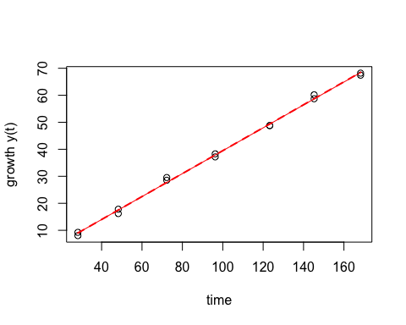

## mu.spline  
## 1 0.8023018

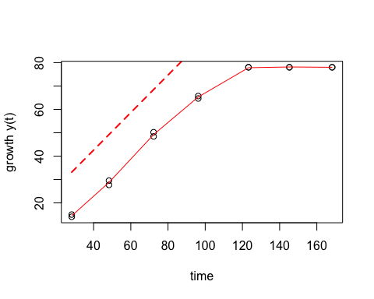

## mu.spline  
## 1 0.8548086

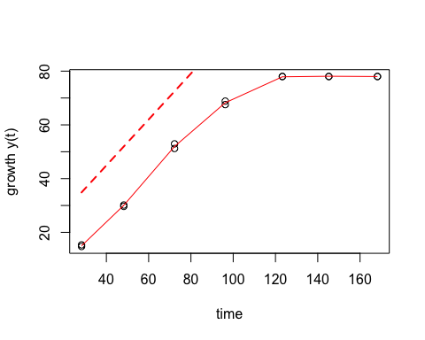

## mu.spline  
## 1 1.196846

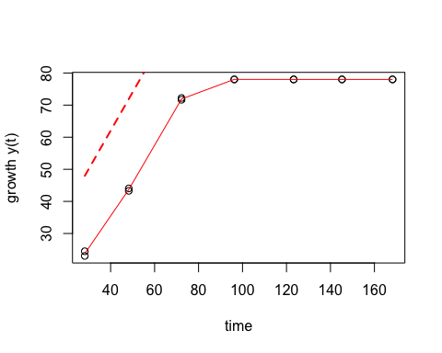

## mu.spline  
## 1 1.14892

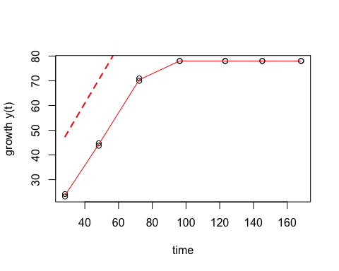

## mu.spline  
## 1 1.598658

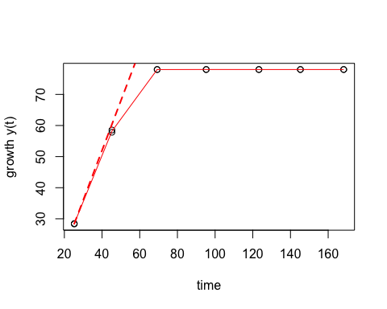

## mu.spline  
## 1 1.706729

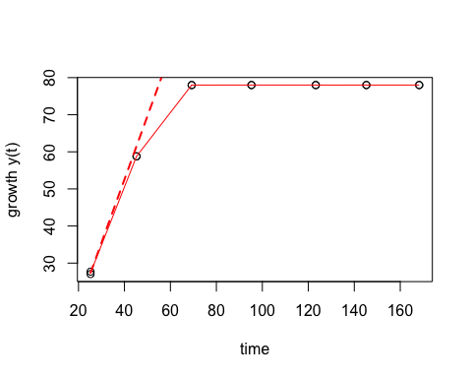

## mu.spline  
## 1 2.579855

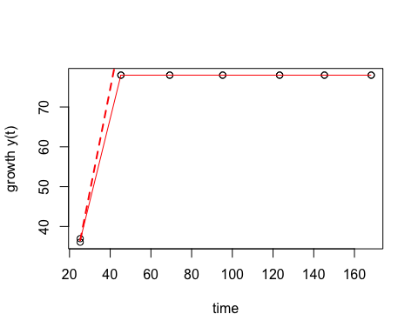

## mu.spline  
## 1 2.357451

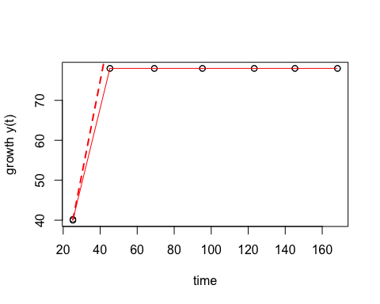

## mu.spline  
## 1 1.405702

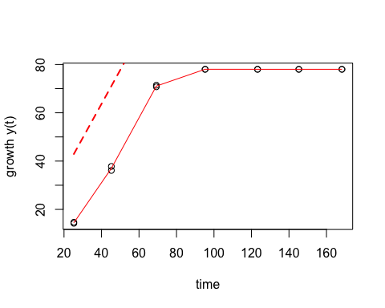

## mu.spline  
## 1 1.389518

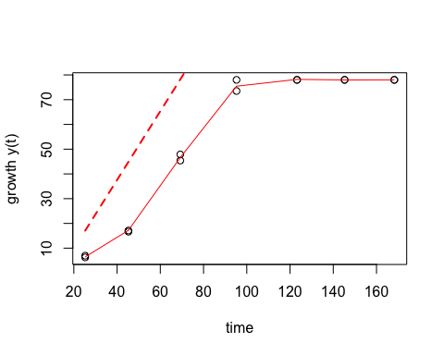

## mu.spline  
## 1 0.4915375

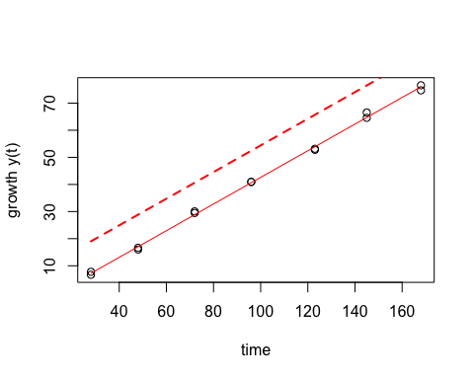

## mu.spline  
## 1 0.5267515

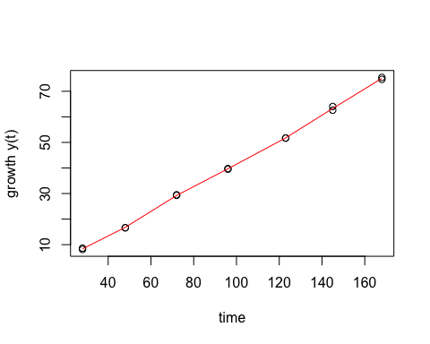

## mu.spline  
## 1 1.129912

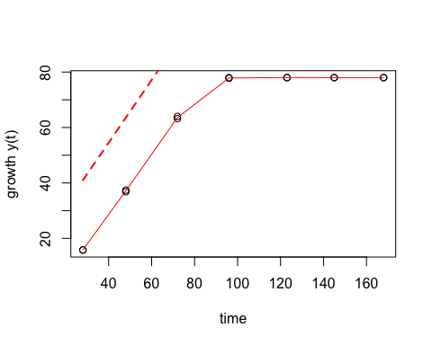

## mu.spline  
## 1 1.196191

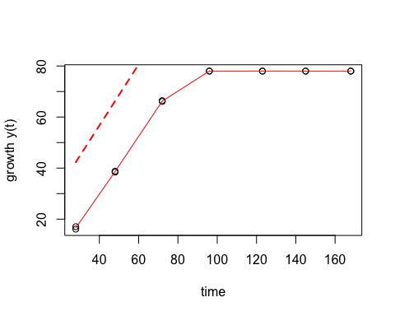

## mu.spline  
## 1 1.392351

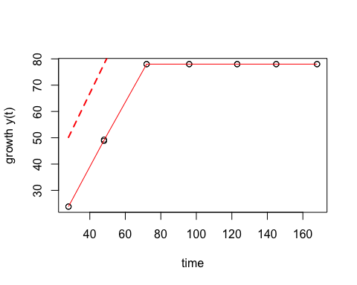

## mu.spline  
## 1 1.458656

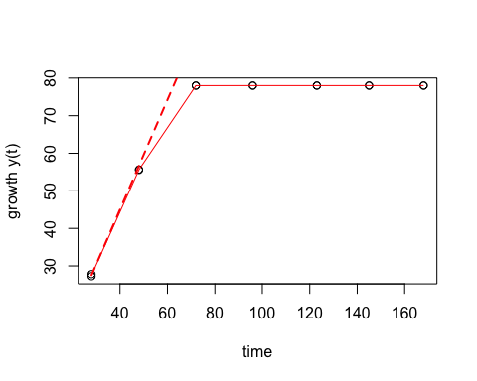

## mu.spline  
## 1 1.862435

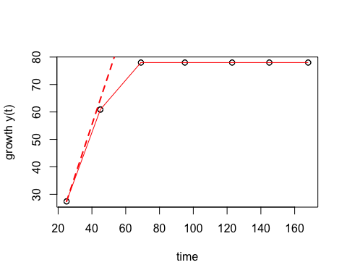

## mu.spline  
## 1 1.921641

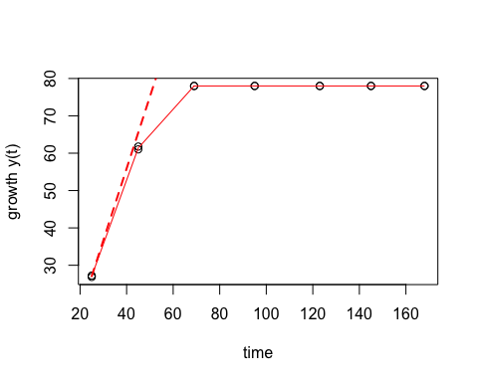

## mu.spline  
## 1 2.572169

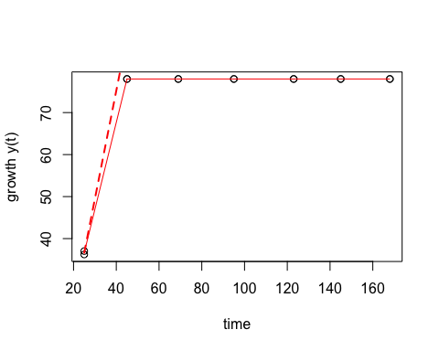

## mu.spline  
## 1 2.450961

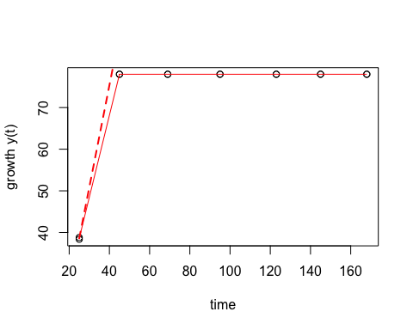

## mu.spline  
## 1 0.7043634

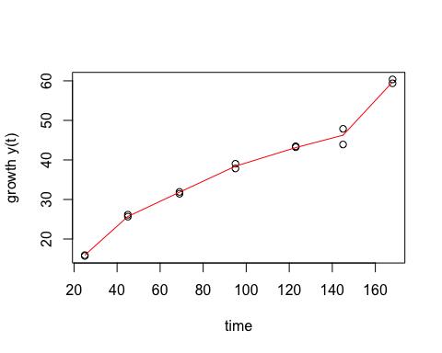

## mu.spline  
## 1 1.221738

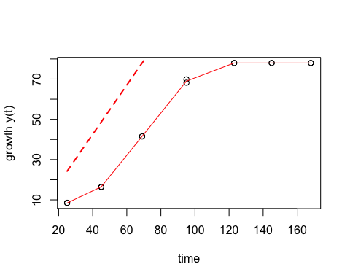

## mu.spline  
## 1 0.5217348

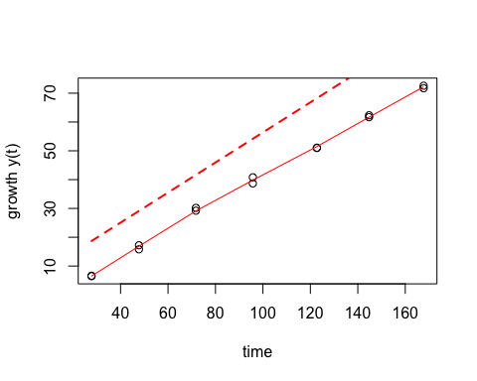

## mu.spline  
## 1 0.5364213

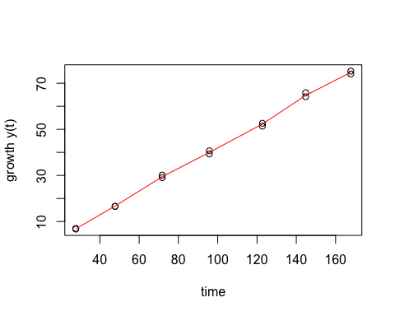

## mu.spline  
## 1 1.02512

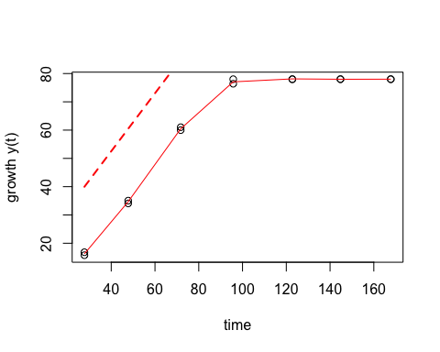

## mu.spline  
## 1 0.9223258

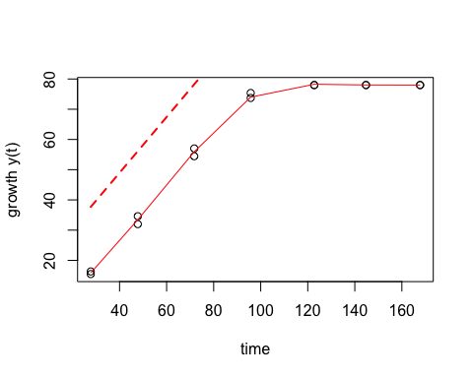

## mu.spline  
## 1 1.385936

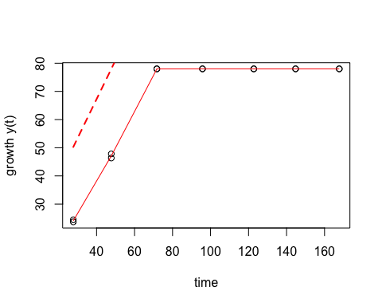

## mu.spline  
## 1 1.311369

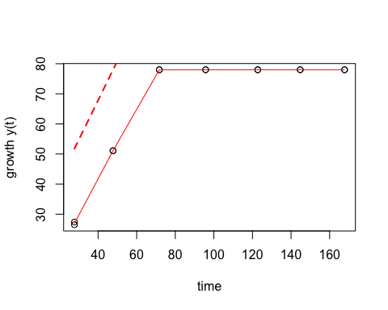

## mu.spline  
## 1 2.035218

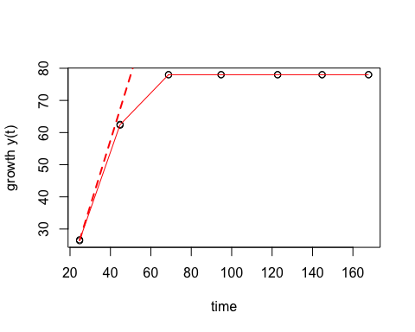

## mu.spline  
## 1 1.63981

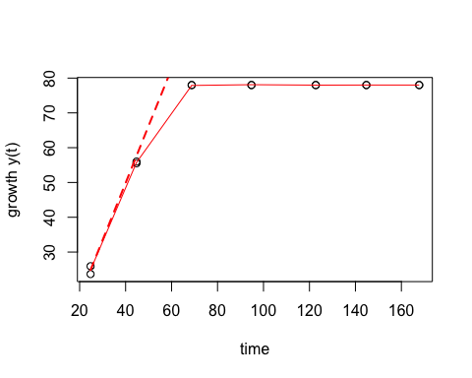

## mu.spline  
## 1 2.550227

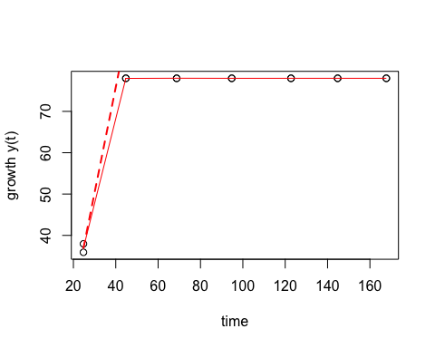

## mu.spline  
## 1 2.387423

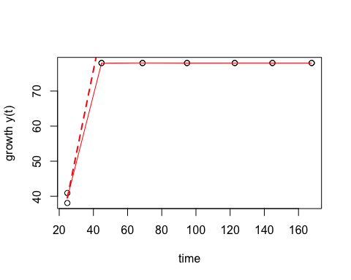

## mu.spline  
## 1 1.63631

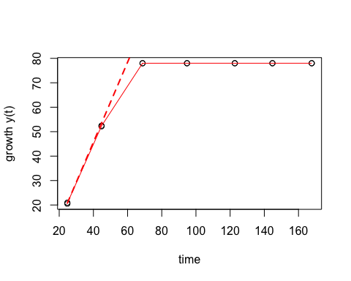

## mu.spline  
## 1 1.667199

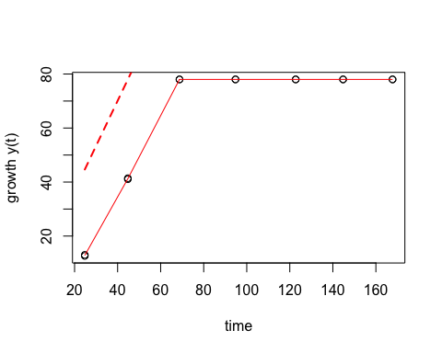

## mu.spline  
## 1 0.4955391

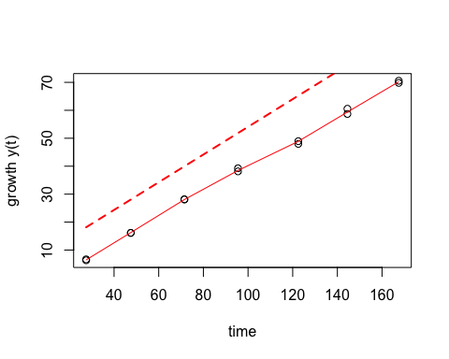

## mu.spline  
## 1 0.5400953

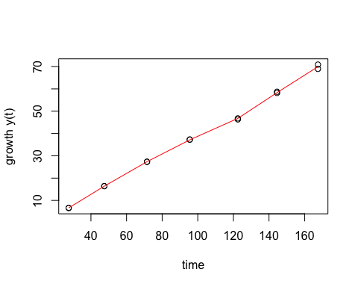

## mu.spline  
## 1 0.8716009

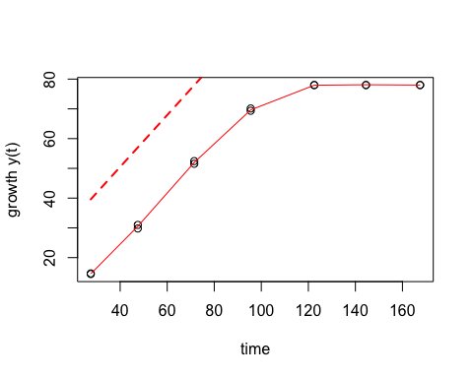

## mu.spline  
## 1 0.9281418

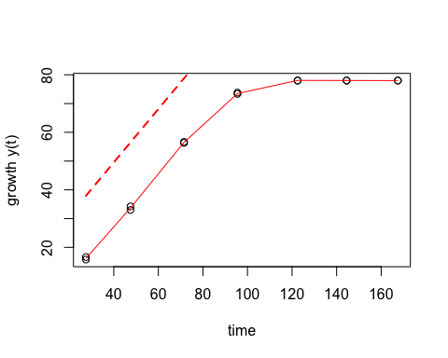

## mu.spline  
## 1 1.443874

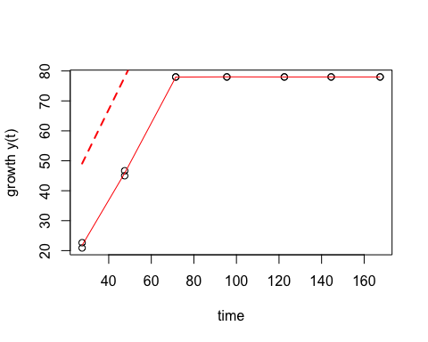

## mu.spline  
## 1 1.38262

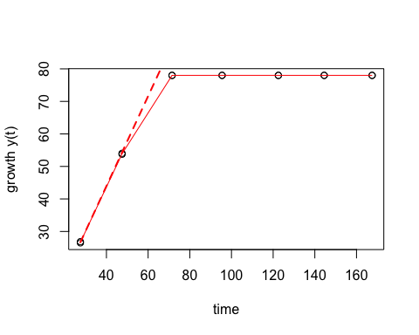

## mu.spline  
## 1 1.710859

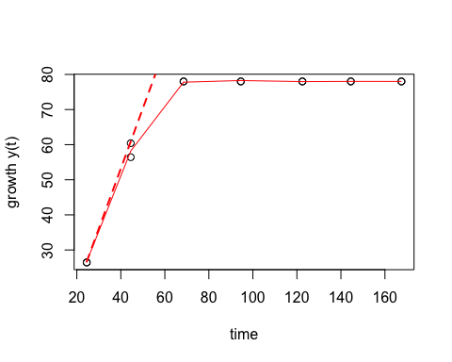

## mu.spline  
## 1 2.062479

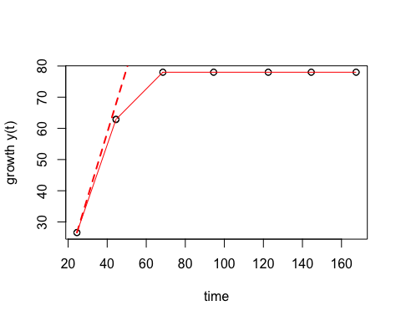

## mu.spline  
## 1 2.710665

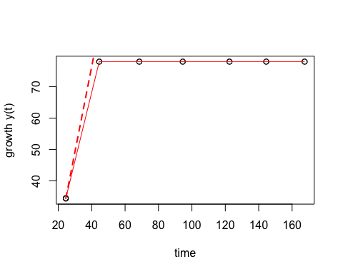

## mu.spline  
## 1 2.599037

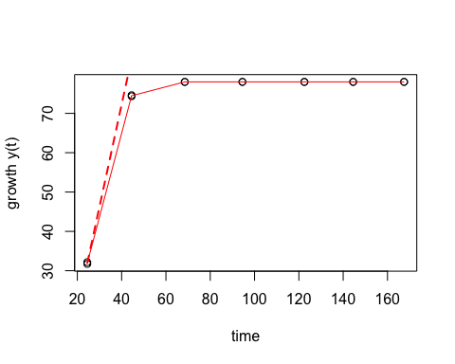

## mu.spline  
## 1 1.450983

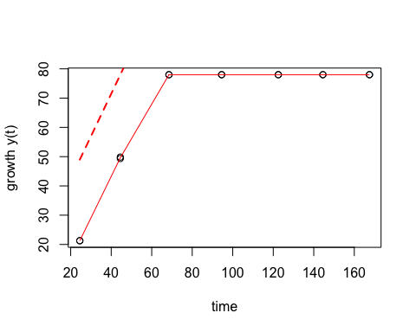

## mu.spline  
## 1 1.613919

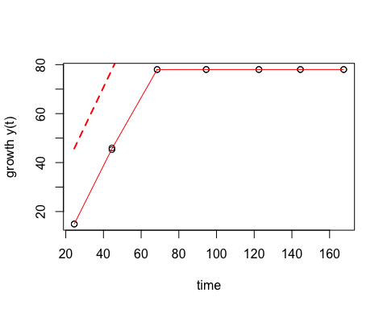

## mu.spline  
## 1 0.3934023

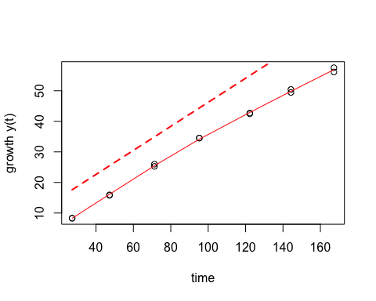

## mu.spline  
## 1 0.4193579

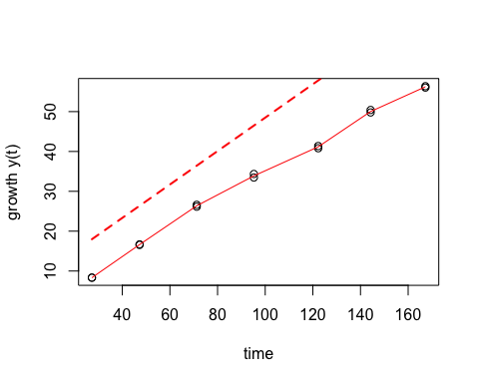

## mu.spline  
## 1 0.7666943

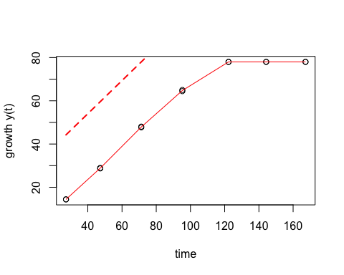

## mu.spline  
## 1 0.7958944

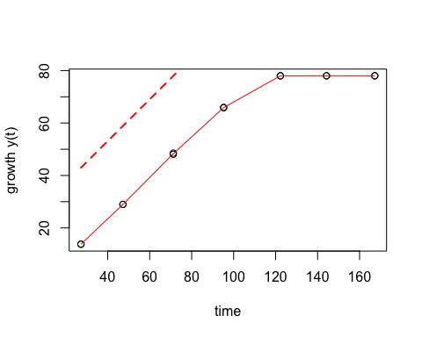

## mu.spline  
## 1 1.126166

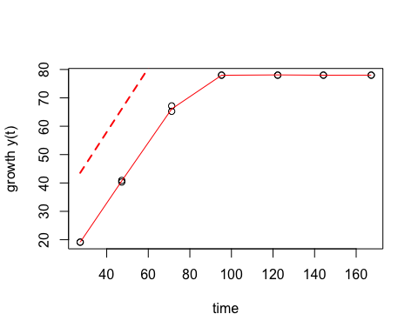

## mu.spline  
## 1 1.130089

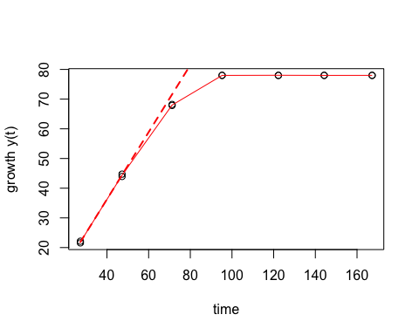

## mu.spline  
## 1 1.355867

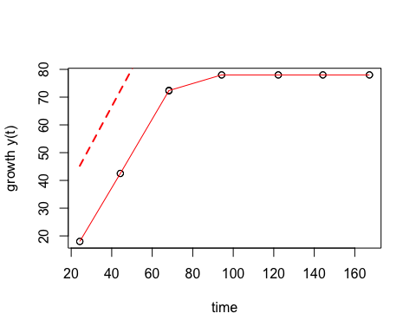

## mu.spline  
## 1 1.3512

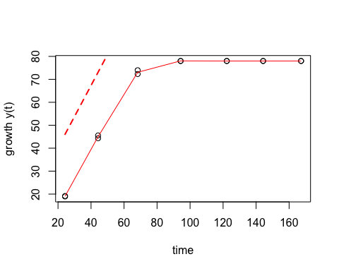

## mu.spline  
## 1 1.598439

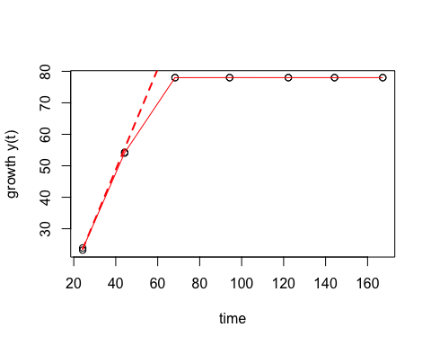

## mu.spline  
## 1 1.613344

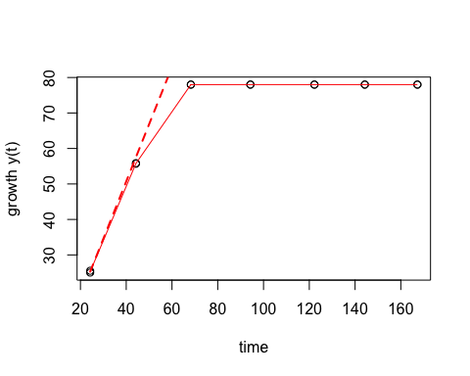

## mu.spline  
## 1 0.439091

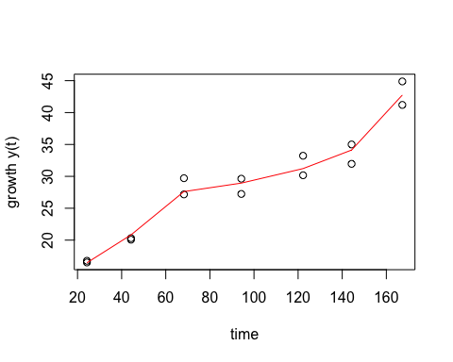

## mu.spline  
## 1 0.1466994

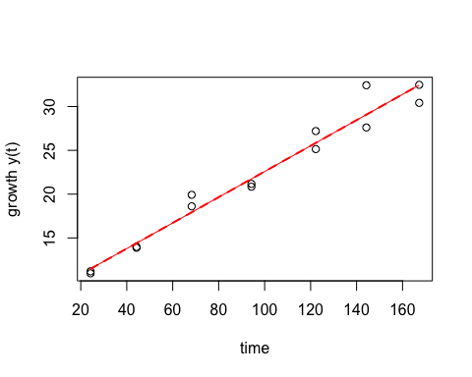

## mu.spline  
## 1 0.4843061

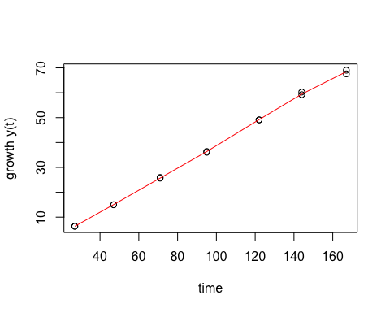

## mu.spline  
## 1 0.5115592

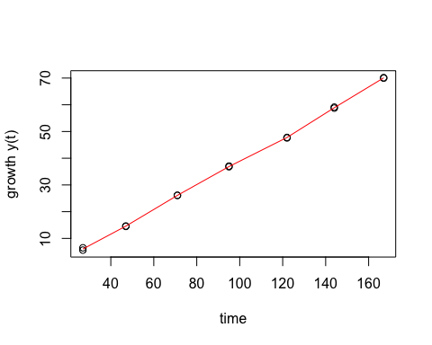

## mu.spline  
## 1 0.8956442

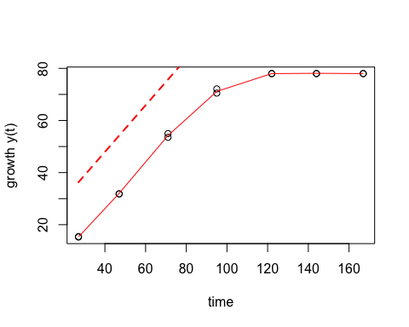

## mu.spline  
## 1 0.8911039

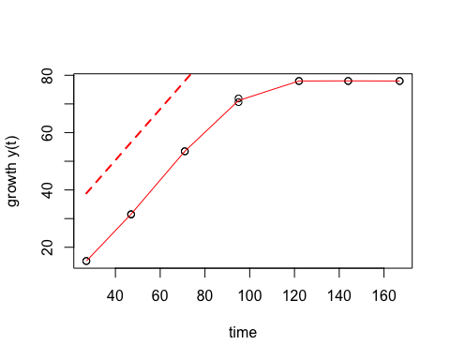

## mu.spline  
## 1 1.312467

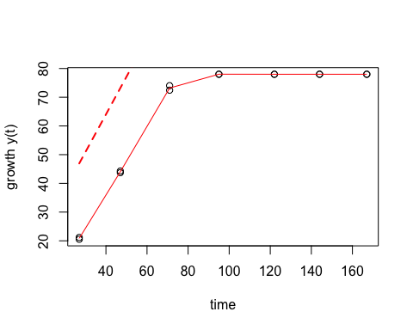

## mu.spline  
## 1 1.290827

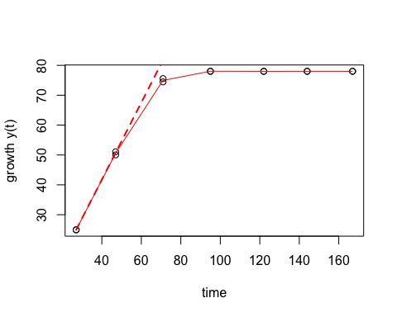

## mu.spline  
## 1 2.016713

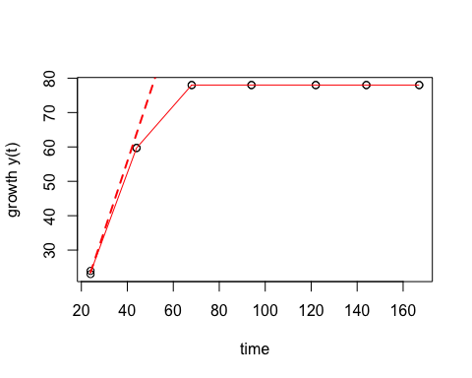

## mu.spline  
## 1 1.80667

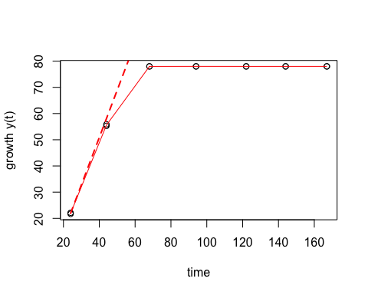

## mu.spline  
## 1 2.305127

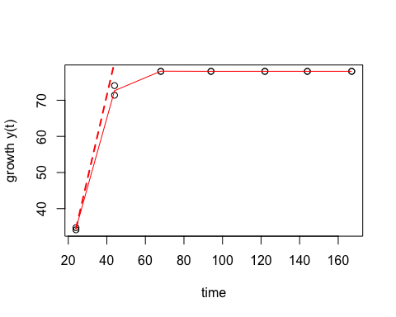

## mu.spline  
## 1 2.225907

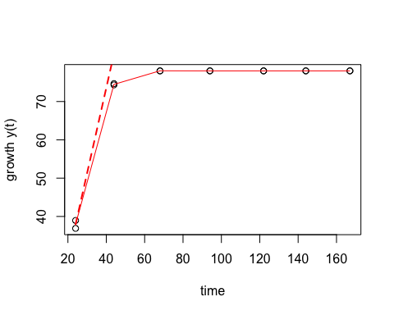

## mu.spline  
## 1 1.33099

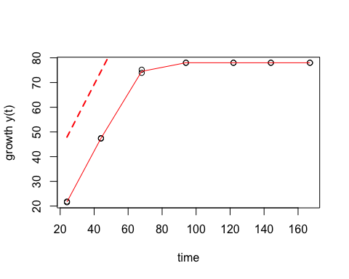

## mu.spline  
## 1 1.52899

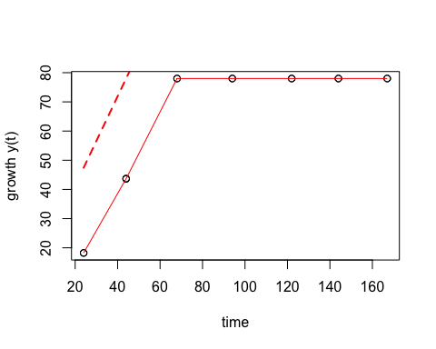

## mu.spline  
## 1 0.433843

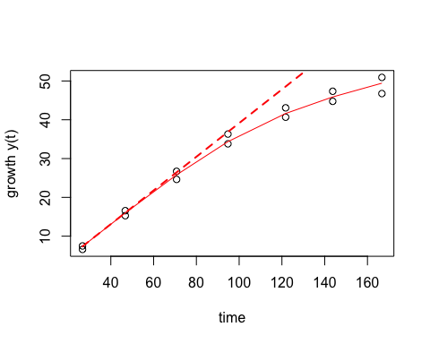

## mu.spline  
## 1 0.4260686

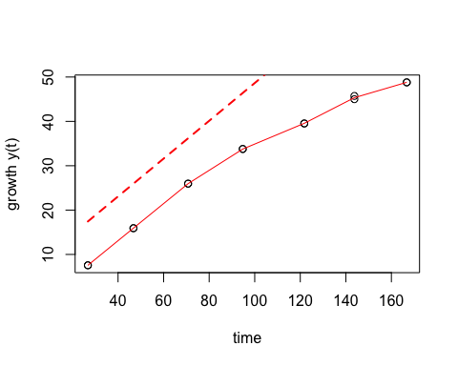

## mu.spline  
## 1 0.7348013

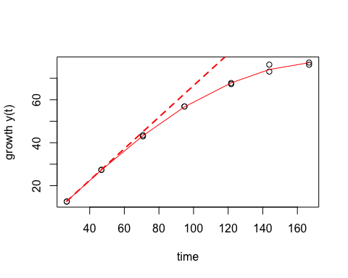

## mu.spline  
## 1 0.7502448

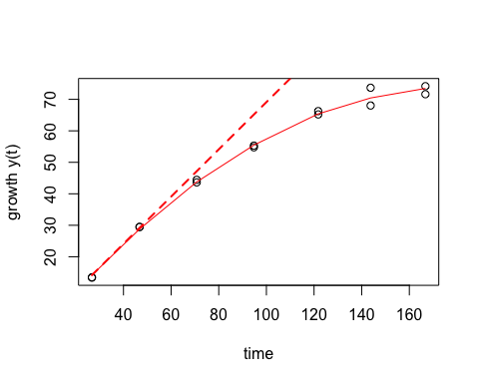

## mu.spline  
## 1 0.9669728

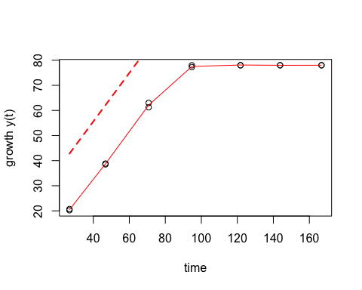

## mu.spline  
## 1 1.006327

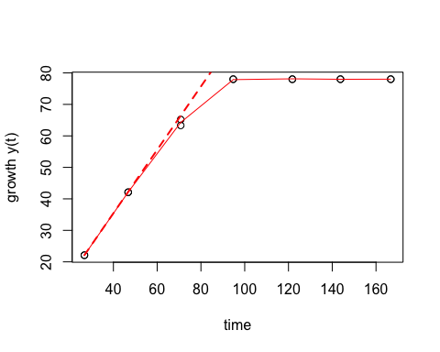

## mu.spline  
## 1 1.280454

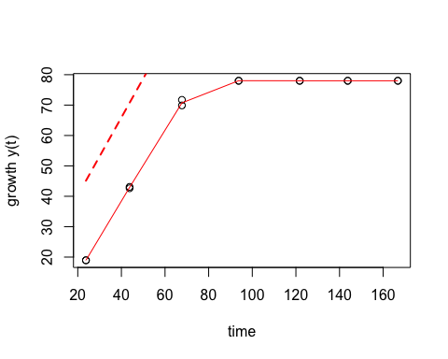

## mu.spline  
## 1 1.337396

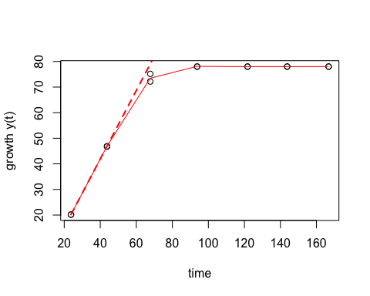

## mu.spline  
## 1 1.350934

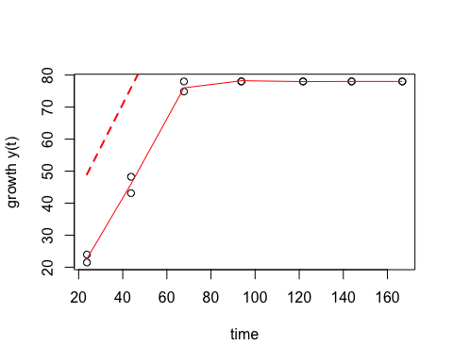

## mu.spline  
## 1 1.376253

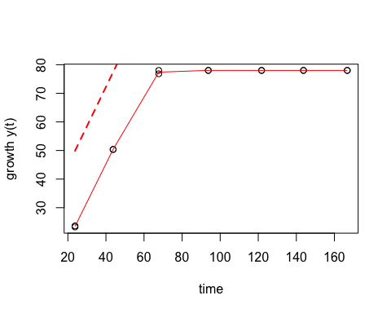

## mu.spline  
## 1 0.5379611

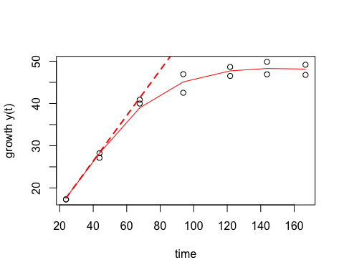

## mu.spline  
## 1 0.5112745

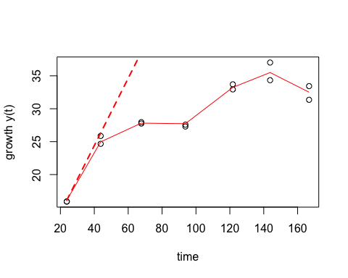

## mu.spline  
## 1 0.4326757

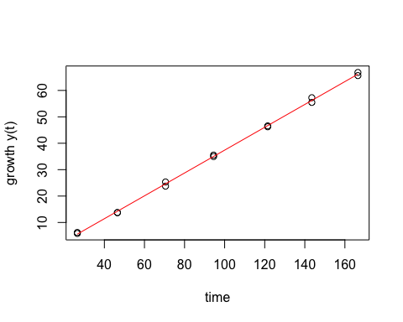

## mu.spline  
## 1 0.4790213

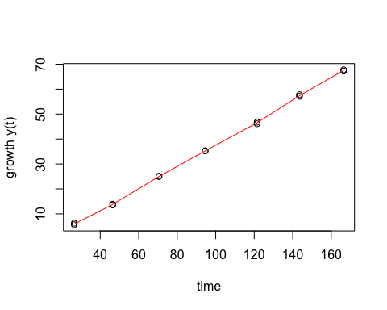

## mu.spline  
## 1 1.015856

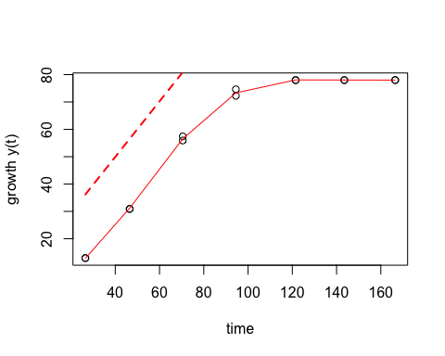

## mu.spline  
## 1 1.125237

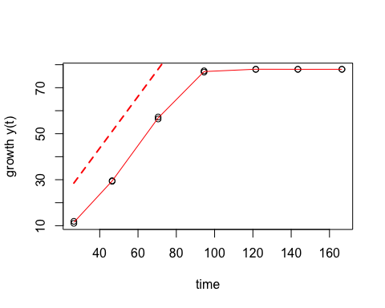

## mu.spline  
## 1 1.479435

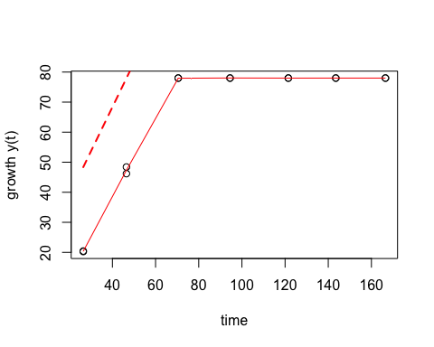

## mu.spline  
## 1 1.501848

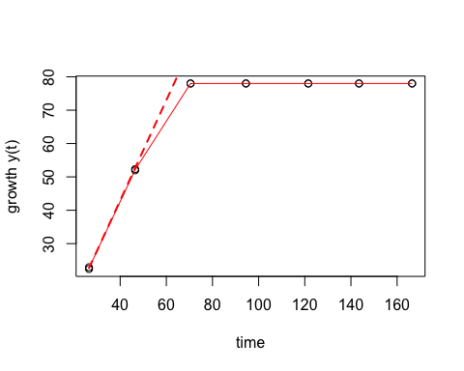

## mu.spline  
## 1 2.04981

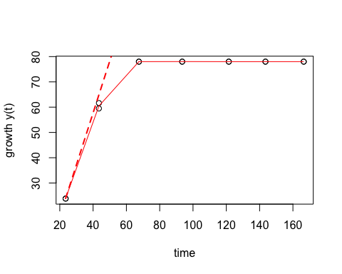

## mu.spline  
## 1 1.95431

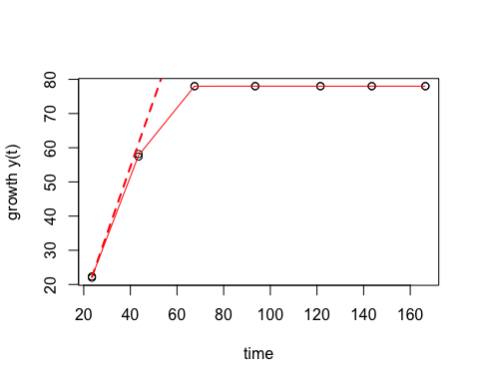

## mu.spline  
## 1 2.722273

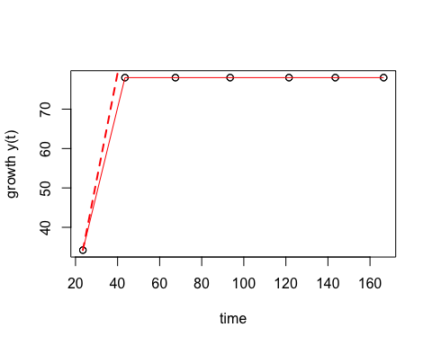

## mu.spline  
## 1 2.492809

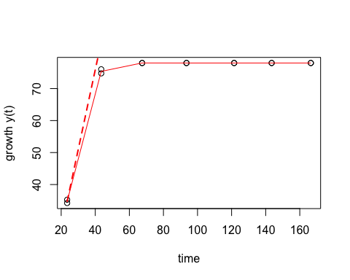

## mu.spline  
## 1 1.002539

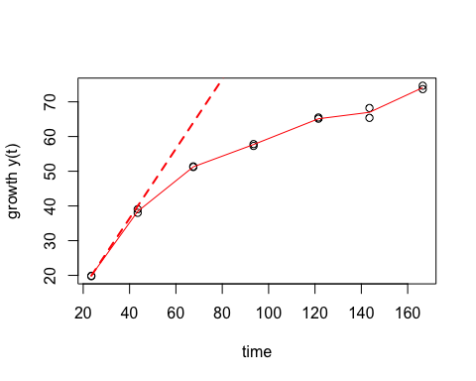

## mu.spline  
## 1 0.8216513

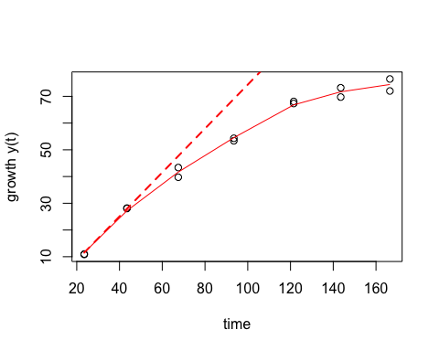

## mu.spline  
## 1 0.5600877

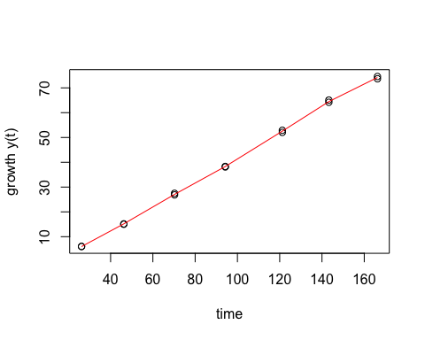

## mu.spline  
## 1 0.5729224

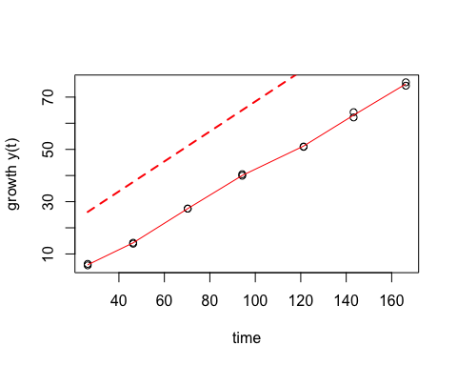

## mu.spline  
## 1 1.205771

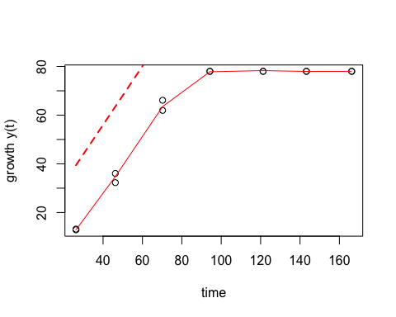

## mu.spline  
## 1 1.140438

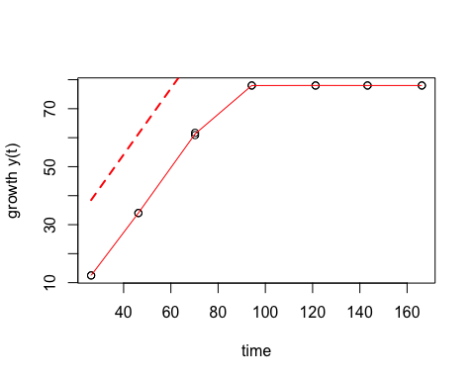

## mu.spline  
## 1 1.463181

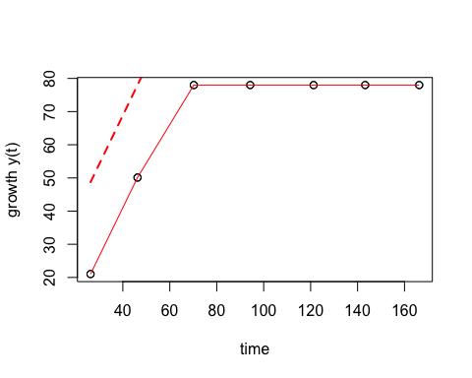

## mu.spline  
## 1 1.617998

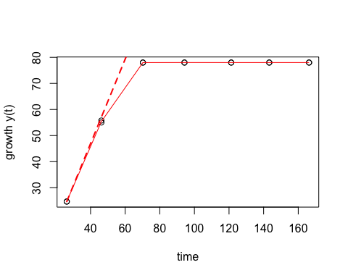

## mu.spline  
## 1 1.674193

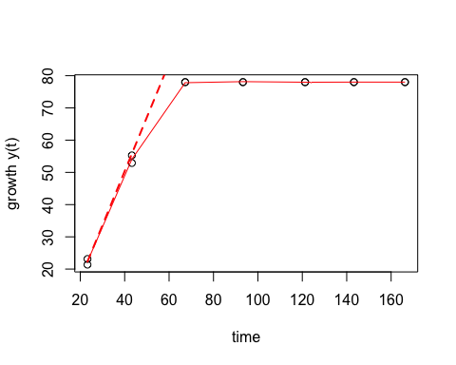

## mu.spline  
## 1 2.002832

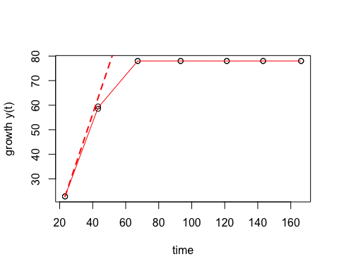

## mu.spline  
## 1 2.740565

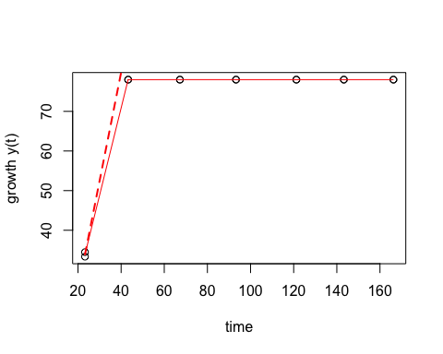

## mu.spline  
## 1 2.621149

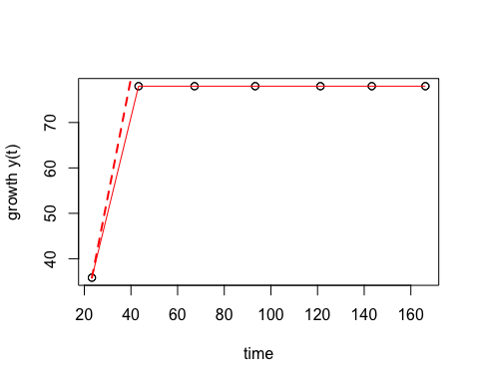

## mu.spline  
## 1 1.086473

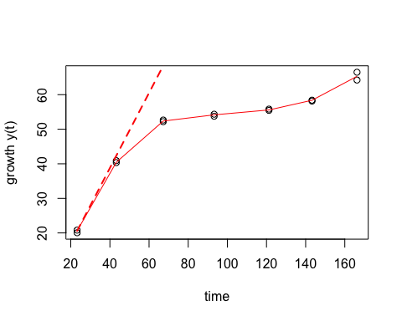

## mu.spline  
## 1 1.131682

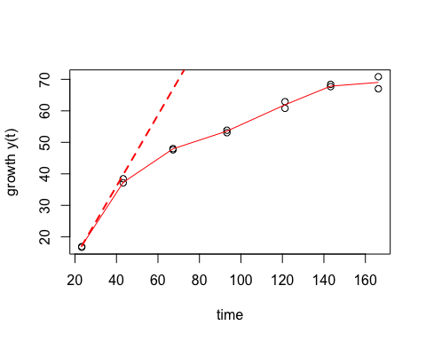

## mu.spline  
## 1 0.6740757

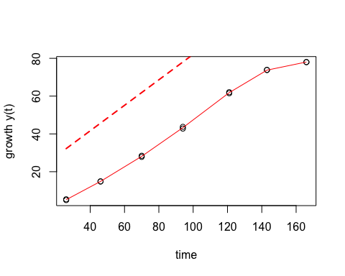

## mu.spline  
## 1 0.6527034

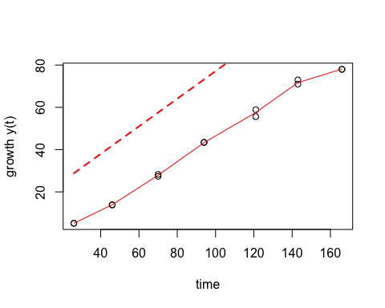

## mu.spline  
## 1 1.200293

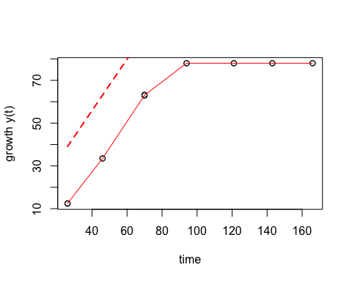

## mu.spline  
## 1 1.050491

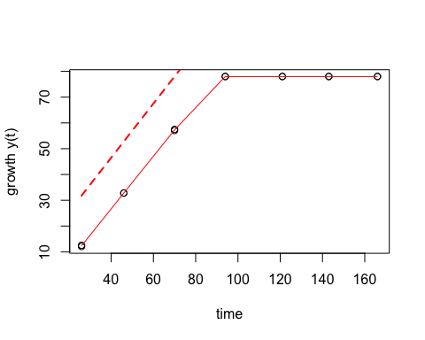

## mu.spline  
## 1 1.535229

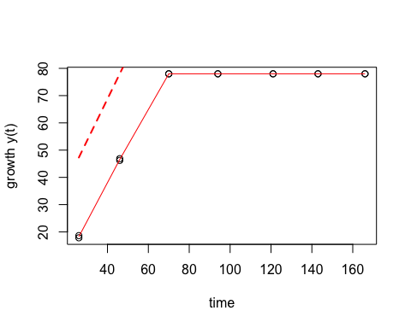

## mu.spline  
## 1 1.53646

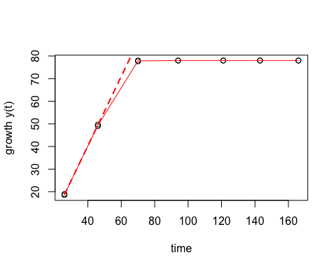

## mu.spline  
## 1 1.638378

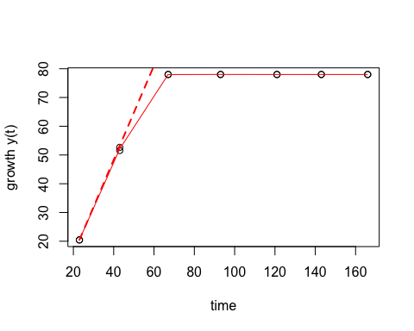

## mu.spline  
## 1 1.830844

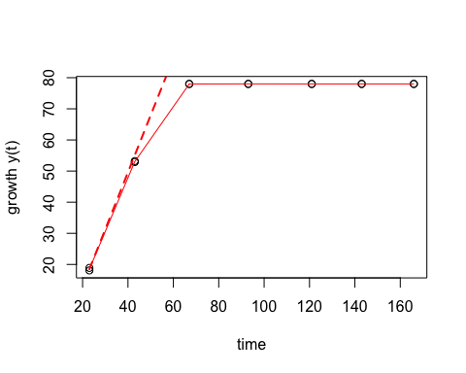

## mu.spline  
## 1 2.154911

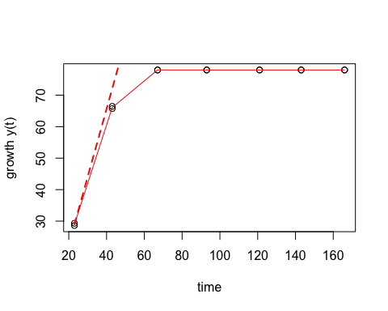

## mu.spline  
## 1 2.196011

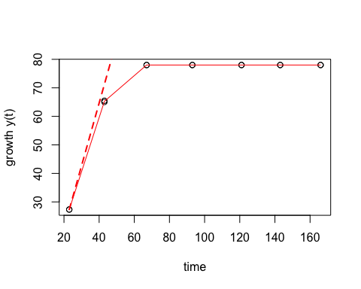

## mu.spline  
## 1 1.170263

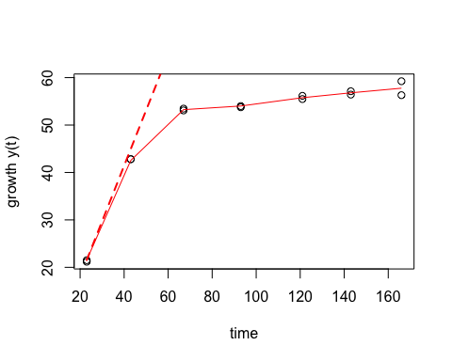

## mu.spline  
## 1 1.38415

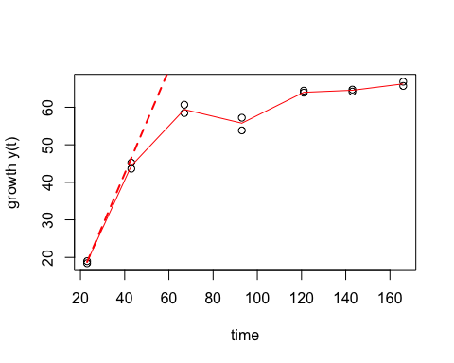

## mu.spline  
## 1 0.5452041

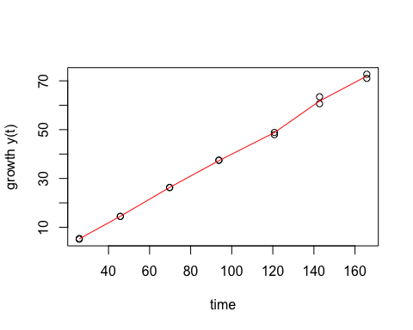

## mu.spline  
## 1 0.5466948

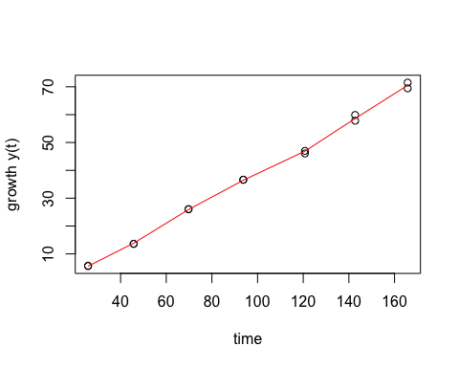

## mu.spline  
## 1 0.9156468

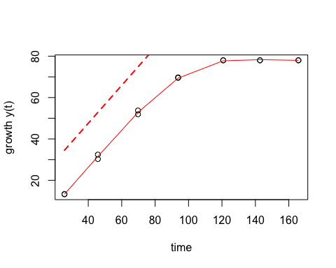

## mu.spline  
## 1 0.9113901

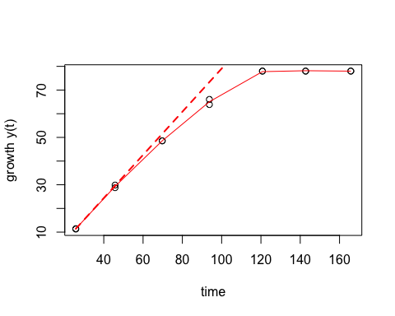

## mu.spline  
## 1 1.157308

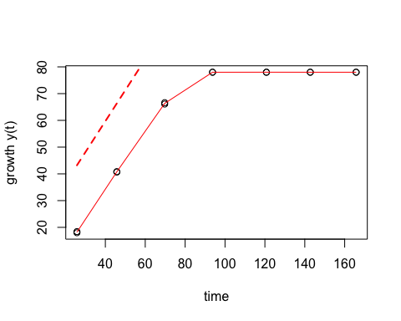

## mu.spline  
## 1 1.368468

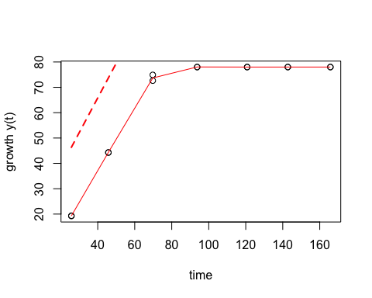

## mu.spline  
## 1 1.874996

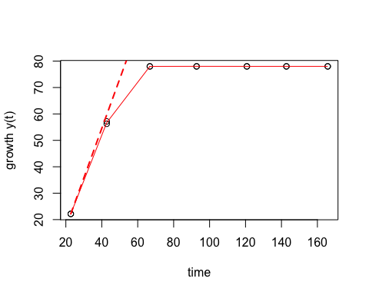

## mu.spline  
## 1 1.775533

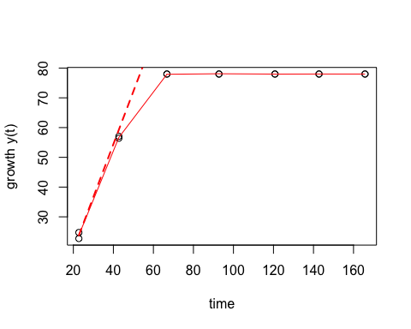

## mu.spline  
## 1 2.723993

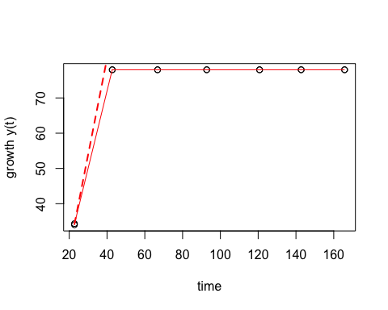

## mu.spline  
## 1 2.522076

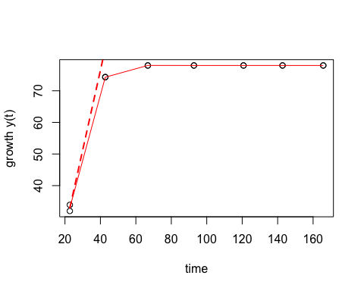

## mu.spline  
## 1 0.9077063

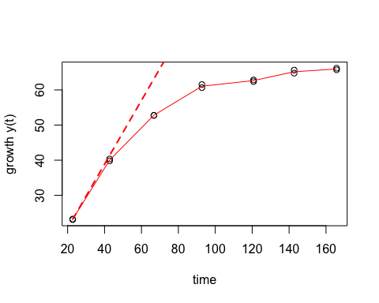

## mu.spline  
## 1 1.298723

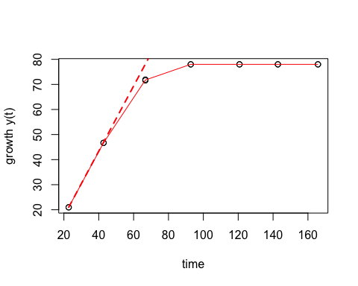

## mu.spline  
## 1 0.6246866

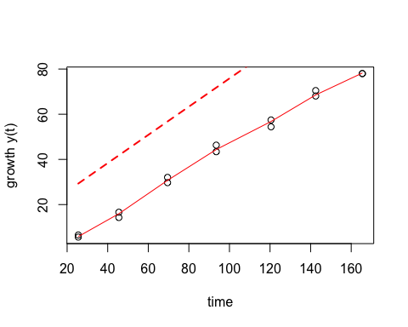

## mu.spline  
## 1 0.5615705

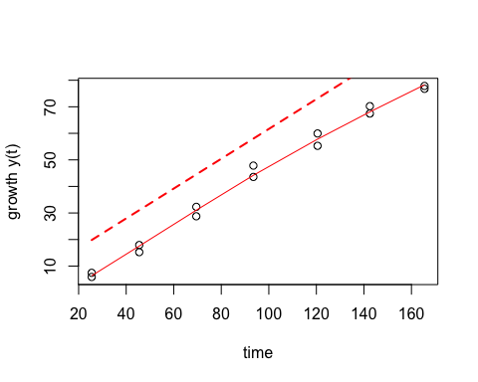

## mu.spline  
## 1 1.261572

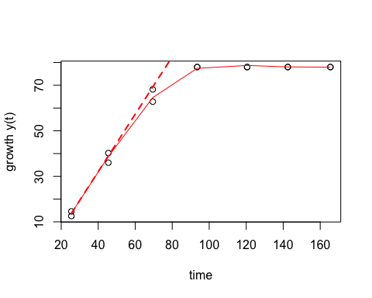

## mu.spline  
## 1 1.16045

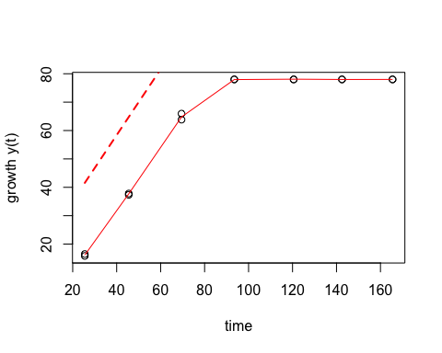

## mu.spline  
## 1 1.361308

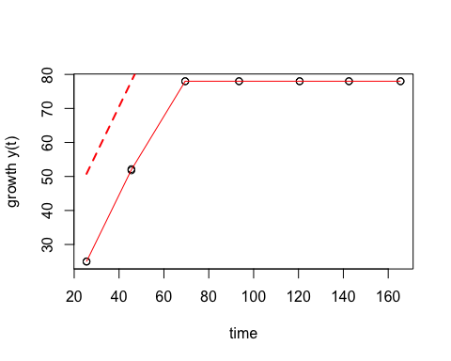

## mu.spline  
## 1 1.357803

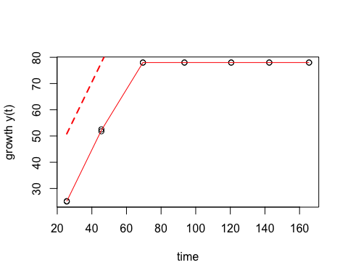

## mu.spline  
## 1 2.084589

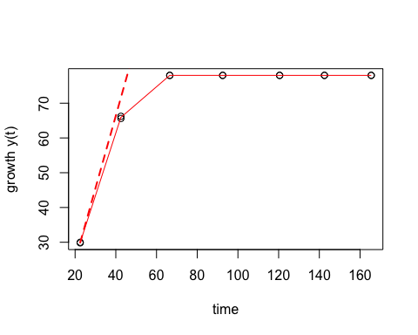

## mu.spline  
## 1 2.298892

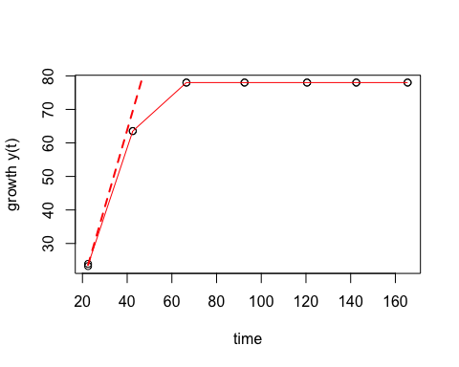

## mu.spline  
## 1 2.424881

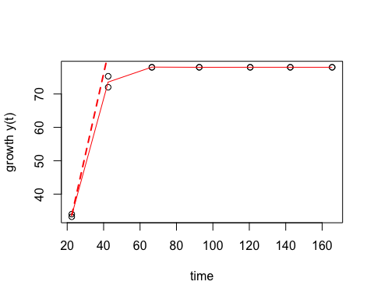

## mu.spline  
## 1 2.382243

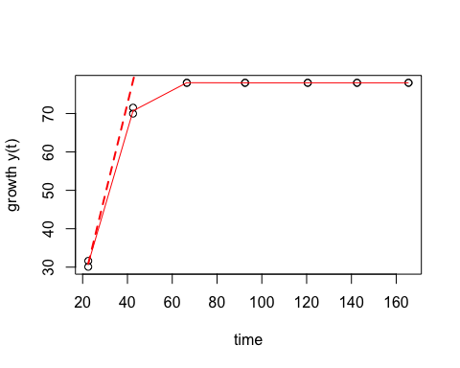

## mu.spline  
## 1 0.8854763

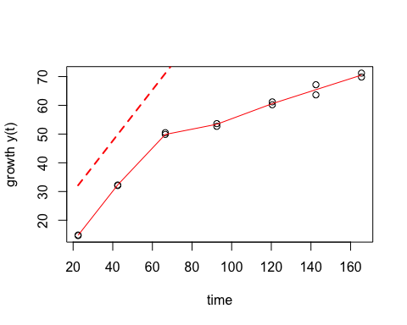

## mu.spline  
## 1 0.6236523

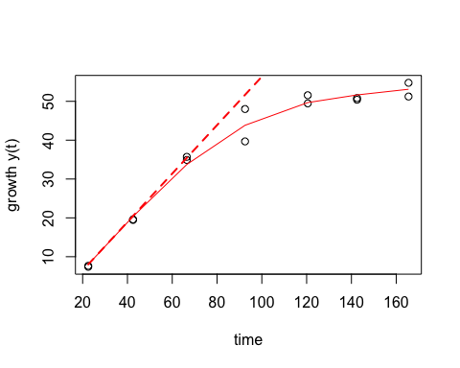

## mu.spline  
## 1 0.711185

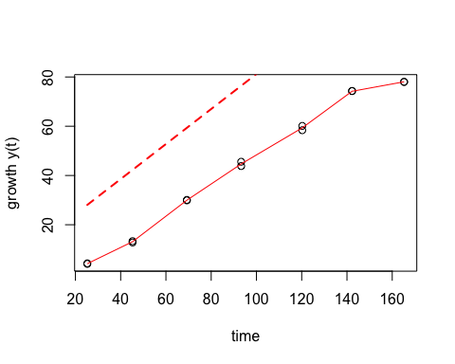

## mu.spline  
## 1 0.6866916

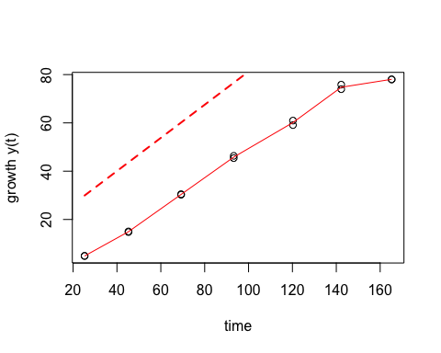

## mu.spline  
## 1 1.247541

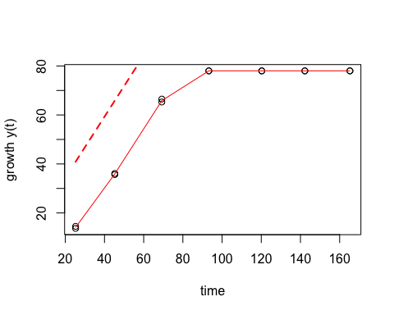

## mu.spline  
## 1 1.269265

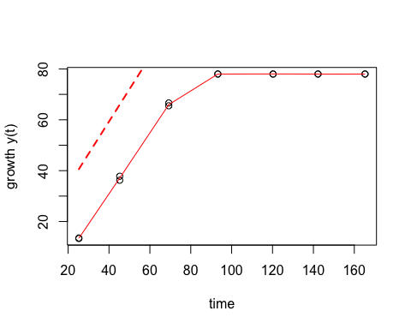

## mu.spline  
## 1 1.480988

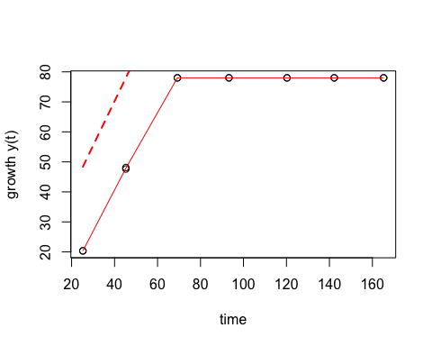

## mu.spline  
## 1 1.460155

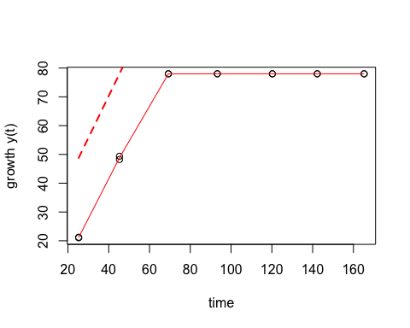

## mu.spline  
## 1 2.096714

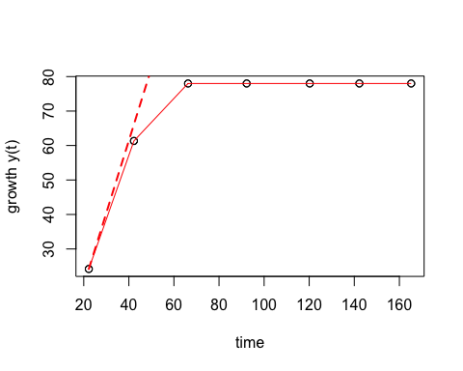

## mu.spline  
## 1 2.337733

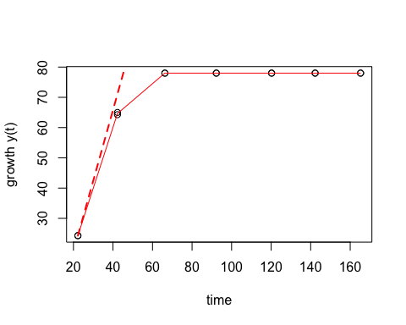

## mu.spline  
## 1 2.689912

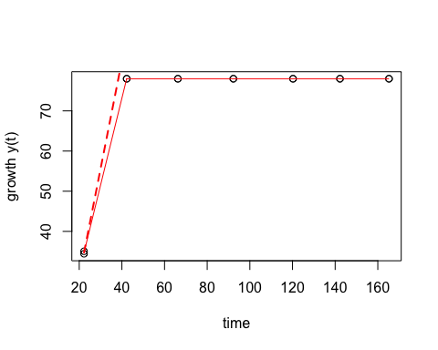

## mu.spline  
## 1 2.69946

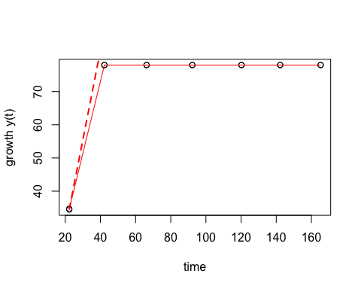

## mu.spline  
## 1 1.489648

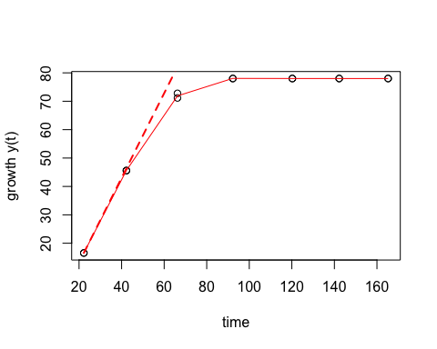

## mu.spline  
## 1 1.418265

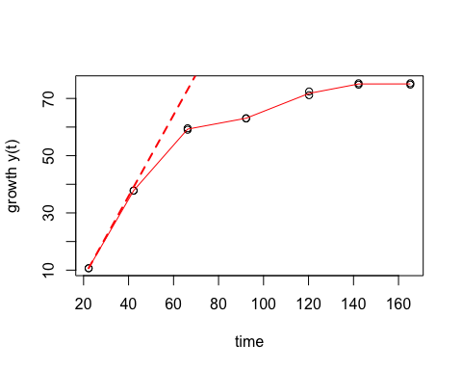

## mu.spline  
## 1 0.5028014

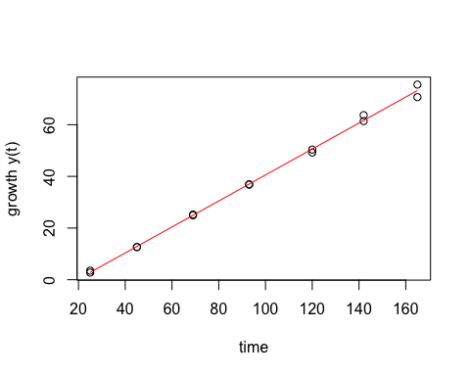

## mu.spline  
## 1 0.5231823

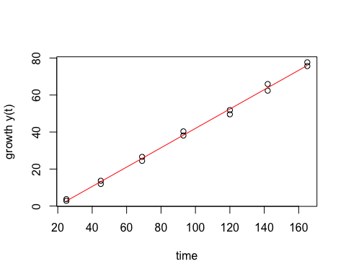

## mu.spline  
## 1 1.126761

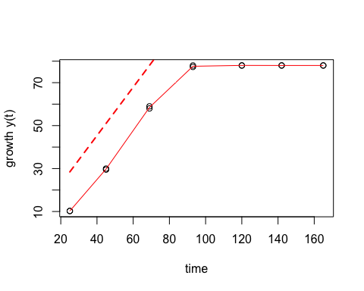

## mu.spline  
## 1 1.122276

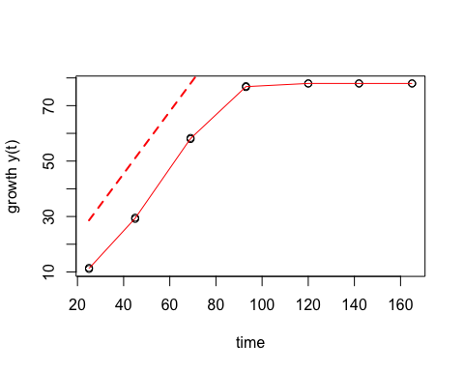

## mu.spline  
## 1 1.479339

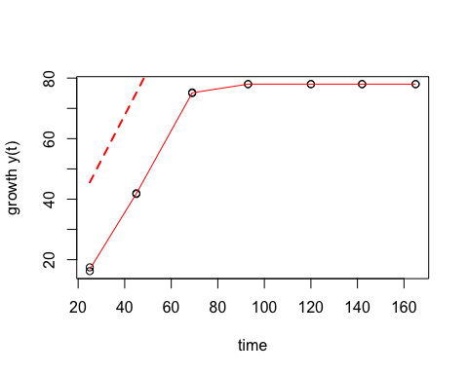

## mu.spline  
## 1 1.530147

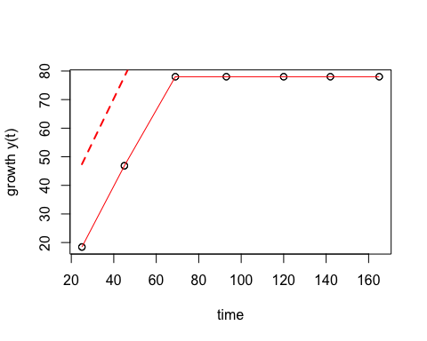

## mu.spline  
## 1 2.083123

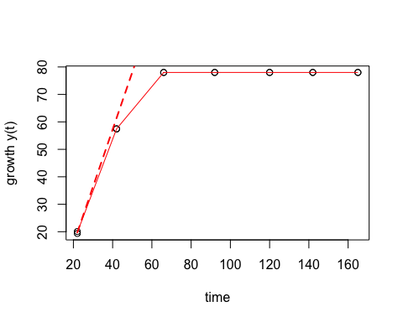

## mu.spline  
## 1 2.126713

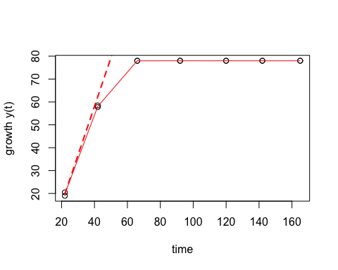

## mu.spline  
## 1 3.021052

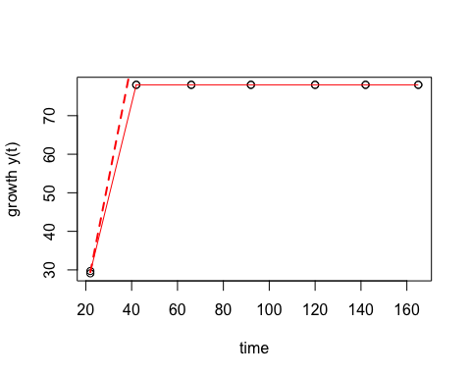

## mu.spline  
## 1 2.510256

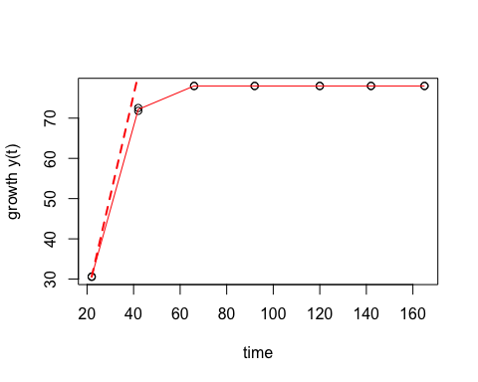

## mu.spline  
## 1 1.384338

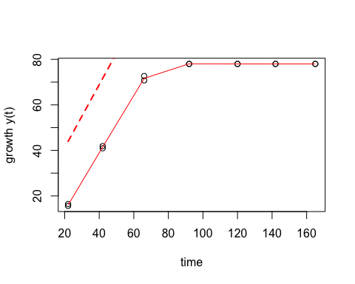

## mu.spline  
## 1 1.398811

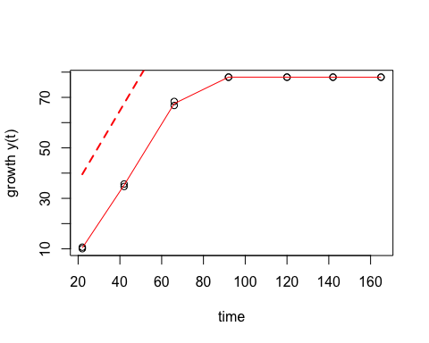

## mu.spline  
## 1 0.4687529

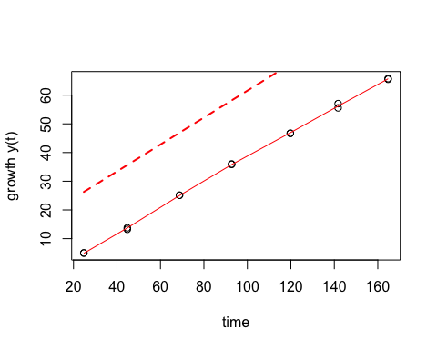

## mu.spline  
## 1 0.524136

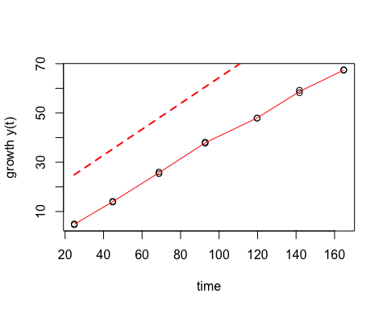

## mu.spline  
## 1 1.137418

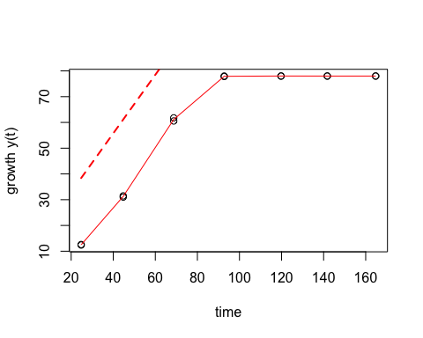

## mu.spline  
## 1 1.220338

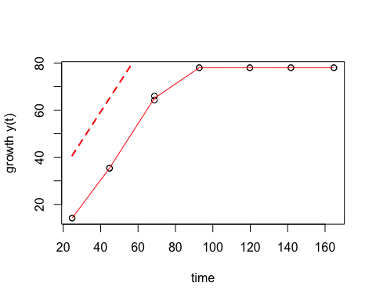

## mu.spline  
## 1 1.468958

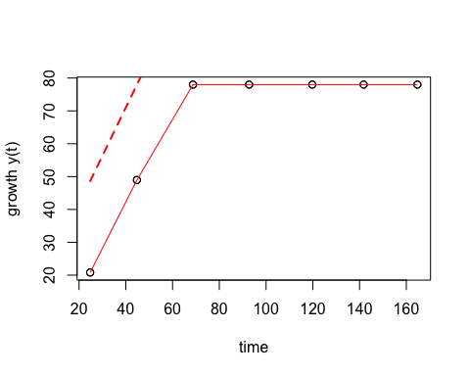

## mu.spline  
## 1 1.569231

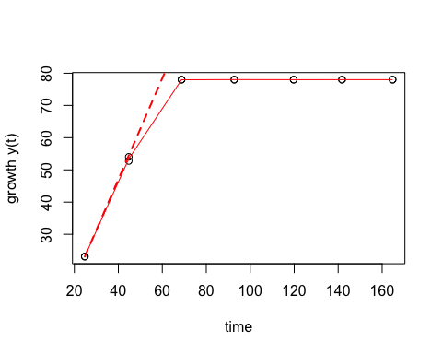

## mu.spline  
## 1 2.544959

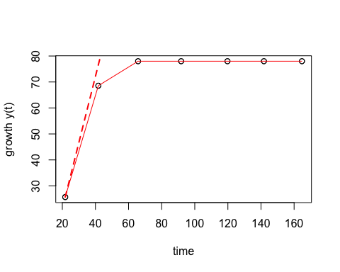

## mu.spline  
## 1 2.28836

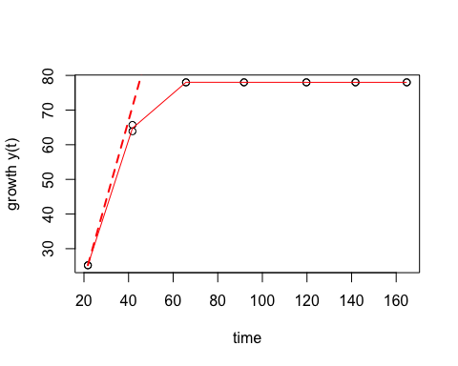

## mu.spline  
## 1 2.655667

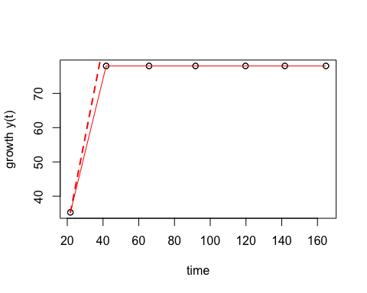

## mu.spline  
## 1 2.737159

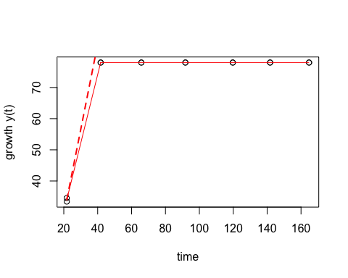

## mu.spline  
## 1 1.243961

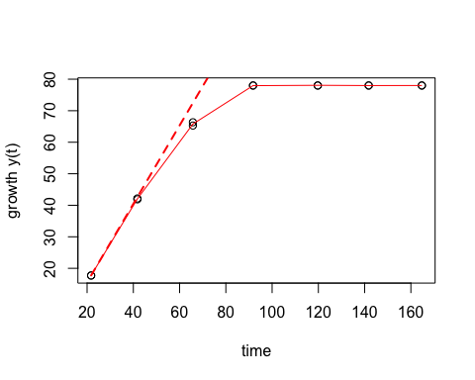

## mu.spline  
## 1 1.323718

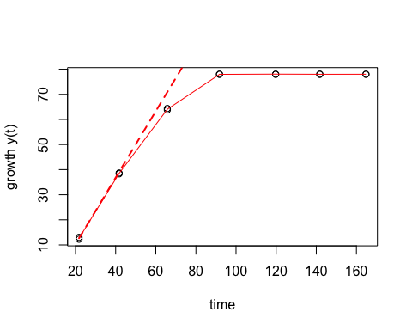

## mu.spline  
## 1 0.4125032

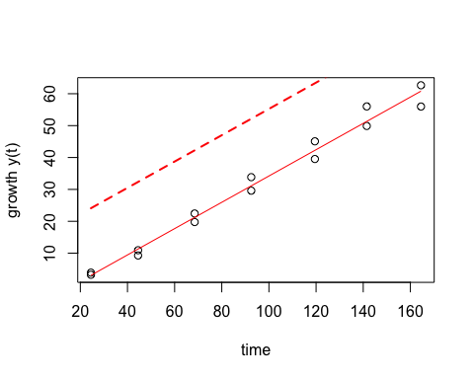

## mu.spline  
## 1 0.4207416

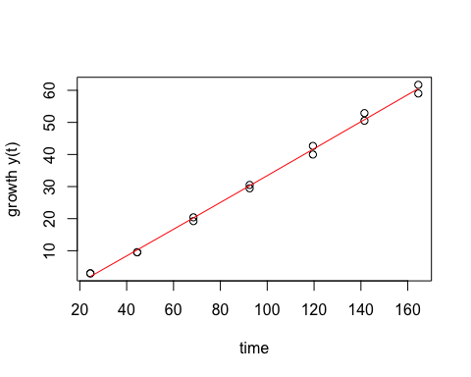

## mu.spline  
## 1 0.6534971

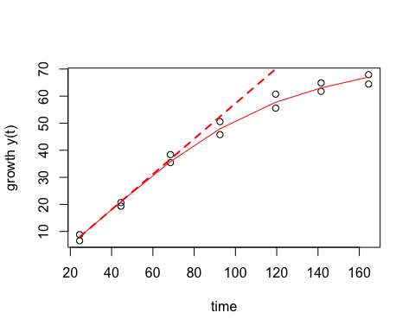

## mu.spline  
## 1 0.6825367

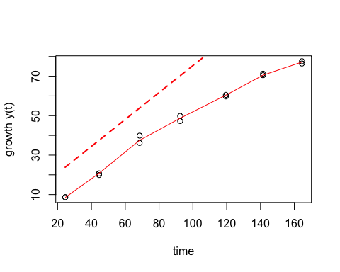

## mu.spline  
## 1 0.6792956

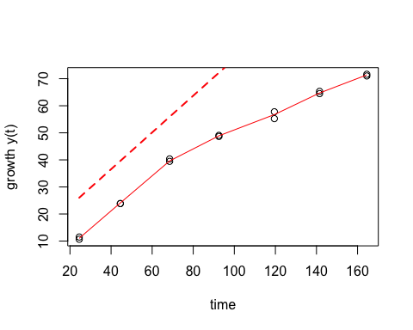

## mu.spline  
## 1 0.6252764

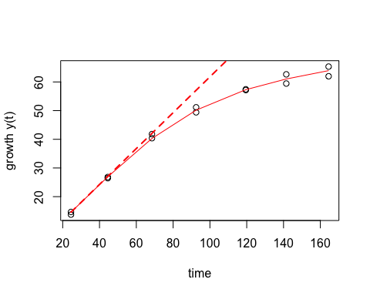

## mu.spline  
## 1 1.003667

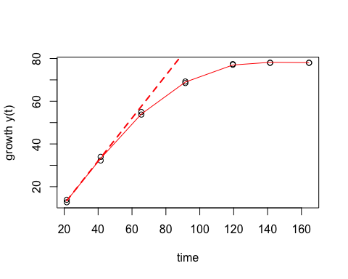

## mu.spline  
## 1 0.9362665

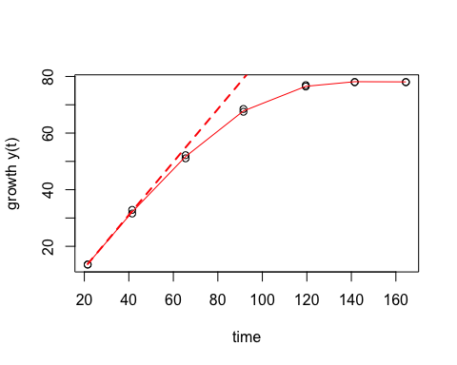

## mu.spline  
## 1 2.744458

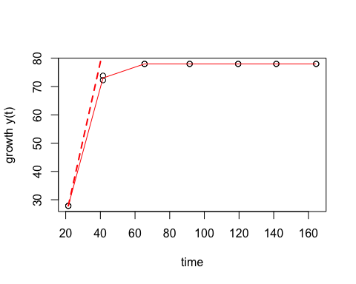

## mu.spline  
## 1 2.560225

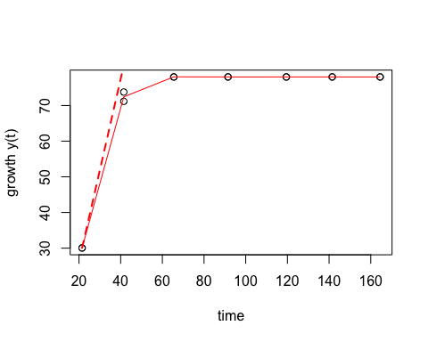

## mu.spline  
## 1 1.50063

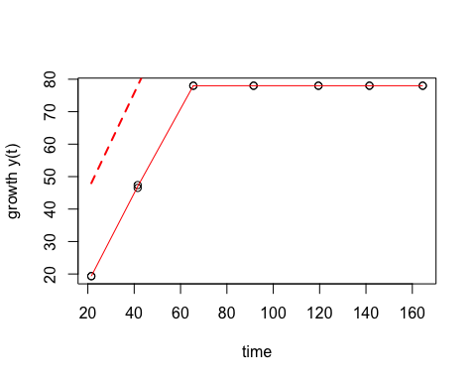

## mu.spline  
## 1 1.629895

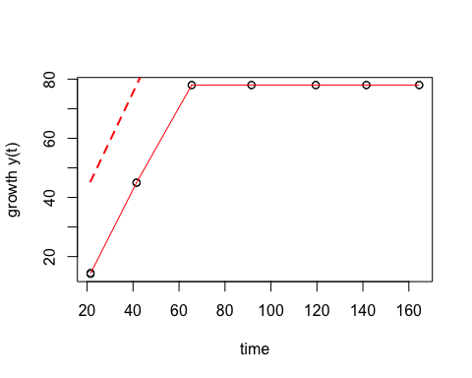

## mu.spline  
## 1 0.5468754

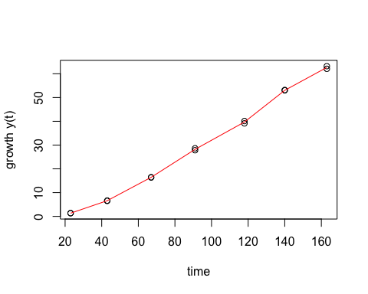

## mu.spline  
## 1 0.5631516

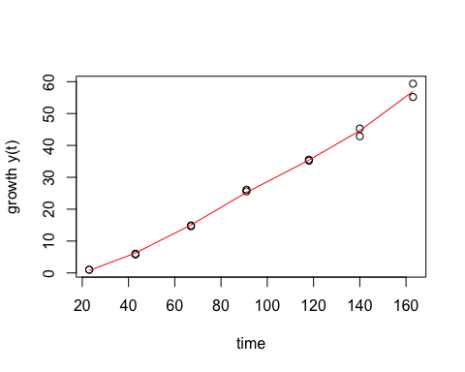

## mu.spline  
## 1 0.9458659

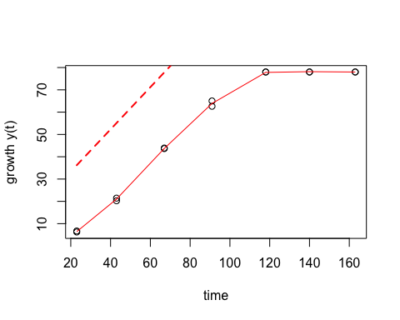

## mu.spline  
## 1 0.9612997

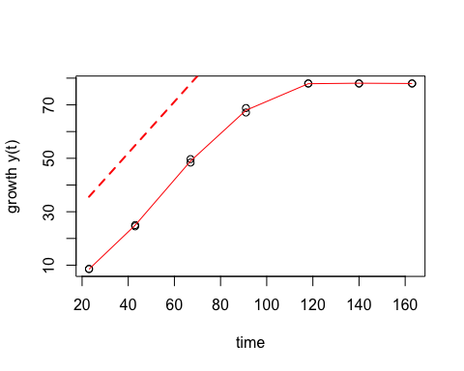

## mu.spline  
## 1 1.400153

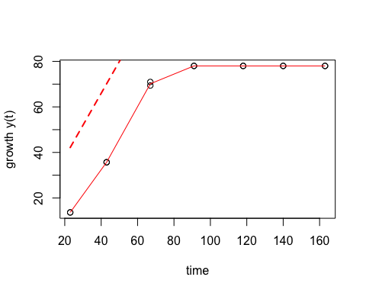

## mu.spline  
## 1 1.39775

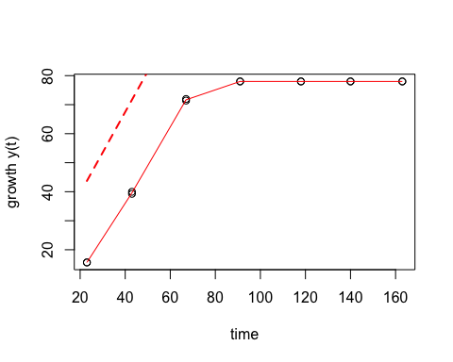

## mu.spline  
## 1 1.876474

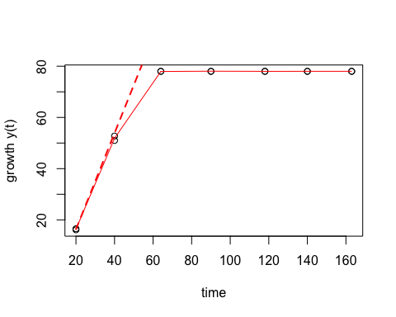

## mu.spline  
## 1 2.030109

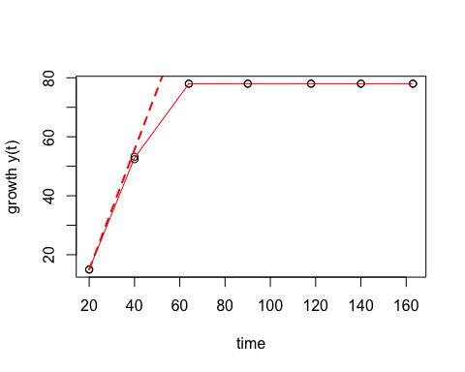

## mu.spline  
## 1 1.936117

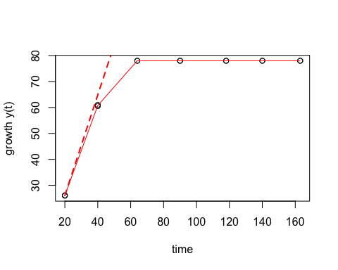

## mu.spline  
## 1 1.844663

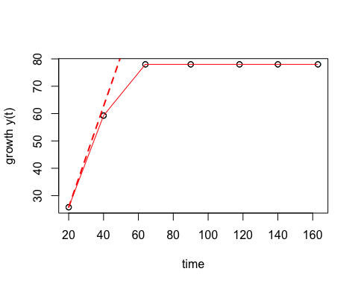

## mu.spline  
## 1 1.537628

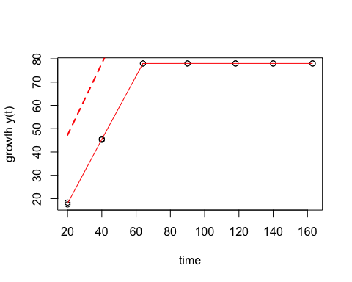

## mu.spline  
## 1 1.627839

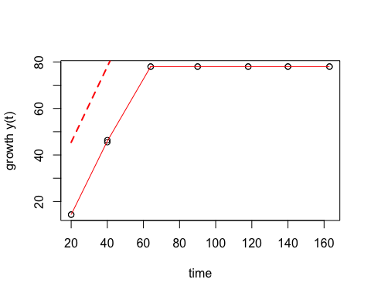

## mu.spline  
## 1 0.3339165

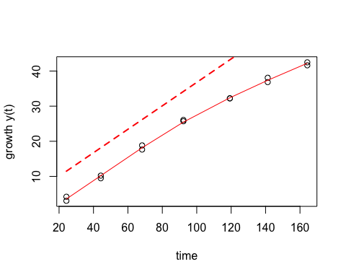

## mu.spline  
## 1 0.3453378

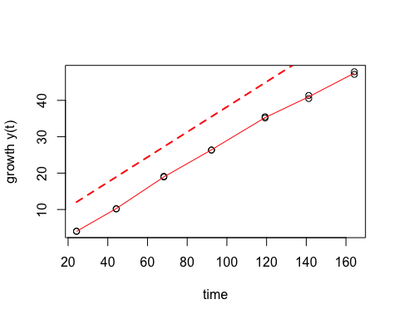

## mu.spline  
## 1 0.6783147

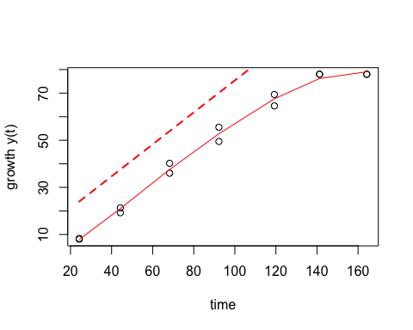

## mu.spline  
## 1 0.683004

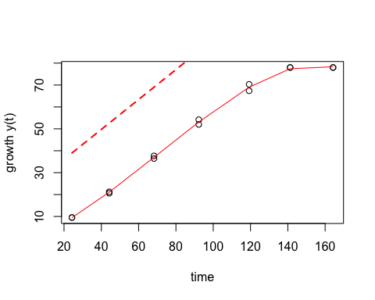

## mu.spline  
## 1 0.8619398

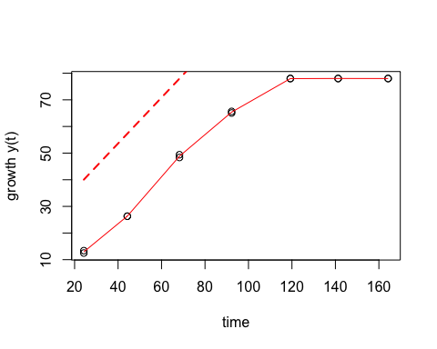

## mu.spline  
## 1 0.8786984

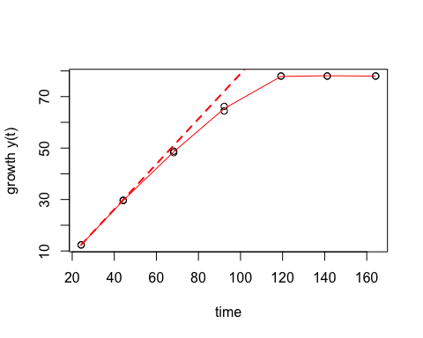

## mu.spline  
## 1 0.9486578

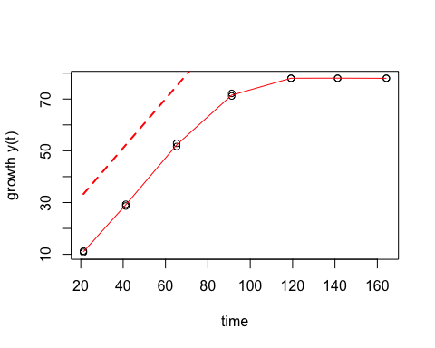

## mu.spline  
## 1 0.7035829

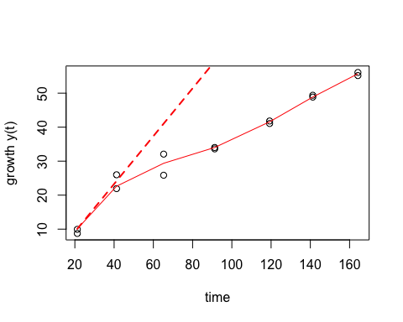

## mu.spline  
## 1 0.8592863

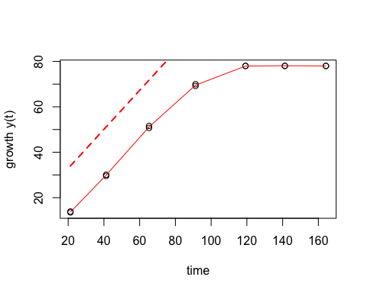

## mu.spline  
## 1 0.9378658

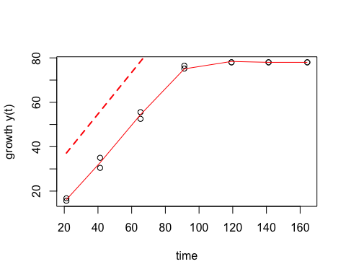

## mu.spline  
## 1 0.7192638

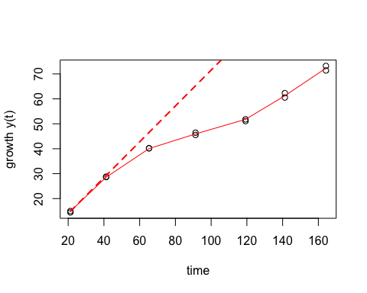

## mu.spline  
## 1 0.7271021

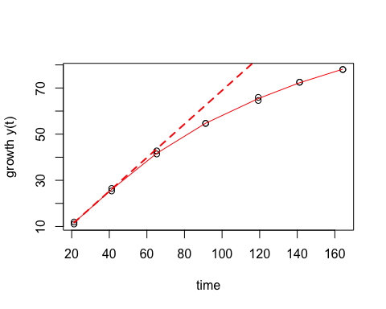

## mu.spline  
## 1 0.4920836

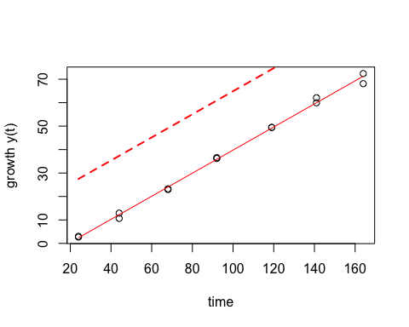

## mu.spline  
## 1 0.5912698

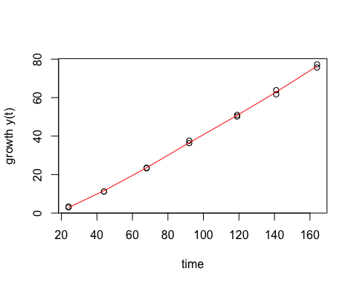

## mu.spline  
## 1 1.196707

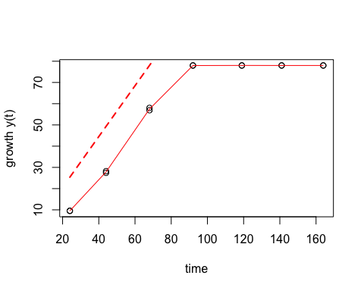

## mu.spline  
## 1 1.200551

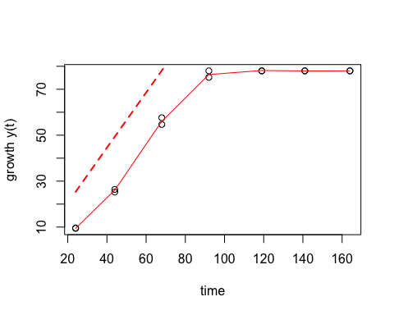

## mu.spline  
## 1 1.570736

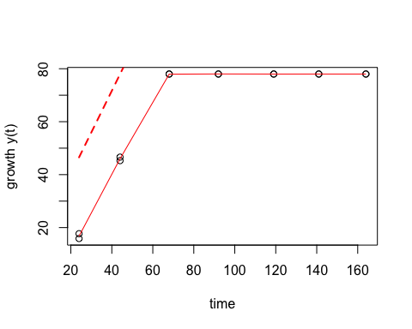

## mu.spline  
## 1 1.522517

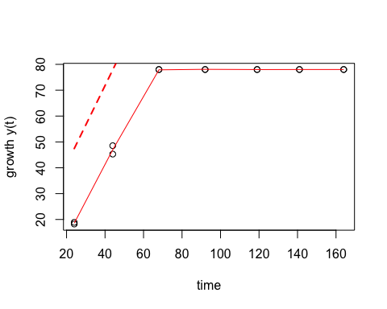

## mu.spline  
## 1 1.607388

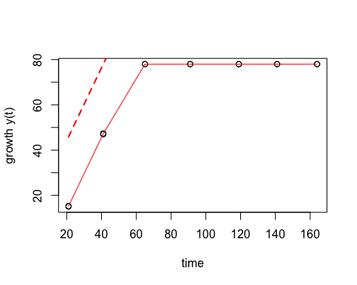

## mu.spline  
## 1 2.114825

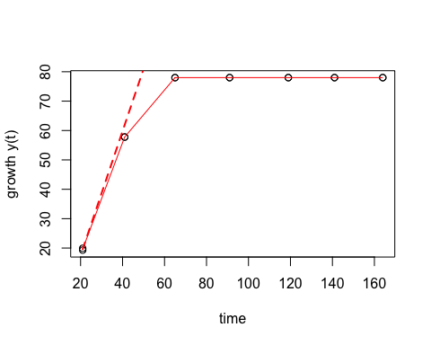

## mu.spline  
## 1 2.179212

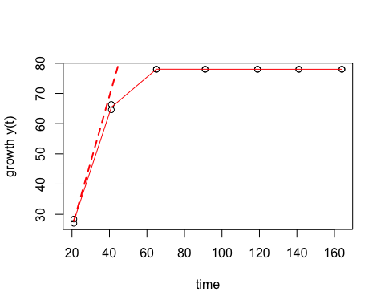

## mu.spline  
## 1 2.224469

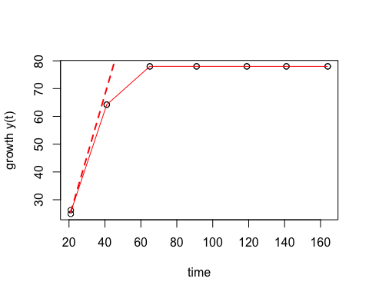

## mu.spline  
## 1 0.9679471

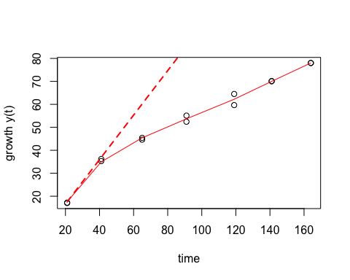

## mu.spline  
## 1 1.155289

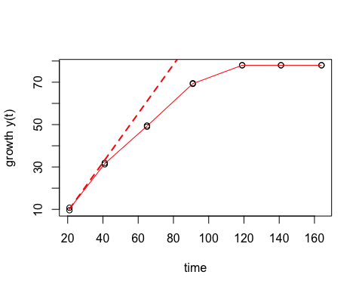

## mu.spline  
## 1 0.5297713

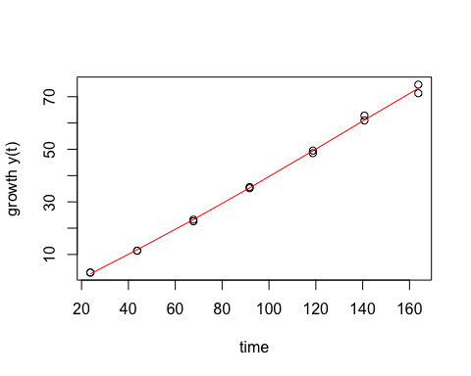

## mu.spline  
## 1 0.5636723

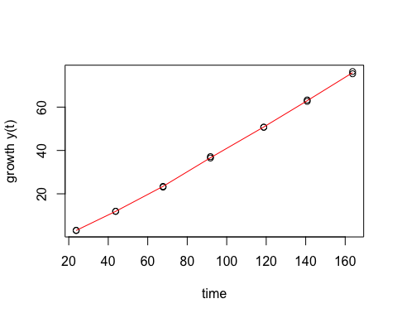

## mu.spline  
## 1 1.125406

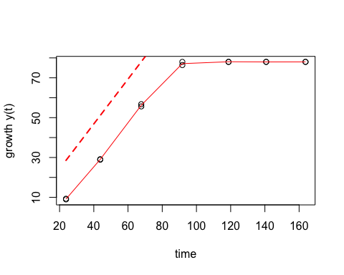

## mu.spline  
## 1 1.153909

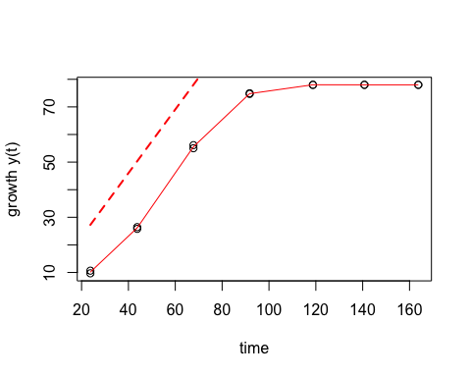

## mu.spline  
## 1 1.46504

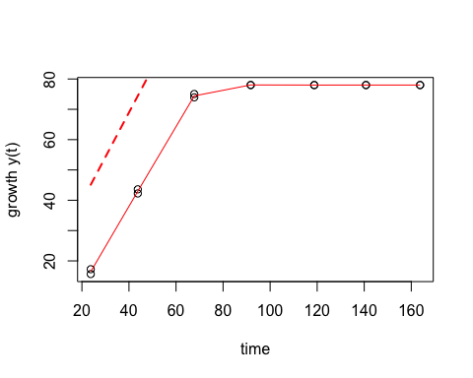

## mu.spline  
## 1 1.517477

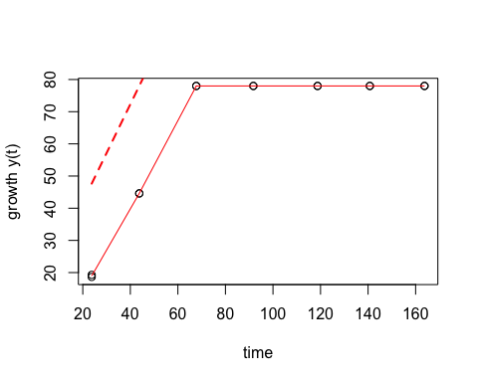

## mu.spline  
## 1 1.941254

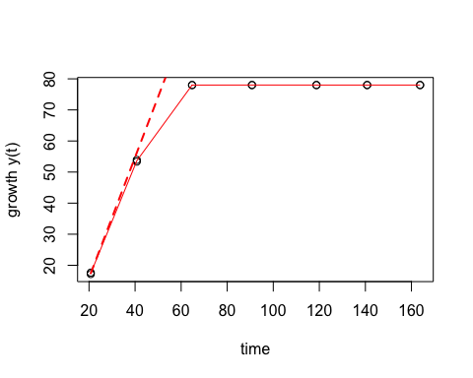

## mu.spline  
## 1 1.999066

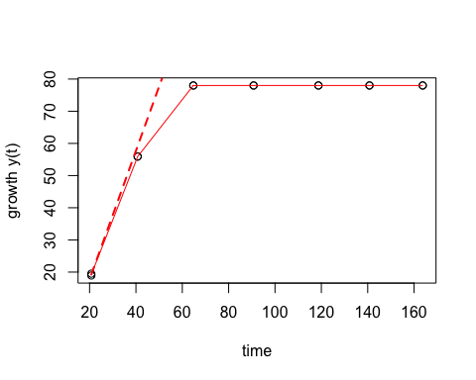

## mu.spline  
## 1 2.043068

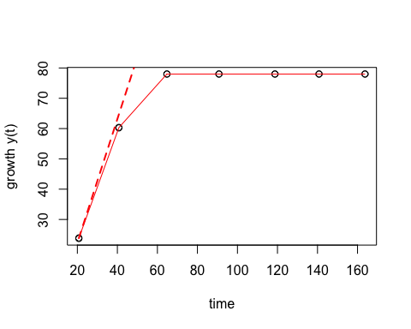

## mu.spline  
## 1 2.117052

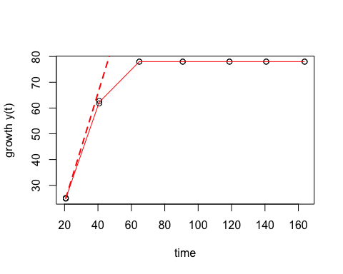

## mu.spline  
## 1 0.6141961

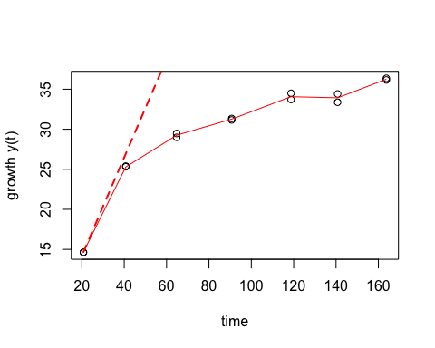

## mu.spline  
## 1 0.4809656

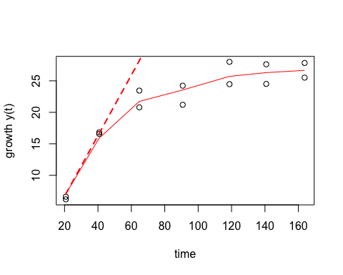

## mu.spline  
## 1 0.6467168

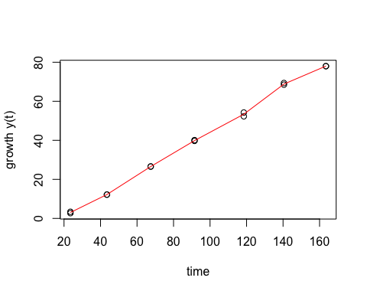

## mu.spline  
## 1 0.5548313

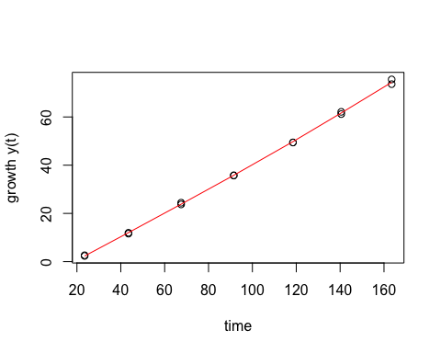

## mu.spline  
## 1 1.117626

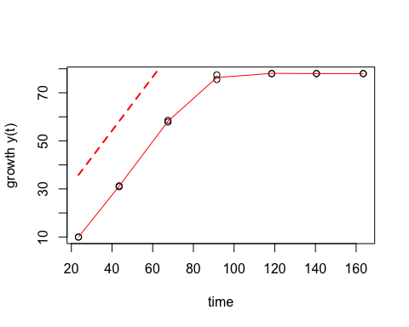

## mu.spline  
## 1 1.110675

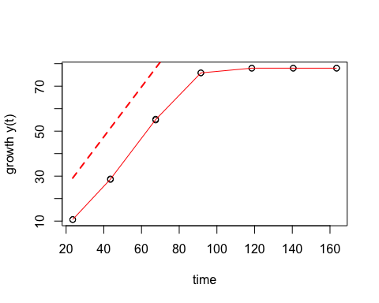

## mu.spline  
## 1 1.567528

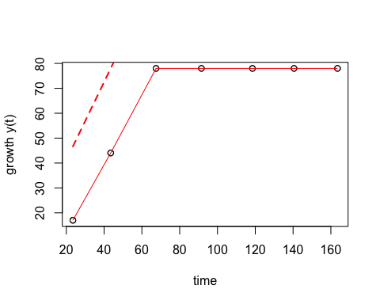

## mu.spline  
## 1 1.527499

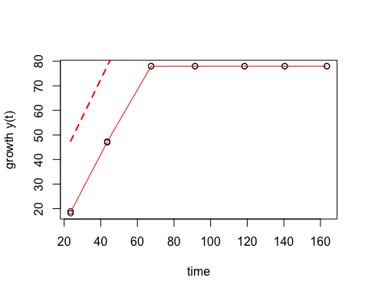

## mu.spline  
## 1 2.201973

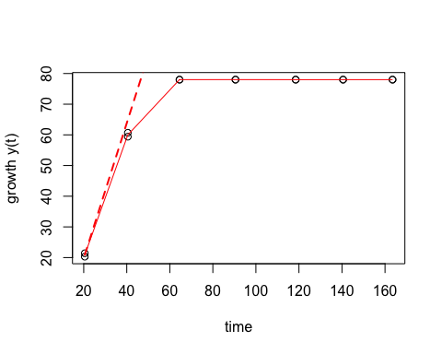

## mu.spline  
## 1 2.368008

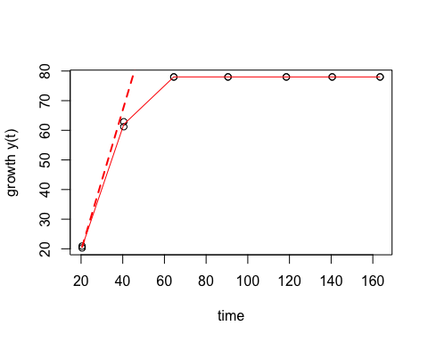

## mu.spline  
## 1 2.935617

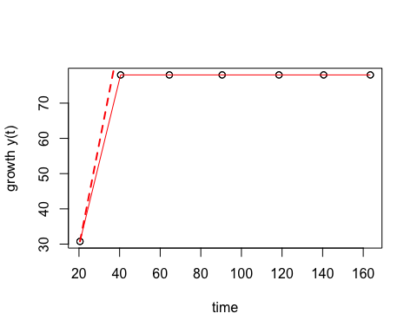

## mu.spline  
## 1 2.943397

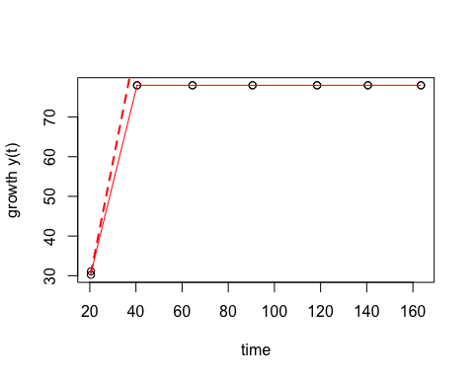

## mu.spline  
## 1 1.053021

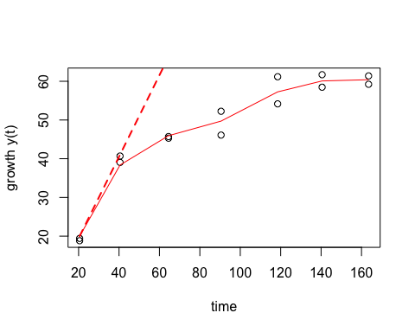

## mu.spline  
## 1 0.8355182

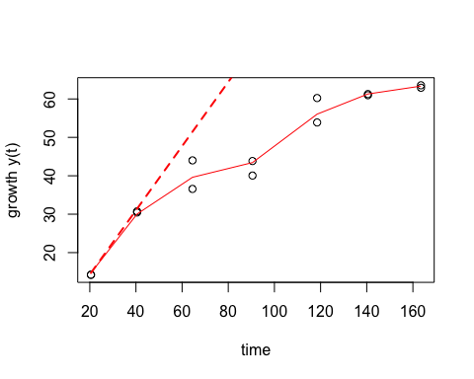

## mu.spline  
## 1 0.542975

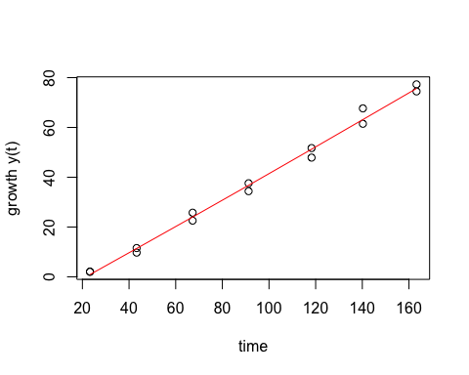

## mu.spline  
## 1 0.5416162

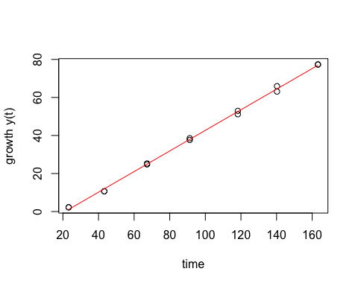

## mu.spline  
## 1 1.195991

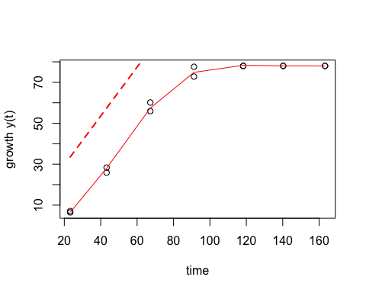

## mu.spline  
## 1 1.056485

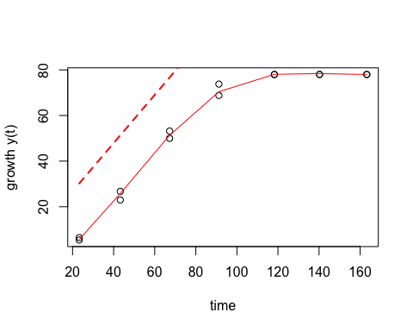

## mu.spline  
## 1 1.417642

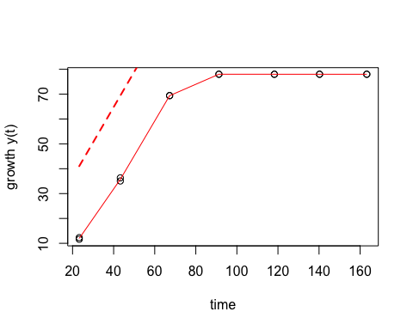

## mu.spline  
## 1 1.389677

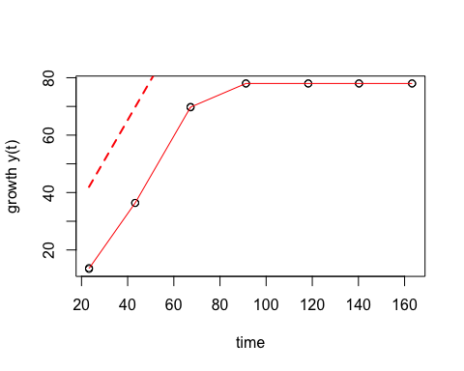

## mu.spline  
## 1 1.661736

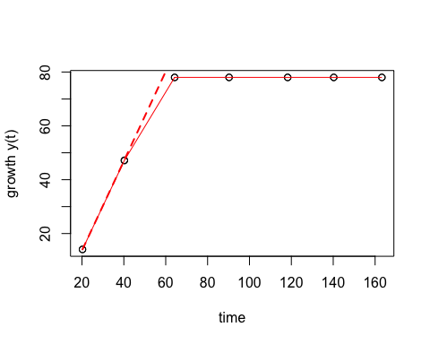

## mu.spline  
## 1 1.656321

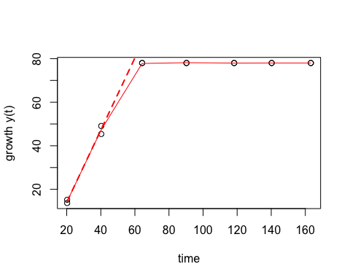

## mu.spline  
## 1 2.220454

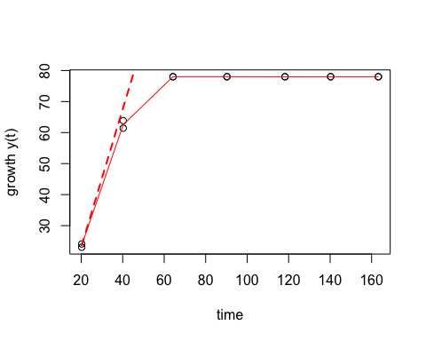

## mu.spline  
## 1 1.595973

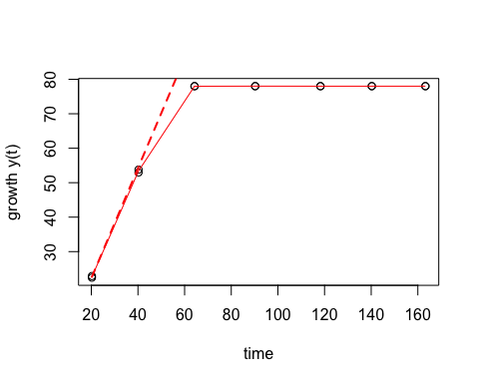

## mu.spline  
## 1 0.7945578

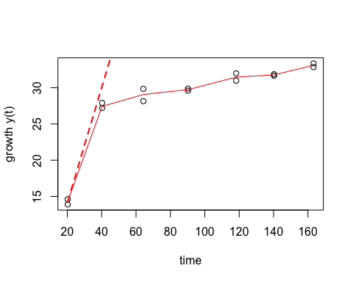

## mu.spline  
## 1 0.6457121

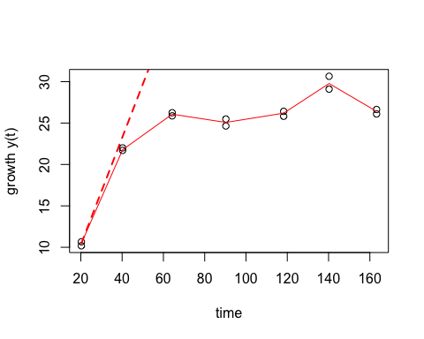

## is..i.. temp..t.. rep..r.. mu.spline  
## 1 Dm13 15 1 0.5496876  
## 2 Dm13 15 2 0.5986732  
## 3 Dm13 20 1 1.0494457  
## 4 Dm13 20 2 1.1034608  
## 5 Dm13 25 1 1.4657350  
## 6 Dm13 25 2 1.5138656  
## 7 Dm13 30 1 1.6533884  
## 8 Dm13 30 2 2.3712501  
## 9 Dm13 35 1 2.6314193  
## 10 Dm13 35 2 2.3611563  
## 11 Dm13 40 1 0.8989155  
## 12 Dm13 40 2 1.4217411  
## 13 Et12 15 1 0.5062591  
## 14 Et12 15 2 0.5266058  
## 15 Et12 20 1 0.8701006  
## 16 Et12 20 2 0.9247650  
## 17 Et12 25 1 1.2925488  
## 18 Et12 25 2 1.2324897  
## 19 Et12 30 1 1.9906279  
## 20 Et12 30 2 2.0806561  
## 21 Et12 35 1 2.1688089  
## 22 Et12 35 2 1.8953753  
## 23 Et12 40 1 1.4705093  
## 24 Et12 40 2 1.7029098  
## 25 Et14 15 1 0.5399363  
## 26 Et14 15 2 0.4583508  
## 27 Et14 20 1 0.8842736  
## 28 Et14 20 2 0.9318106  
## 29 Et14 25 1 1.2247903  
## 30 Et14 25 2 1.2955097  
## 31 Et14 30 1 1.7559846  
## 32 Et14 30 2 1.8098766  
## 33 Et14 35 1 2.2754386  
## 34 Et14 35 2 1.9377444  
## 35 Et14 40 1 1.6491641  
## 36 Et14 40 2 1.9909776  
## 37 Et17 15 1 0.4939822  
## 38 Et17 15 2 0.4998116  
## 39 Et17 20 1 1.2442578  
## 40 Et17 20 2 1.2726852  
## 41 Et17 25 1 1.3655118  
## 42 Et17 25 2 1.7218384  
## 43 Et17 30 1 1.6861915  
## 44 Et17 30 2 2.2508795  
## 45 Et17 35 1 2.0345003  
## 46 Et17 35 2 1.6864042  
## 47 Et17 40 1 0.5705839  
## 48 Et17 40 2 0.9563678  
## 49 Et18 15 1 0.5299017  
## 50 Et18 15 2 0.4635624  
## 51 Et18 20 1 1.0989215  
## 52 Et18 20 2 1.0190704  
## 53 Et18 25 1 1.4014680  
## 54 Et18 25 2 1.6043860  
## 55 Et18 30 1 2.2886786  
## 56 Et18 30 2 2.4024071  
## 57 Et18 35 1 2.2551856  
## 58 Et18 35 2 2.2697911  
## 59 Et18 40 1 1.7080878  
## 60 Et18 40 2 1.9350210  
## 61 IN12-4 15 1 0.4982299  
## 62 IN12-4 15 2 0.4587825  
## 63 IN12-4 20 1 0.8734576  
## 64 IN12-4 20 2 0.9153057  
## 65 IN12-4 25 1 1.1759245  
## 66 IN12-4 25 2 1.2780599  
## 67 IN12-4 30 1 2.1371043  
## 68 IN12-4 30 2 1.5587060  
## 69 IN12-4 35 1 2.4476561  
## 70 IN12-4 35 2 2.2530621  
## 71 IN12-4 40 1 1.6261474  
## 72 IN12-4 40 2 2.0657934  
## 73 IN12-8-3 15 1 0.5257489  
## 74 IN12-8-3 15 2 0.5896658  
## 75 IN12-8-3 20 1 1.1093109  
## 76 IN12-8-3 20 2 1.0684672  
## 77 IN12-8-3 25 1 1.3926649  
## 78 IN12-8-3 25 2 1.5395703  
## 79 IN12-8-3 30 1 1.9518843  
## 80 IN12-8-3 30 2 2.1786206  
## 81 IN12-8-3 35 1 2.3273065  
## 82 IN12-8-3 35 2 1.9345936  
## 83 IN12-8-3 40 1 1.3106912  
## 84 IN12-8-3 40 2 1.6314297  
## 85 IN12-9-4 15 1 0.6103366  
## 86 IN12-9-4 15 2 0.6376289  
## 87 IN12-9-4 20 1 1.0579381  
## 88 IN12-9-4 20 2 1.1399477  
## 89 IN12-9-4 25 1 1.3820589  
## 90 IN12-9-4 25 2 1.3984264  
## 91 IN12-9-4 30 1 1.8426976  
## 92 IN12-9-4 30 2 1.9622063  
## 93 IN12-9-4 35 1 2.5824712  
## 94 IN12-9-4 35 2 2.4016999  
## 95 IN12-9-4 40 1 0.2109520  
## 96 IN12-9-4 40 2 0.2177516  
## 97 IN12-9-6 15 1 0.4625643  
## 98 IN12-9-6 15 2 0.4914511  
## 99 IN12-9-6 20 1 0.9532103  
## 100 IN12-9-6 20 2 0.9054273  
## 101 IN12-9-6 25 1 1.3320359  
## 102 IN12-9-6 25 2 1.4009845  
## 103 IN12-9-6 30 1 1.7687286  
## 104 IN12-9-6 30 2 1.4896853  
## 105 IN12-9-6 35 1 2.6919088  
## 106 IN12-9-6 35 2 2.4421977  
## 107 IN12-9-6 40 1 1.0329684  
## 108 IN12-9-6 40 2 1.4563975  
## 109 IN12-PO-3 15 1 0.4605466  
## 110 IN12-PO-3 15 2 0.5207794  
## 111 IN12-PO-3 20 1 1.0214285  
## 112 IN12-PO-3 20 2 1.0756761  
## 113 IN12-PO-3 25 1 1.4923703  
## 114 IN12-PO-3 25 2 1.5864306  
## 115 IN12-PO-3 30 1 2.2531980  
## 116 IN12-PO-3 30 2 2.1477496  
## 117 IN12-PO-3 35 1 2.5936984  
## 118 IN12-PO-3 35 2 2.6833405  
## 119 IN12-PO-3 40 1 0.9561809  
## 120 IN12-PO-3 40 2 1.3236606  
## 121 Md10 15 1 0.4377659  
## 122 Md10 15 2 0.4551404  
## 123 Md10 20 1 0.9651851  
## 124 Md10 20 2 0.9405746  
## 125 Md10 25 1 1.3745636  
## 126 Md10 25 2 1.3639652  
## 127 Md10 30 1 1.9280918  
## 128 Md10 30 2 1.6659785  
## 129 Md10 35 1 2.2585782  
## 130 Md10 35 2 2.2349680  
## 131 Md10 40 1 1.0457972  
## 132 Md10 40 2 1.2804599  
## 133 Md3 15 1 0.4982087  
## 134 Md3 15 2 0.4248215  
## 135 Md3 20 1 0.8023018  
## 136 Md3 20 2 0.8548086  
## 137 Md3 25 1 1.1968464  
## 138 Md3 25 2 1.1489202  
## 139 Md3 30 1 1.5986577  
## 140 Md3 30 2 1.7067292  
## 141 Md3 35 1 2.5798549  
## 142 Md3 35 2 2.3574507  
## 143 Md3 40 1 1.4057017  
## 144 Md3 40 2 1.3895185  
## 145 Md5 15 1 0.4915375  
## 146 Md5 15 2 0.5267515  
## 147 Md5 20 1 1.1299118  
## 148 Md5 20 2 1.1961907  
## 149 Md5 25 1 1.3923514  
## 150 Md5 25 2 1.4586564  
## 151 Md5 30 1 1.8624349  
## 152 Md5 30 2 1.9216413  
## 153 Md5 35 1 2.5721690  
## 154 Md5 35 2 2.4509606  
## 155 Md5 40 1 0.7043634  
## 156 Md5 40 2 1.2217379  
## 157 Md6 15 1 0.5217348  
## 158 Md6 15 2 0.5364213  
## 159 Md6 20 1 1.0251198  
## 160 Md6 20 2 0.9223258  
## 161 Md6 25 1 1.3859355  
## 162 Md6 25 2 1.3113686  
## 163 Md6 30 1 2.0352180  
## 164 Md6 30 2 1.6398101  
## 165 Md6 35 1 2.5502267  
## 166 Md6 35 2 2.3874230  
## 167 Md6 40 1 1.6363099  
## 168 Md6 40 2 1.6671986  
## 169 Md7 15 1 0.4955391  
## 170 Md7 15 2 0.5400953  
## 171 Md7 20 1 0.8716009  
## 172 Md7 20 2 0.9281418  
## 173 Md7 25 1 1.4438737  
## 174 Md7 25 2 1.3826201  
## 175 Md7 30 1 1.7108594  
## 176 Md7 30 2 2.0624785  
## 177 Md7 35 1 2.7106650  
## 178 Md7 35 2 2.5990374  
## 179 Md7 40 1 1.4509826  
## 180 Md7 40 2 1.6139194  
## 181 MP144 15 1 0.3934023  
## 182 MP144 15 2 0.4193579  
## 183 MP144 20 1 0.7666943  
## 184 MP144 20 2 0.7958944  
## 185 MP144 25 1 1.1261660  
## 186 MP144 25 2 1.1300890  
## 187 MP144 30 1 1.3558674  
## 188 MP144 30 2 1.3511998  
## 189 MP144 35 1 1.5984387  
## 190 MP144 35 2 1.6133438  
## 191 MP144 40 1 0.4390910  
## 192 MP144 40 2 0.1466994  
## 193 MP220 15 1 0.4843061  
## 194 MP220 15 2 0.5115592  
## 195 MP220 20 1 0.8956442  
## 196 MP220 20 2 0.8911039  
## 197 MP220 25 1 1.3124668  
## 198 MP220 25 2 1.2908268  
## 199 MP220 30 1 2.0167133  
## 200 MP220 30 2 1.8066702  
## 201 MP220 35 1 2.3051273  
## 202 MP220 35 2 2.2259074  
## 203 MP220 40 1 1.3309904  
## 204 MP220 40 2 1.5289899  
## 205 MP223 15 1 0.4338430  
## 206 MP223 15 2 0.4260686  
## 207 MP223 20 1 0.7348013  
## 208 MP223 20 2 0.7502448  
## 209 MP223 25 1 0.9669728  
## 210 MP223 25 2 1.0063270  
## 211 MP223 30 1 1.2804538  
## 212 MP223 30 2 1.3373963  
## 213 MP223 35 1 1.3509338  
## 214 MP223 35 2 1.3762529  
## 215 MP223 40 1 0.5379611  
## 216 MP223 40 2 0.5112745  
## 217 MP249 15 1 0.4326757  
## 218 MP249 15 2 0.4790213  
## 219 MP249 20 1 1.0158561  
## 220 MP249 20 2 1.1252366  
## 221 MP249 25 1 1.4794354  
## 222 MP249 25 2 1.5018478  
## 223 MP249 30 1 2.0498097  
## 224 MP249 30 2 1.9543099  
## 225 MP249 35 1 2.7222728  
## 226 MP249 35 2 2.4928089  
## 227 MP249 40 1 1.0025390  
## 228 MP249 40 2 0.8216513  
## 229 MP250 15 1 0.5600877  
## 230 MP250 15 2 0.5729224  
## 231 MP250 20 1 1.2057707  
## 232 MP250 20 2 1.1404384  
## 233 MP250 25 1 1.4631811  
## 234 MP250 25 2 1.6179977  
## 235 MP250 30 1 1.6741929  
## 236 MP250 30 2 2.0028325  
## 237 MP250 35 1 2.7405648  
## 238 MP250 35 2 2.6211485  
## 239 MP250 40 1 1.0864729  
## 240 MP250 40 2 1.1316820  
## 241 MP258 15 1 0.6740757  
## 242 MP258 15 2 0.6527034  
## 243 MP258 20 1 1.2002930  
## 244 MP258 20 2 1.0504913  
## 245 MP258 25 1 1.5352288  
## 246 MP258 25 2 1.5364603  
## 247 MP258 30 1 1.6383781  
## 248 MP258 30 2 1.8308439  
## 249 MP258 35 1 2.1549107  
## 250 MP258 35 2 2.1960114  
## 251 MP258 40 1 1.1702629  
## 252 MP258 40 2 1.3841501  
## 253 TN262 15 1 0.5452041  
## 254 TN262 15 2 0.5466948  
## 255 TN262 20 1 0.9156468  
## 256 TN262 20 2 0.9113901  
## 257 TN262 25 1 1.1573077  
## 258 TN262 25 2 1.3684683  
## 259 TN262 30 1 1.8749965  
## 260 TN262 30 2 1.7755334  
## 261 TN262 35 1 2.7239926  
## 262 TN262 35 2 2.5220756  
## 263 TN262 40 1 0.9077063  
## 264 TN262 40 2 1.2987233  
## 265 TN264 15 1 0.6246866  
## 266 TN264 15 2 0.5615705  
## 267 TN264 20 1 1.2615722  
## 268 TN264 20 2 1.1604502  
## 269 TN264 25 1 1.3613080  
## 270 TN264 25 2 1.3578028  
## 271 TN264 30 1 2.0845894  
## 272 TN264 30 2 2.2988917  
## 273 TN264 35 1 2.4248814  
## 274 TN264 35 2 2.3822432  
## 275 TN264 40 1 0.8854763  
## 276 TN264 40 2 0.6236523  
## 277 TN270 15 1 0.7111850  
## 278 TN270 15 2 0.6866916  
## 279 TN270 20 1 1.2475406  
## 280 TN270 20 2 1.2692652  
## 281 TN270 25 1 1.4809876  
## 282 TN270 25 2 1.4601553  
## 283 TN270 30 1 2.0967142  
## 284 TN270 30 2 2.3377334  
## 285 TN270 35 1 2.6899115  
## 286 TN270 35 2 2.6994596  
## 287 TN270 40 1 1.4896483  
## 288 TN270 40 2 1.4182649  
## 289 TN279 15 1 0.5028014  
## 290 TN279 15 2 0.5231823  
## 291 TN279 20 1 1.1267612  
## 292 TN279 20 2 1.1222760  
## 293 TN279 25 1 1.4793392  
## 294 TN279 25 2 1.5301470  
## 295 TN279 30 1 2.0831230  
## 296 TN279 30 2 2.1267135  
## 297 TN279 35 1 3.0210522  
## 298 TN279 35 2 2.5102557  
## 299 TN279 40 1 1.3843378  
## 300 TN279 40 2 1.3988106  
## 301 TN280 15 1 0.4687529  
## 302 TN280 15 2 0.5241360  
## 303 TN280 20 1 1.1374184  
## 304 TN280 20 2 1.2203382  
## 305 TN280 25 1 1.4689583  
## 306 TN280 25 2 1.5692311  
## 307 TN280 30 1 2.5449590  
## 308 TN280 30 2 2.2883598  
## 309 TN280 35 1 2.6556666  
## 310 TN280 35 2 2.7371594  
## 311 TN280 40 1 1.2439608  
## 312 TN280 40 2 1.3237184  
## 313 TN380 15 1 0.4125032  
## 314 TN380 15 2 0.4207416  
## 315 TN380 20 1 0.6534971  
## 316 TN380 20 2 0.6825367  
## 317 TN380 25 1 0.6792956  
## 318 TN380 25 2 0.6252764  
## 319 TN380 30 1 1.0036668  
## 320 TN380 30 2 0.9362665  
## 321 TN380 35 1 2.7444578  
## 322 TN380 35 2 2.5602248  
## 323 TN380 40 1 1.5006302  
## 324 TN380 40 2 1.6298947  
## 325 TN4 15 1 0.5468754  
## 326 TN4 15 2 0.5631516  
## 327 TN4 20 1 0.9458659  
## 328 TN4 20 2 0.9612997  
## 329 TN4 25 1 1.4001526  
## 330 TN4 25 2 1.3977503  
## 331 TN4 30 1 1.8764737  
## 332 TN4 30 2 2.0301092  
## 333 TN4 35 1 1.9361175  
## 334 TN4 35 2 1.8446630  
## 335 TN4 40 1 1.5376278  
## 336 TN4 40 2 1.6278390  
## 337 TN501 15 1 0.3339165  
## 338 TN501 15 2 0.3453378  
## 339 TN501 20 1 0.6783147  
## 340 TN501 20 2 0.6830040  
## 341 TN501 25 1 0.8619398  
## 342 TN501 25 2 0.8786984  
## 343 TN501 30 1 0.9486578  
## 344 TN501 30 2 0.7035829  
## 345 TN501 35 1 0.8592863  
## 346 TN501 35 2 0.9378658  
## 347 TN501 40 1 0.7192638  
## 348 TN501 40 2 0.7271021  
## 349 TN550 15 1 0.4920836  
## 350 TN550 15 2 0.5912698  
## 351 TN550 20 1 1.1967071  
## 352 TN550 20 2 1.2005511  
## 353 TN550 25 1 1.5707361  
## 354 TN550 25 2 1.5225171  
## 355 TN550 30 1 1.6073875  
## 356 TN550 30 2 2.1148250  
## 357 TN550 35 1 2.1792125  
## 358 TN550 35 2 2.2244687  
## 359 TN550 40 1 0.9679471  
## 360 TN550 40 2 1.1552893  
## 361 W12-6 15 1 0.5297713  
## 362 W12-6 15 2 0.5636723  
## 363 W12-6 20 1 1.1254062  
## 364 W12-6 20 2 1.1539090  
## 365 W12-6 25 1 1.4650405  
## 366 W12-6 25 2 1.5174773  
## 367 W12-6 30 1 1.9412539  
## 368 W12-6 30 2 1.9990660  
## 369 W12-6 35 1 2.0430682  
## 370 W12-6 35 2 2.1170517  
## 371 W12-6 40 1 0.6141961  
## 372 W12-6 40 2 0.4809656  
## 373 W23 15 1 0.6467168  
## 374 W23 15 2 0.5548313  
## 375 W23 20 1 1.1176256  
## 376 W23 20 2 1.1106745  
## 377 W23 25 1 1.5675284  
## 378 W23 25 2 1.5274992  
## 379 W23 30 1 2.2019728  
## 380 W23 30 2 2.3680079  
## 381 W23 35 1 2.9356168  
## 382 W23 35 2 2.9433972  
## 383 W23 40 1 1.0530205  
## 384 W23 40 2 0.8355182  
## 385 W3-5 15 1 0.5429750  
## 386 W3-5 15 2 0.5416162  
## 387 W3-5 20 1 1.1959911  
## 388 W3-5 20 2 1.0564852  
## 389 W3-5 25 1 1.4176419  
## 390 W3-5 25 2 1.3896772  
## 391 W3-5 30 1 1.6617360  
## 392 W3-5 30 2 1.6563214  
## 393 W3-5 35 1 2.2204541  
## 394 W3-5 35 2 1.5959734  
## 395 W3-5 40 1 0.7945578  
## 396 W3-5 40 2 0.6457121

## [1] "data.frame"

## isolate temp rep grate  
## 1 Dm13 15 1 0.5496876  
## 2 Dm13 15 2 0.5986732  
## 3 Dm13 20 1 1.0494457  
## 4 Dm13 20 2 1.1034608  
## 5 Dm13 25 1 1.4657350  
## 6 Dm13 25 2 1.5138656  
## 7 Dm13 30 1 1.6533884  
## 8 Dm13 30 2 2.3712501  
## 9 Dm13 35 1 2.6314193  
## 10 Dm13 35 2 2.3611563  
## 11 Dm13 40 1 0.8989155  
## 12 Dm13 40 2 1.4217411  
## 13 Et12 15 1 0.5062591  
## 14 Et12 15 2 0.5266058  
## 15 Et12 20 1 0.8701006  
## 16 Et12 20 2 0.9247650  
## 17 Et12 25 1 1.2925488  
## 18 Et12 25 2 1.2324897  
## 19 Et12 30 1 1.9906279  
## 20 Et12 30 2 2.0806561  
## 21 Et12 35 1 2.1688089  
## 22 Et12 35 2 1.8953753  
## 23 Et12 40 1 1.4705093  
## 24 Et12 40 2 1.7029098  
## 25 Et14 15 1 0.5399363  
## 26 Et14 15 2 0.4583508  
## 27 Et14 20 1 0.8842736  
## 28 Et14 20 2 0.9318106  
## 29 Et14 25 1 1.2247903  
## 30 Et14 25 2 1.2955097  
## 31 Et14 30 1 1.7559846  
## 32 Et14 30 2 1.8098766  
## 33 Et14 35 1 2.2754386  
## 34 Et14 35 2 1.9377444  
## 35 Et14 40 1 1.6491641  
## 36 Et14 40 2 1.9909776  
## 37 Et17 15 1 0.4939822  
## 38 Et17 15 2 0.4998116  
## 39 Et17 20 1 1.2442578  
## 40 Et17 20 2 1.2726852  
## 41 Et17 25 1 1.3655118  
## 42 Et17 25 2 1.7218384  
## 43 Et17 30 1 1.6861915  
## 44 Et17 30 2 2.2508795  
## 45 Et17 35 1 2.0345003  
## 46 Et17 35 2 1.6864042  
## 47 Et17 40 1 0.5705839  
## 48 Et17 40 2 0.9563678  
## 49 Et18 15 1 0.5299017  
## 50 Et18 15 2 0.4635624  
## 51 Et18 20 1 1.0989215  
## 52 Et18 20 2 1.0190704  
## 53 Et18 25 1 1.4014680  
## 54 Et18 25 2 1.6043860  
## 55 Et18 30 1 2.2886786  
## 56 Et18 30 2 2.4024071  
## 57 Et18 35 1 2.2551856  
## 58 Et18 35 2 2.2697911  
## 59 Et18 40 1 1.7080878  
## 60 Et18 40 2 1.9350210  
## 61 IN12-4 15 1 0.4982299  
## 62 IN12-4 15 2 0.4587825  
## 63 IN12-4 20 1 0.8734576  
## 64 IN12-4 20 2 0.9153057  
## 65 IN12-4 25 1 1.1759245  
## 66 IN12-4 25 2 1.2780599  
## 67 IN12-4 30 1 2.1371043  
## 68 IN12-4 30 2 1.5587060  
## 69 IN12-4 35 1 2.4476561  
## 70 IN12-4 35 2 2.2530621  
## 71 IN12-4 40 1 1.6261474  
## 72 IN12-4 40 2 2.0657934  
## 73 IN12-8-3 15 1 0.5257489  
## 74 IN12-8-3 15 2 0.5896658  
## 75 IN12-8-3 20 1 1.1093109  
## 76 IN12-8-3 20 2 1.0684672  
## 77 IN12-8-3 25 1 1.3926649  
## 78 IN12-8-3 25 2 1.5395703  
## 79 IN12-8-3 30 1 1.9518843  
## 80 IN12-8-3 30 2 2.1786206  
## 81 IN12-8-3 35 1 2.3273065  
## 82 IN12-8-3 35 2 1.9345936  
## 83 IN12-8-3 40 1 1.3106912  
## 84 IN12-8-3 40 2 1.6314297  
## 85 IN12-9-4 15 1 0.6103366  
## 86 IN12-9-4 15 2 0.6376289  
## 87 IN12-9-4 20 1 1.0579381  
## 88 IN12-9-4 20 2 1.1399477  
## 89 IN12-9-4 25 1 1.3820589  
## 90 IN12-9-4 25 2 1.3984264  
## 91 IN12-9-4 30 1 1.8426976  
## 92 IN12-9-4 30 2 1.9622063  
## 93 IN12-9-4 35 1 2.5824712  
## 94 IN12-9-4 35 2 2.4016999  
## 95 IN12-9-4 40 1 0.2109520  
## 96 IN12-9-4 40 2 0.2177516  
## 97 IN12-9-6 15 1 0.4625643  
## 98 IN12-9-6 15 2 0.4914511  
## 99 IN12-9-6 20 1 0.9532103  
## 100 IN12-9-6 20 2 0.9054273  
## 101 IN12-9-6 25 1 1.3320359  
## 102 IN12-9-6 25 2 1.4009845  
## 103 IN12-9-6 30 1 1.7687286  
## 104 IN12-9-6 30 2 1.4896853  
## 105 IN12-9-6 35 1 2.6919088  
## 106 IN12-9-6 35 2 2.4421977  
## 107 IN12-9-6 40 1 1.0329684  
## 108 IN12-9-6 40 2 1.4563975  
## 109 IN12-PO-3 15 1 0.4605466  
## 110 IN12-PO-3 15 2 0.5207794  
## 111 IN12-PO-3 20 1 1.0214285  
## 112 IN12-PO-3 20 2 1.0756761  
## 113 IN12-PO-3 25 1 1.4923703  
## 114 IN12-PO-3 25 2 1.5864306  
## 115 IN12-PO-3 30 1 2.2531980  
## 116 IN12-PO-3 30 2 2.1477496  
## 117 IN12-PO-3 35 1 2.5936984  
## 118 IN12-PO-3 35 2 2.6833405  
## 119 IN12-PO-3 40 1 0.9561809  
## 120 IN12-PO-3 40 2 1.3236606  
## 121 Md10 15 1 0.4377659  
## 122 Md10 15 2 0.4551404  
## 123 Md10 20 1 0.9651851  
## 124 Md10 20 2 0.9405746  
## 125 Md10 25 1 1.3745636  
## 126 Md10 25 2 1.3639652  
## 127 Md10 30 1 1.9280918  
## 128 Md10 30 2 1.6659785  
## 129 Md10 35 1 2.2585782  
## 130 Md10 35 2 2.2349680  
## 131 Md10 40 1 1.0457972  
## 132 Md10 40 2 1.2804599  
## 133 Md3 15 1 0.4982087  
## 134 Md3 15 2 0.4248215  
## 135 Md3 20 1 0.8023018  
## 136 Md3 20 2 0.8548086  
## 137 Md3 25 1 1.1968464  
## 138 Md3 25 2 1.1489202  
## 139 Md3 30 1 1.5986577  
## 140 Md3 30 2 1.7067292  
## 141 Md3 35 1 2.5798549  
## 142 Md3 35 2 2.3574507  
## 143 Md3 40 1 1.4057017  
## 144 Md3 40 2 1.3895185  
## 145 Md5 15 1 0.4915375  
## 146 Md5 15 2 0.5267515  
## 147 Md5 20 1 1.1299118  
## 148 Md5 20 2 1.1961907  
## 149 Md5 25 1 1.3923514  
## 150 Md5 25 2 1.4586564  
## 151 Md5 30 1 1.8624349  
## 152 Md5 30 2 1.9216413  
## 153 Md5 35 1 2.5721690  
## 154 Md5 35 2 2.4509606  
## 155 Md5 40 1 0.7043634  
## 156 Md5 40 2 1.2217379  
## 157 Md6 15 1 0.5217348  
## 158 Md6 15 2 0.5364213  
## 159 Md6 20 1 1.0251198  
## 160 Md6 20 2 0.9223258  
## 161 Md6 25 1 1.3859355  
## 162 Md6 25 2 1.3113686  
## 163 Md6 30 1 2.0352180  
## 164 Md6 30 2 1.6398101  
## 165 Md6 35 1 2.5502267  
## 166 Md6 35 2 2.3874230  
## 167 Md6 40 1 1.6363099  
## 168 Md6 40 2 1.6671986  
## 169 Md7 15 1 0.4955391  
## 170 Md7 15 2 0.5400953  
## 171 Md7 20 1 0.8716009  
## 172 Md7 20 2 0.9281418  
## 173 Md7 25 1 1.4438737  
## 174 Md7 25 2 1.3826201  
## 175 Md7 30 1 1.7108594  
## 176 Md7 30 2 2.0624785  
## 177 Md7 35 1 2.7106650  
## 178 Md7 35 2 2.5990374  
## 179 Md7 40 1 1.4509826  
## 180 Md7 40 2 1.6139194  
## 181 MP144 15 1 0.3934023  
## 182 MP144 15 2 0.4193579  
## 183 MP144 20 1 0.7666943  
## 184 MP144 20 2 0.7958944  
## 185 MP144 25 1 1.1261660  
## 186 MP144 25 2 1.1300890  
## 187 MP144 30 1 1.3558674  
## 188 MP144 30 2 1.3511998  
## 189 MP144 35 1 1.5984387  
## 190 MP144 35 2 1.6133438  
## 191 MP144 40 1 0.4390910  
## 192 MP144 40 2 0.1466994  
## 193 MP220 15 1 0.4843061  
## 194 MP220 15 2 0.5115592  
## 195 MP220 20 1 0.8956442  
## 196 MP220 20 2 0.8911039  
## 197 MP220 25 1 1.3124668  
## 198 MP220 25 2 1.2908268  
## 199 MP220 30 1 2.0167133  
## 200 MP220 30 2 1.8066702  
## 201 MP220 35 1 2.3051273  
## 202 MP220 35 2 2.2259074  
## 203 MP220 40 1 1.3309904  
## 204 MP220 40 2 1.5289899  
## 205 MP223 15 1 0.4338430  
## 206 MP223 15 2 0.4260686  
## 207 MP223 20 1 0.7348013  
## 208 MP223 20 2 0.7502448  
## 209 MP223 25 1 0.9669728  
## 210 MP223 25 2 1.0063270  
## 211 MP223 30 1 1.2804538  
## 212 MP223 30 2 1.3373963  
## 213 MP223 35 1 1.3509338  
## 214 MP223 35 2 1.3762529  
## 215 MP223 40 1 0.5379611  
## 216 MP223 40 2 0.5112745  
## 217 MP249 15 1 0.4326757  
## 218 MP249 15 2 0.4790213  
## 219 MP249 20 1 1.0158561  
## 220 MP249 20 2 1.1252366  
## 221 MP249 25 1 1.4794354  
## 222 MP249 25 2 1.5018478  
## 223 MP249 30 1 2.0498097  
## 224 MP249 30 2 1.9543099  
## 225 MP249 35 1 2.7222728  
## 226 MP249 35 2 2.4928089  
## 227 MP249 40 1 1.0025390  
## 228 MP249 40 2 0.8216513  
## 229 MP250 15 1 0.5600877  
## 230 MP250 15 2 0.5729224  
## 231 MP250 20 1 1.2057707  
## 232 MP250 20 2 1.1404384  
## 233 MP250 25 1 1.4631811  
## 234 MP250 25 2 1.6179977  
## 235 MP250 30 1 1.6741929  
## 236 MP250 30 2 2.0028325  
## 237 MP250 35 1 2.7405648  
## 238 MP250 35 2 2.6211485  
## 239 MP250 40 1 1.0864729  
## 240 MP250 40 2 1.1316820  
## 241 MP258 15 1 0.6740757  
## 242 MP258 15 2 0.6527034  
## 243 MP258 20 1 1.2002930  
## 244 MP258 20 2 1.0504913  
## 245 MP258 25 1 1.5352288  
## 246 MP258 25 2 1.5364603  
## 247 MP258 30 1 1.6383781  
## 248 MP258 30 2 1.8308439  
## 249 MP258 35 1 2.1549107  
## 250 MP258 35 2 2.1960114  
## 251 MP258 40 1 1.1702629  
## 252 MP258 40 2 1.3841501  
## 253 TN262 15 1 0.5452041  
## 254 TN262 15 2 0.5466948  
## 255 TN262 20 1 0.9156468  
## 256 TN262 20 2 0.9113901  
## 257 TN262 25 1 1.1573077  
## 258 TN262 25 2 1.3684683  
## 259 TN262 30 1 1.8749965  
## 260 TN262 30 2 1.7755334  
## 261 TN262 35 1 2.7239926  
## 262 TN262 35 2 2.5220756  
## 263 TN262 40 1 0.9077063  
## 264 TN262 40 2 1.2987233  
## 265 TN264 15 1 0.6246866  
## 266 TN264 15 2 0.5615705  
## 267 TN264 20 1 1.2615722  
## 268 TN264 20 2 1.1604502  
## 269 TN264 25 1 1.3613080  
## 270 TN264 25 2 1.3578028  
## 271 TN264 30 1 2.0845894  
## 272 TN264 30 2 2.2988917  
## 273 TN264 35 1 2.4248814  
## 274 TN264 35 2 2.3822432  
## 275 TN264 40 1 0.8854763  
## 276 TN264 40 2 0.6236523  
## 277 TN270 15 1 0.7111850  
## 278 TN270 15 2 0.6866916  
## 279 TN270 20 1 1.2475406  
## 280 TN270 20 2 1.2692652  
## 281 TN270 25 1 1.4809876  
## 282 TN270 25 2 1.4601553  
## 283 TN270 30 1 2.0967142  
## 284 TN270 30 2 2.3377334  
## 285 TN270 35 1 2.6899115  
## 286 TN270 35 2 2.6994596  
## 287 TN270 40 1 1.4896483  
## 288 TN270 40 2 1.4182649  
## 289 TN279 15 1 0.5028014  
## 290 TN279 15 2 0.5231823  
## 291 TN279 20 1 1.1267612  
## 292 TN279 20 2 1.1222760  
## 293 TN279 25 1 1.4793392  
## 294 TN279 25 2 1.5301470  
## 295 TN279 30 1 2.0831230  
## 296 TN279 30 2 2.1267135  
## 297 TN279 35 1 3.0210522  
## 298 TN279 35 2 2.5102557  
## 299 TN279 40 1 1.3843378  
## 300 TN279 40 2 1.3988106  
## 301 TN280 15 1 0.4687529  
## 302 TN280 15 2 0.5241360  
## 303 TN280 20 1 1.1374184  
## 304 TN280 20 2 1.2203382  
## 305 TN280 25 1 1.4689583  
## 306 TN280 25 2 1.5692311  
## 307 TN280 30 1 2.5449590  
## 308 TN280 30 2 2.2883598  
## 309 TN280 35 1 2.6556666  
## 310 TN280 35 2 2.7371594  
## 311 TN280 40 1 1.2439608  
## 312 TN280 40 2 1.3237184  
## 313 TN380 15 1 0.4125032  
## 314 TN380 15 2 0.4207416  
## 315 TN380 20 1 0.6534971  
## 316 TN380 20 2 0.6825367  
## 317 TN380 25 1 0.6792956  
## 318 TN380 25 2 0.6252764  
## 319 TN380 30 1 1.0036668  
## 320 TN380 30 2 0.9362665  
## 321 TN380 35 1 2.7444578  
## 322 TN380 35 2 2.5602248  
## 323 TN380 40 1 1.5006302  
## 324 TN380 40 2 1.6298947  
## 325 TN4 15 1 0.5468754  
## 326 TN4 15 2 0.5631516  
## 327 TN4 20 1 0.9458659  
## 328 TN4 20 2 0.9612997  
## 329 TN4 25 1 1.4001526  
## 330 TN4 25 2 1.3977503  
## 331 TN4 30 1 1.8764737  
## 332 TN4 30 2 2.0301092  
## 333 TN4 35 1 1.9361175  
## 334 TN4 35 2 1.8446630  
## 335 TN4 40 1 1.5376278  
## 336 TN4 40 2 1.6278390  
## 337 TN501 15 1 0.3339165  
## 338 TN501 15 2 0.3453378  
## 339 TN501 20 1 0.6783147  
## 340 TN501 20 2 0.6830040  
## 341 TN501 25 1 0.8619398  
## 342 TN501 25 2 0.8786984  
## 343 TN501 30 1 0.9486578  
## 344 TN501 30 2 0.7035829  
## 345 TN501 35 1 0.8592863  
## 346 TN501 35 2 0.9378658  
## 347 TN501 40 1 0.7192638  
## 348 TN501 40 2 0.7271021  
## 349 TN550 15 1 0.4920836  
## 350 TN550 15 2 0.5912698  
## 351 TN550 20 1 1.1967071  
## 352 TN550 20 2 1.2005511  
## 353 TN550 25 1 1.5707361  
## 354 TN550 25 2 1.5225171  
## 355 TN550 30 1 1.6073875  
## 356 TN550 30 2 2.1148250  
## 357 TN550 35 1 2.1792125  
## 358 TN550 35 2 2.2244687  
## 359 TN550 40 1 0.9679471  
## 360 TN550 40 2 1.1552893  
## 361 W12-6 15 1 0.5297713  
## 362 W12-6 15 2 0.5636723  
## 363 W12-6 20 1 1.1254062  
## 364 W12-6 20 2 1.1539090  
## 365 W12-6 25 1 1.4650405  
## 366 W12-6 25 2 1.5174773  
## 367 W12-6 30 1 1.9412539  
## 368 W12-6 30 2 1.9990660  
## 369 W12-6 35 1 2.0430682  
## 370 W12-6 35 2 2.1170517  
## 371 W12-6 40 1 0.6141961  
## 372 W12-6 40 2 0.4809656  
## 373 W23 15 1 0.6467168  
## 374 W23 15 2 0.5548313  
## 375 W23 20 1 1.1176256  
## 376 W23 20 2 1.1106745  
## 377 W23 25 1 1.5675284  
## 378 W23 25 2 1.5274992  
## 379 W23 30 1 2.2019728  
## 380 W23 30 2 2.3680079  
## 381 W23 35 1 2.9356168  
## 382 W23 35 2 2.9433972  
## 383 W23 40 1 1.0530205  
## 384 W23 40 2 0.8355182  
## 385 W3-5 15 1 0.5429750  
## 386 W3-5 15 2 0.5416162  
## 387 W3-5 20 1 1.1959911  
## 388 W3-5 20 2 1.0564852  
## 389 W3-5 25 1 1.4176419  
## 390 W3-5 25 2 1.3896772  
## 391 W3-5 30 1 1.6617360  
## 392 W3-5 30 2 1.6563214  
## 393 W3-5 35 1 2.2204541  
## 394 W3-5 35 2 1.5959734  
## 395 W3-5 40 1 0.7945578  
## 396 W3-5 40 2 0.6457121

## R Markdown

This is an R Markdown document. Markdown is a simple formatting syntax for authoring HTML, PDF, and MS Word documents. For more details on using R Markdown see <http://rmarkdown.rstudio.com>.

When you click the **Knit** button a document will be generated that includes both content as well as the output of any embedded R code chunks within the document. You can embed an R code chunk like this:

summary(cars)

## speed dist   
## Min. : 4.0 Min. : 2.00   
## 1st Qu.:12.0 1st Qu.: 26.00   
## Median :15.0 Median : 36.00   
## Mean :15.4 Mean : 42.98   
## 3rd Qu.:19.0 3rd Qu.: 56.00   
## Max. :25.0 Max. :120.00

## Including Plots

You can also embed plots, for example:

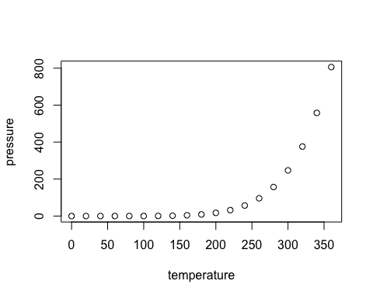

Note that the echo = FALSE parameter was added to the code chunk to prevent printing of the R code that generated the plot.